
Western Cape Education Department
Directorate: Curriculum FET

MATHEMATICAL LITERACY

REVISION BOOKLET
2025 TERM 3 and 4

Grade 10

This revision program is designed to assist you in revising the critical content and skills covered during the 3rd and 4th term. The purpose is to prepare you to understand the key concepts and to provide you with an opportunity to establish the required standard and the application of the knowledge necessary to succeed in the examination.
The revision program covers the following topics:
- FINANCE
- MEASUREMENT
- MAPS AND PLANS
- DATA HANDLING
- PROBABILITY

FINANCE
Income and Expenditure, Profit and Loss

- Identify the types of income & Expenditure in the list below:

  - Wages
  - Overtime pay
  - Selling some old clothes
1.4 Buying data
  - Buying a new jacket
  - Paying school fees

- Calculations with income and expenditure:

  - Kate earns R 20 000 as a monthly salary, determine her annual income.
  - Pete pays a total of R 48 600 in rent every year, calculate how much this is per month?
  - Sammy makes and sells fudge; she sells it for R4 a block. What is her
weekly income if she sold 75 blocks?
  - Thabelo is a waiter at a restaurant over weekends (Fri-Sun). He works three
weekends a month and works 5 hours per day on those weekends. Calculate
his monthly income if the restaurant pays him R40/hour on Friday as well as Saturday and R65/ hour on Sunday.
  - Zintle calculated that she spends on average 30% of her pocket money on
data. If she receives R450 pocket money monthly, how much does she spend
on data?

- Calculations involving profit and loss:

In each case determine if this person makes a profit or suffers a loss and the amount:
  - Tyler earns R 8 500 monthly and has the following expenses: Rent - R 2750,
Water and Electricity - R600, cellphone - R450, bus fare - R385 and food –
R2900.
  - Chelsea calculated that her average monthly income is R 10 890 and her
annual expenses on average are about R107 700.

FINANCE
Budgets and Income & Expenditure statements

Mr. and Mrs. Mbeki decide that they are spending too much money and they looked at their expenditure for the month of May, including items that are quoted for a year but must be paid monthly. This is what they found:

Bond repayments on the house | R5 000 p.m.
Water and electricity | R 800 p.m.
School fees for 2 children | R1 200 p.a. (each)
Clothing account | R 560 p.m.
Insurance on 2 cars | R3 600 p.a.
Retirement policy | R1 200 p.a.
Insurance on house and content | R8 400 p.a.
Church contributions | R150 p.m.
Bank charges | R 70 p.m.
Entertainment and eating out | R1 000 p.m.
Fitness club | R 79 p.m.
Petrol | R 500 p.m.
Wages for domestic worker | R1 500 p.m.
Food | R3 000 p.m.
Cell phones for 3 family members | R1 200 p.m.
Hired movies | R300 p.m.
DSTV | R5 200 p.a.

- Calculate the monthly payments that are quoted for the year.
- How much did the Mbeki’s spend in May?
- Mr. and Mrs. Mbeki earn R15 000 a month.
How much did they overspend in May?
- What is the ratio of food to the Mbeki’s income?
Write your answer in simplest form.
- They need to reduce their expenses. Suggest 2 ways in which they can achieve this. Make sure that you substantiate your answers.
- Mr. Mbeki decides to sell one of his cars and buy a bicycle to save money.
  - The bicycle cost R1 699. The shop gives 15% discount for cash.
Determine the cost of the bicycle after discount.
  - He bought his car for R90 000 and sold it for R55 000.
Calculate the percentage lost.
- The electricity portion of this account was R550, and they used 622,45kWh.
What is the tariff for electricity? Round your answer to 2 decimal places.

FINANCE
Interest and Taxation

If R1 300,00 is invested at a rate of 6% simple interest per year

1.1 Calculate how much money there will be in the investment after 1 year.
1.2 Calculate how much money will there be in the same investment after 5 years.

If a patient does not pay their account in full by the end of the month, Dr. Smith charges 10% per month simple interest on the outstanding balance. Rachel forgot to pay the bill and owes R560.
Determine how much money she would owe in total if she only paid her bill after:

2.1. 6 months
2.2. 1 year

Gemma invested R5 000 in a simple interest savings account. After two years her investment had grown to R5 700.

  - Calculate the amount of interest earned per year.
3.2 At what interest rate was her money invested?
Calculate the VAT on each of the following VAT-exclusive amounts:

4.1 R260
4.2. R3 200
Calculate the VAT-inclusive amount on each of the following VAT-exclusive amounts:

5.1 R1400
5.2 R38
Calculate the VAT-exclusive amount on each of the following VAT-inclusive amounts:

6.1 R11,99
  - R24,95

- The till slip below shows purchases made at Checkers. Study the till slip and answer the following questions:

Checkers
Willow Village, Tygervalley
Tel: (021) 943 1480
Tax Invoice No. 4420106777
TEMPO 1EA | R5,79
BRW BREAD 700G | R10,99 | *
TOMATO PILCHARDS 700G | R6,99 | *
TOMATO PILCHARDS 700G | R6,99 | *
GOVERRNMENT BAG 24L | R0,39
JAM SWISS ROLL | R16,99
GOVERRNMENT BAG 24L | R0,39
CARROT YNG PBAG | R5,99 | *
TOMATO ROMA PP | R12,99 | *
COTTAGE CHEESE | R16,99
L/F MILK BOTT 2L | R17,99 | *
GRABOUW B/WORS | R27,58
12 BALANCE DUE | 130.05
Cash Rounding | 0.02
CHANGE | 19.95
Rate VAT | TOTAL
15% 8,89 | 68,13
*0,00% 0,00 | 61,94
C0092 #0041 11:27: 36 290712 | S48385 | R04
Please keep your till slip as proof of purchase

  - How are the VAT-exempted items indicated on the slip?
  - Explain how the final amount the client must pay (‘balance due’) was
calculated.
  - Determine the total of the VAT-exempted goods.
  - Calculate the total of the goods that include VAT.
  - Calculate the VAT-exclusive amount by using the VAT-inclusive amount.
  - Write down the VAT amount indicated on the till slip.
  - Use the VAT-exclusive amount you have calculated in Question 7.5 to
show that the VAT amount was calculated correctly.
  - What method of payment was used to pay for the goods?

FINANCE
Banking, loans & investments

- Study the following bank statement and answer the questions that follow:
BB Bank

Account name: | Mr. PP Jonathan | Statement date: | 30 May 2019
Account Number: | 1292113613 | Frequency: | Monthly
Type: | Current account | Statement period | 30 April 2019 to
Branch: | Claremont (129236) |  | 30 May 2019
 |  | Overdraft limit: | R10 000
 |  | Interest on overdraft:
 |  | Up to R5 000: | 9%
 |  | Above R5 000: | 13,5%
Date | Transaction details | Debits | Credits | Balance
2019-04-30 | Opening balance |  |  | -R2 260,00
2019-05-01 | Stop order – Rent | 1500,00 |  | -R3 760,00
2019-05-01 | Debit order – Multichoice | 225,00 |  | -R3 985,00
2019-05-03 | ATM cash withdrawal | 200,00 |  | -R4 185,00
2019-05-05 | Debit transfer | 420,00 |  | R4 605,00
2019-05-08 | Cash deposit (branch) |  | 500,00 | -R4 105,00
2019-05-09 | ATM cash withdrawal | 300,00 |  | -R4 405,00
2019-05-12 | Checkers – debit card purchases | 530,00 |  | -R4 935,00
2019-05-24 | Credit transfer |  | 1 000,00 | -R3 935,00
2019-05-25 | Interest | 29,51 |  | -R3 964,51
2019-05-29 | Transaction fees | 182,60 |  | -R4 147,11
2019-05-29 | Overdraft service fee | 24,00 |  | -R4 171,11
2019-05-29 | Salary EFT deposit |  | 10 500,00 | R6 328,89
 | Closing balance |  |  | R 6 328,89

  - What type of bank account is this?
  - What is the name of the bank?
  - What is name of the account holder?
  - Give the name of the branch and the branch code.
  - What is the time period represented by the statement?
  - What is the opening balance on the statement?

  - How many transactions were:
1.7.1 EFT payments
1.7.2 cash withdrawals at an ATM
1.7.3 debit card purchases
1.7.4 stop/debit orders
1.8. What was the total amount deposited into the account over this period?
1.9. Interest was calculated on the 25th of the month.
1.9.1 What was the interest rate used?
1.9.2 How much interest was charged?
1.10 Determine the total bank charges for this period.
1.11 What was the closing balance on the statement?
  - Is the closing balance a debit or credit balance? Explain your answer.

- Below is an extract of the bank charges & transaction fees for B- Bank:
Transaction: | Fee:
Monthly Account Charge | R55
Deposits:
Cash deposit at the ATM | R1,50 + R2,00/ R100
Cash deposit at a branch counter | R20 + 3,5 % of transaction value
Cash Withdrawals:
At B-Bank ATM | R2,00 per R100
At another Bank’s ATM | R11,50 + R2,00/R100
At POS (or purchases) | R2,00
Balance enquiries:
On internet Banking | FREE
At B- Bank ATM | FREE
At another Bank’s ATM | R4,50

Use the bank fee structure above to answer the questions that follow:
2.1 How much would a customer at B bank pay to do a balance enquiry at ABC Bank? (remember to look at what bank the fees are for).
2.2 Where would you suggest a client at B-bank does a balance enquiry?
2.3 How much would you pay to withdraw R500 at
2.3.1 B-Bank ATM
2.3.2 Another Bank’s ATM
2.3.3 POS
2.4 How much more would you pay to deposit R3 000 at the branch counter than at the ATM?
MEASUREMENT
Perimeter and Area
- A cricket stadium is called an “Oval” due to its unique shape. Use the diagram
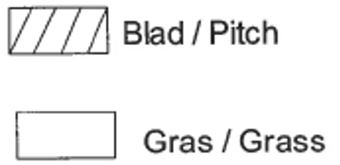
below to answer the questions that follow.

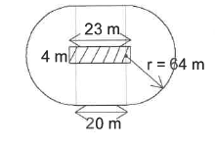

You may use the following formulae:
$$Area=length ×breadth$$
$$Area=πr^{2}$$
$$Circumference=2πr$$

    - Calculate the area of the pitch.
    - Calculate the area of the oval to two decimals.
    - Calculate the area of the grass only.

  - The stadium has a capacity of 28 000 seats. Around the stadium the seating is arranged in 8 blocks.
    - On average, how many seats are there in one block?
    - Each row of seats in the stadium needs a height of 700 mm and the height of the stadium is 30 m. The caretaker indicates that there are 43 rows in each block. Verify through calculation if this is correct.

- Mpho wants to make a tablecloth for her rectangular table. The width of the tablecloth material that she would like to use is 140 cm. There must be a 20 cm overhang. The dimensions of the table are 1 m × 2,5 m.

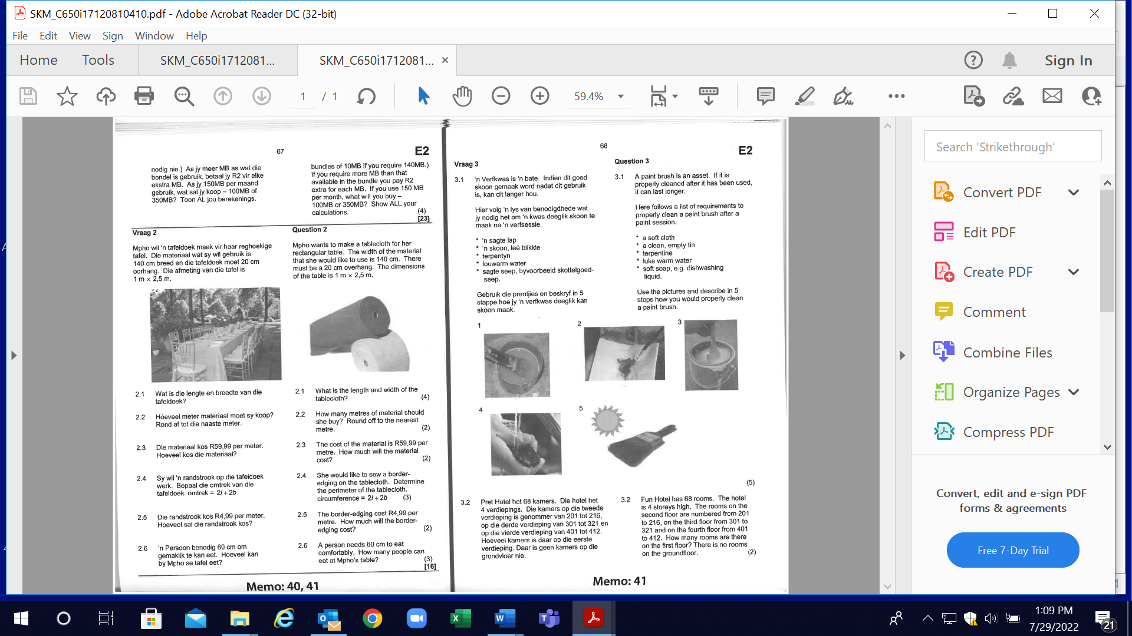

  - Calculate the length and width of the tablecloth.
  - How many metres of material should she buy? Round of the nearest metre.
  - The cost of the material is R59,99 per metre. How much will the material cost?
  - She would like to sew a border-edging on the tablecloth.
Determine the perimeter of the tablecloth.

You may use the following formula:
Perimeter = 2l + 2b
  - The border-edging cost R4,99 per metre. Calculate the cost of the border-edging for this tablecloth.
  - A person needs 60 cm to eat comfortably.
Determine the maximum amount of people that can be sat at this table.

MAPS, PLANS AND OTHER REPRESENTATIONS
- Henry would like to change their outside room into a room with a bath for himself. He draws a scaled diagram of the room.

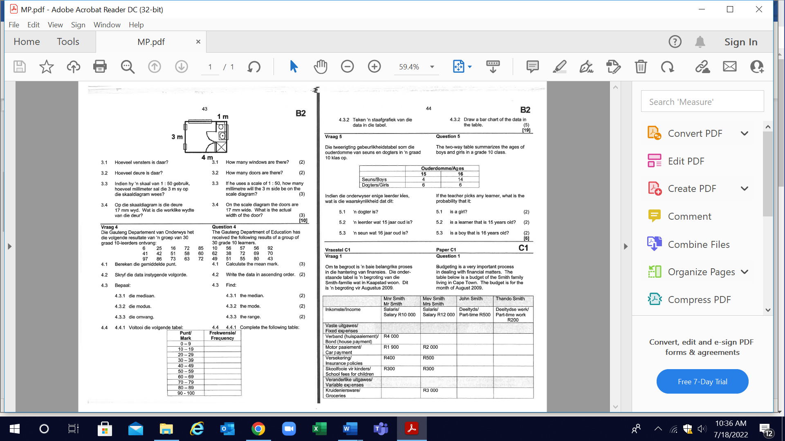

  - How many windows are there?
  - How many doors are there?
  - If he uses a scale of 1:50, calculate the measurement in millimeters of the 3 m side on the scaled diagram

  - On the scale diagram the doors are 17 mm wide. Determine the actual width of the door

- Study the floor plan and answer the questions below.
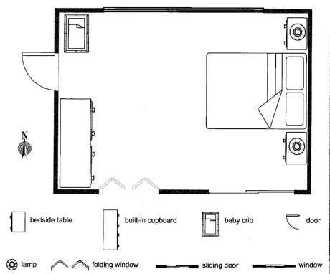
Scale 1: 50

  - Complete the following table:
Object | Length on plan  (round off to the nearest centimetre) | Actual length  (give your answer in metres)
Length of bedroom | (a) | (b)
Width of bedroom | ( c) | (d)
Length of bed | ( e) | (f)
Width of bed | (g) | (h)

  - The owner wishes to replace the entire carpet in the bedroom. The cost of the carpet he chooses is R389,82 per m², plus a cost of R35,32 per m².Calculate how much it will cost to replace the carpet.

  - Determine the area of the ceiling of the bedroom, in order to determine how many tins of paint is required .

Use the fact that 1 tin has a spread rate of 25 m². Remember the ceiling needs two coats of paint.

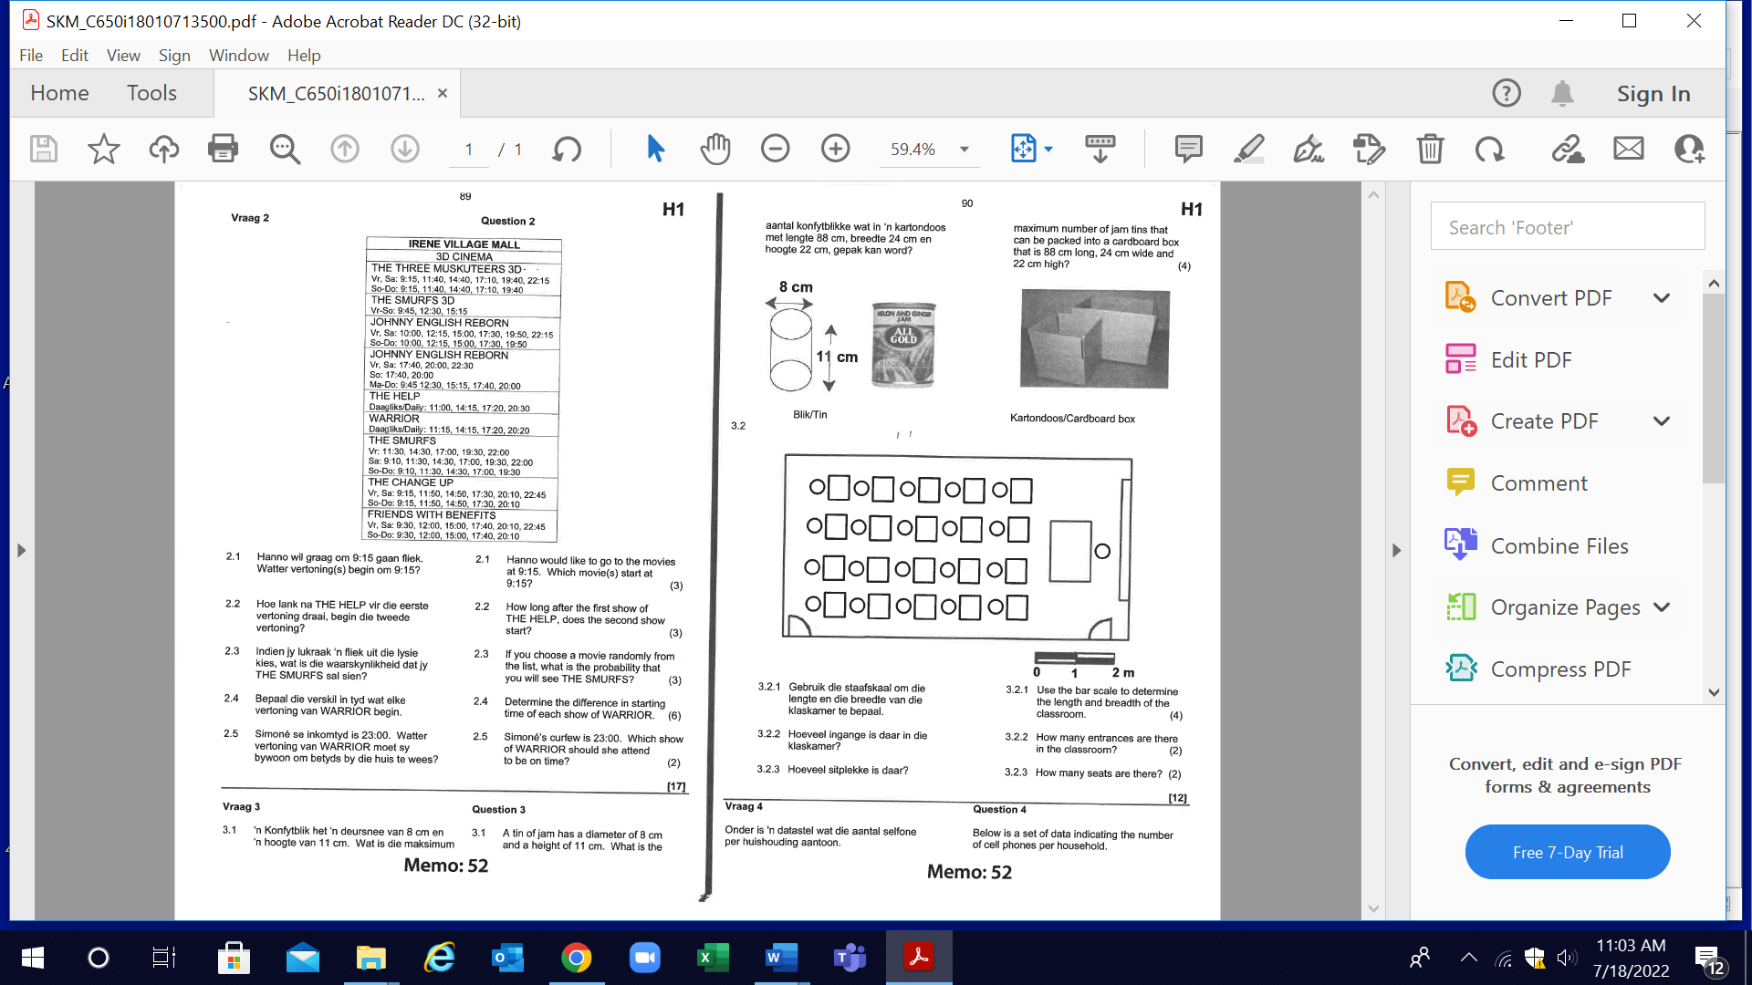
- A tin of jam has a diameter of 8 cm and a height of 11 cm.

Determine the maximum number of jam tins that can be packed into a cardboard box that is 88 cm long, 24 cm wide and 22 cm high.

- The layout of a classroom is shown below. Study the layout and answer the questions that follow.

  - Use the bar scale to determine the length and breadth of the classroom.
  - How many entrances are there in the classroom?
  - How many seats are there?

- Study the diagrammatic for assembling a TV stand and then answer the questions that follow:
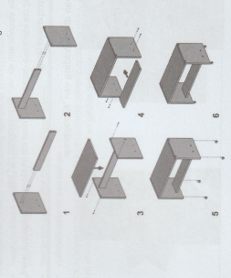

  - When two pieces are fixed together, two screws are required and this is indicated in the diagram with dotted parallel lines.
Determine the number of screws required for assembly.

  - Complie a list (with diagrams) of the parts that make up the TV stand.
  - Write down the instructions for Step 1.
  - Write down the instructions for Step 5.
DATA HANDLING

- The boys in a Grade 10 class receives the following amounts of pocket money per month:

R100; R80; R85; R60; R40; R50; R80; R55

  - Determine the mean amount pocket money that the learners receive.
  - Find the median and the range of the amounts of pocket money.

- The pie chart represents the Cohen family’s monthly budget.

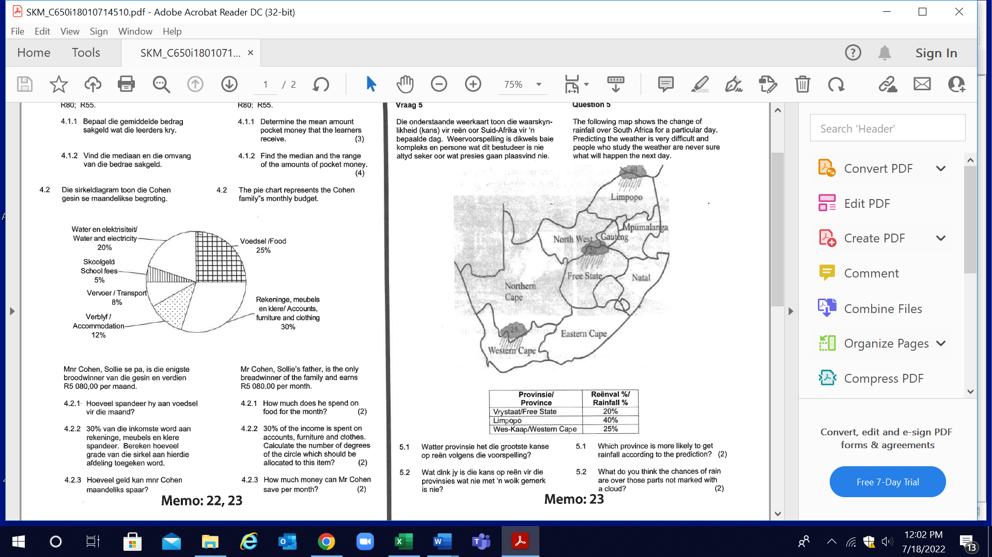
Mr. Cohen, Sollie’s father, is the only breadwinner of the family and ears
R5 080 per month.

  - Calculate the amount of money spent on food for the month.
  - 30% of the income is spent on accounts, furniture, and clothes.
Calculate the number of degrees of the circle which should be allocated to this item.
  - How much money can Mr Cohen save per month?
  - How much money does Ms. Cohen earn per month?
  - On which item of the budget can less be spent? Give a reason.

- The following graph indicates the number of milk producing cattle in a number of towns in KwaZulu-Natal.

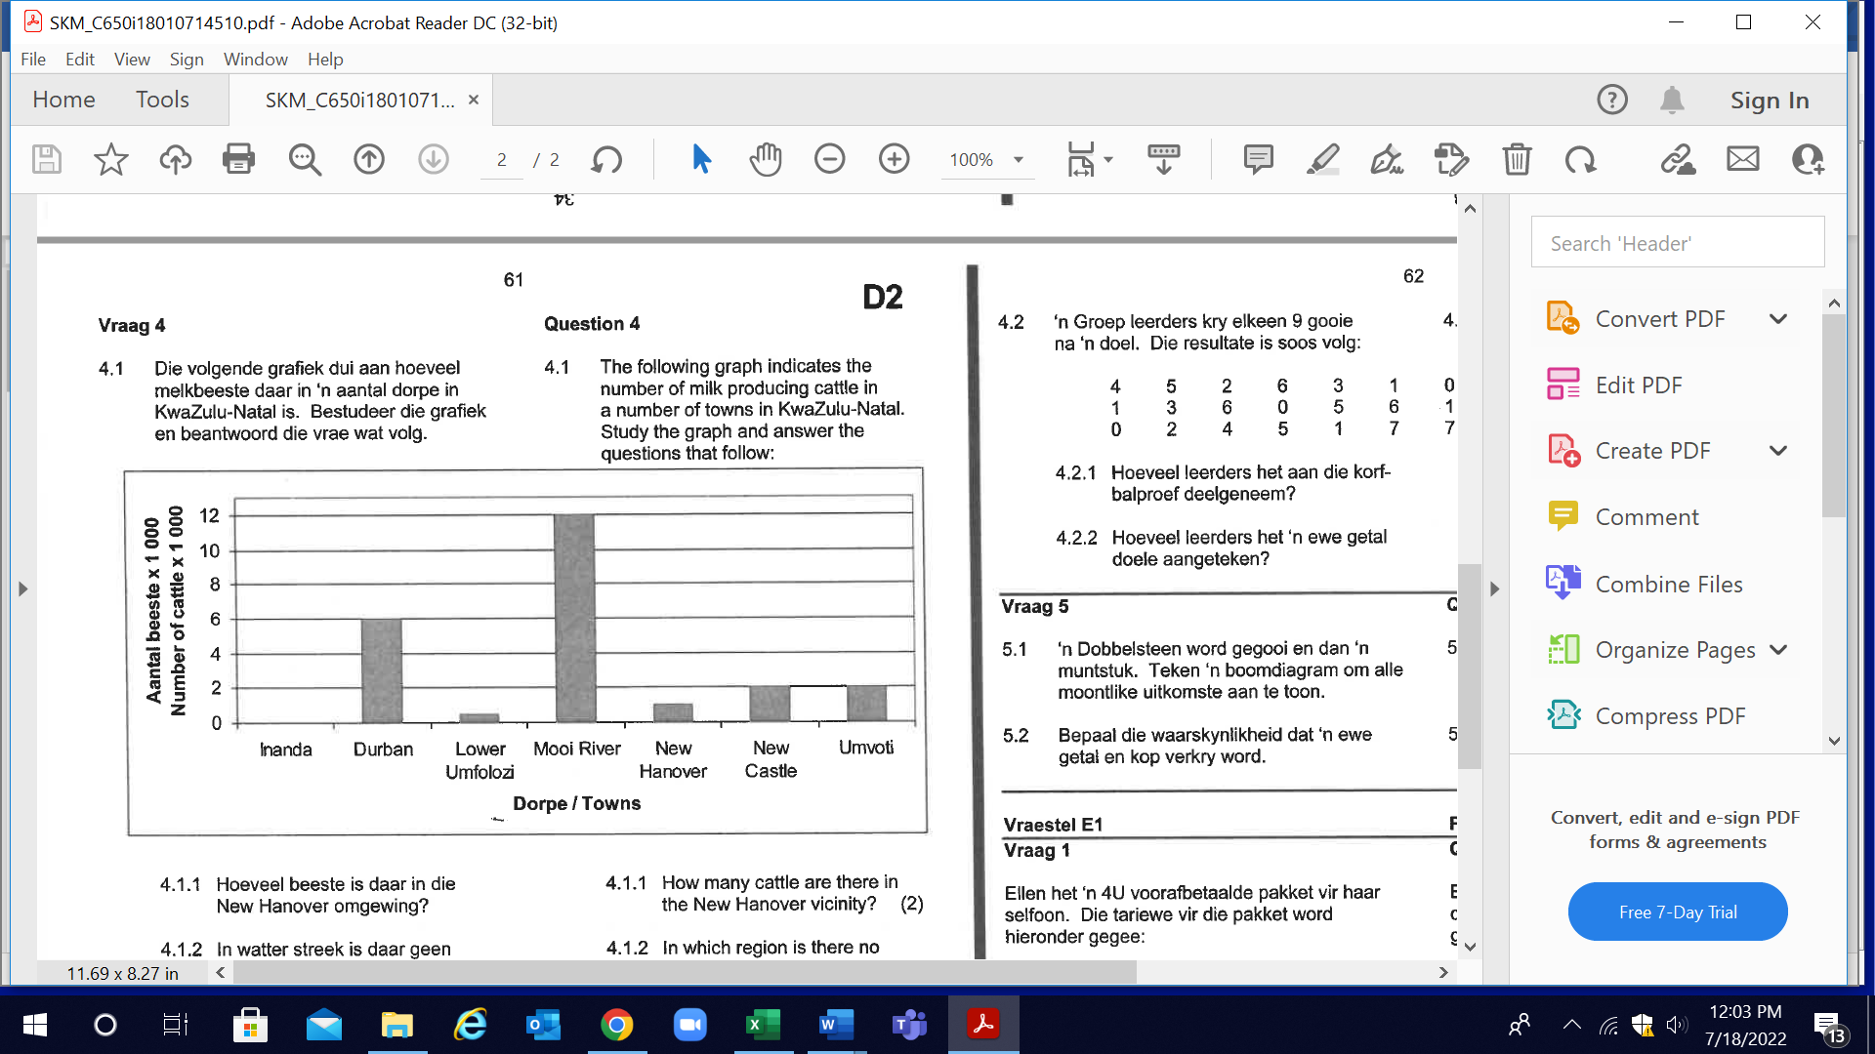

  - Write down the number of cattle in the New Hanover vicinity.
  - In which region is there no milk producing cattle?
  - Foot and mouth disease breaks out in KwaZulu-Natal. In which region will the farmers suffer the greatest loss?

  - Calculate the total number of cattle in the above-mentioned towns.
  - Calculate the percentage of cattle in New Castle from the total number of cattle in KwaZulu-Natal.

PROBABILITY

- The following map shows the change of rainfall over South Africa for a particular day.

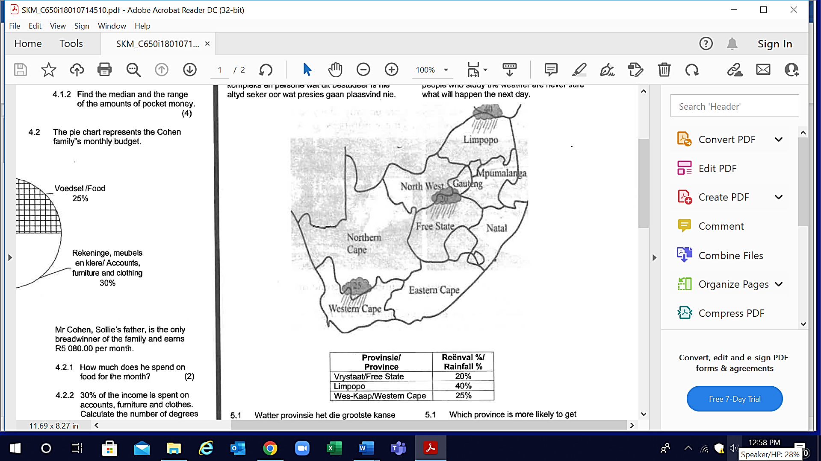

  - Which province is more likely to get rainfall according to the prediction?
  - What do you think the chances of rain are over parts not marked with a cloud?
  - A friend tells you that there is a one in five chance of rain in the Free State. Is this the same prediction as shown on the map? Explain your answer.

  - Determine the chance of rain in the Limpopo. Write your answer as a fraction in its simplest form.

  - The chance of rain in Limpopo increases by 10% from the previous day’s forecast. What will the new forecast for the following day be?

- A standard pack of 52 playing cards consists of four suits:
hearts (♥), diamonds (♦), spades (♠) and clubs (♣).
Each suit consists of 13 cards:
2 to 10, a Jack (J), a Queen (Q), a King (K) ana an Ace (A).

  - If you pick a card out of 52 cards, what is the probability that it will be a seven?
  - To win at Blackjack you need your cards equal to 21 points. An ace may equal 1 or 11 points, all the face cards, Jacks, Queens and Kings equal 10 points. The other number cards equal their number in points.
2.2.1 From a pack of 52 cards, give two possible ways that you can make 21 with:
- Two cards
- Three cards
2.2.2 If you already have a 7 and a 5, determine the probability that your next card from the rest of the pack will be equal to ten points.

