
Western Cape Education Department
Directorate: Curriculum FET

MATHEMATICAL LITERACY

REVISION BOOKLET
2025 TERM 2

Grade 10

This revision program is designed to assist you in revising the critical content and skills covered during the 2nd term. The purpose is to prepare you to understand the key concepts and to provide you with an opportunity to establish the required standard and the application of the knowledge necessary to succeed in the examination.
The revision program covers the following topics:
- FINANCE
- MEASUREMENT
- MAPS AND PLANS

FINANCE
Financial Documents
1. Consider the following till slip and answer the questions:

***KFC***
WORCESTER
Tel(023) 342 0436
Manager 0613481235
BTW # 12345678901

3 Sandra B
------------------------------------------------------
Chk 1256 20 Mrt’ 20 14:25

Take Out
1 Wrapsta Box with Regular drink 49,90
1 Colonel Burger 39,90
Add R2 Hope 2,00
Cash 100,00

Subtotal 89,80
Service Chrg 2,00
Payment 91,80
Change Due 8,20

11,97 VAT Sales 89,80
Net TTL 79,83

1.1 What is the name of the store or restaurant?
1.2 What is the name of the branch of this outlet?
1.3 Which number would you dial if you wanted to call the store?
1.4 What is the name of the person who served you?
1.5 What was the date that you went to this outlet?
1.6 What bank note did you pay with?
1.7 What was the total bill for your purchase?
1.8 What was the amount of VAT charged on the bill?

2. Study the following household utility bill and answer the questions that follow.
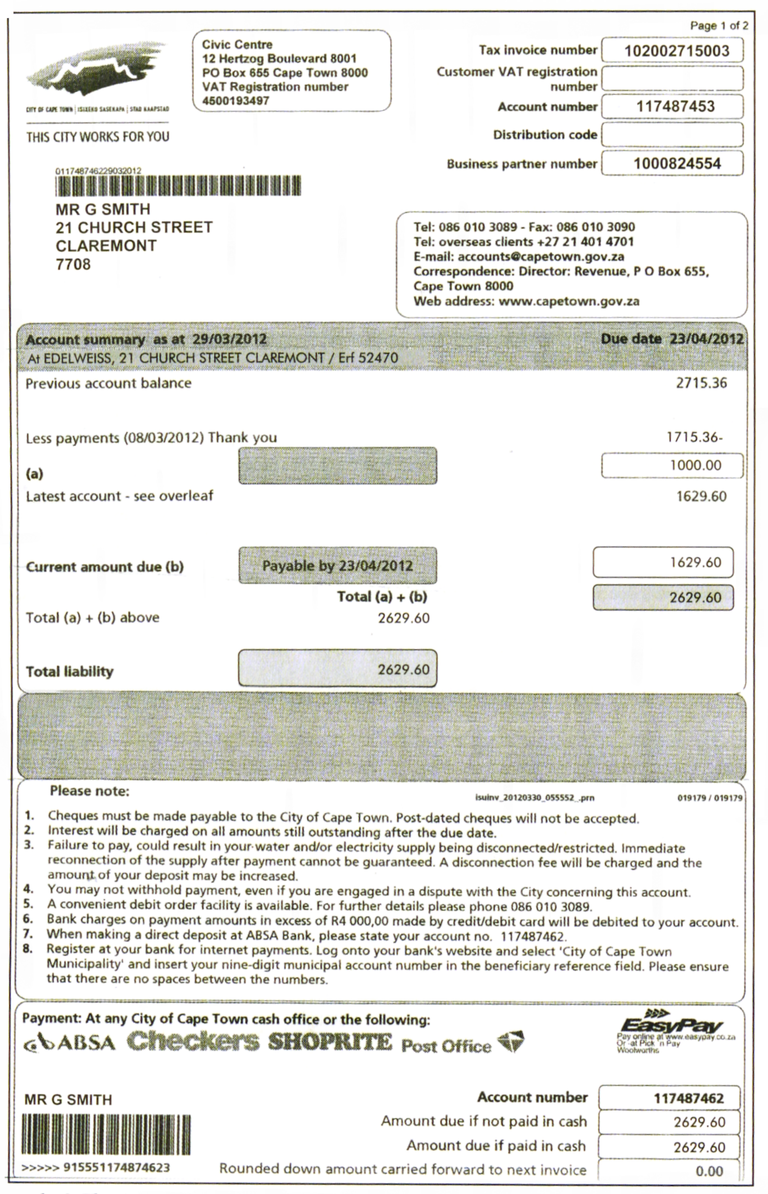
2.1 Who is responsible for this account?
2.2 Where do he/she live?
2.3 What was the amount of the previous months account?
2.4 When must the account be paid?
2.5 What number can the client call if he/she have a question about their account?
3. Neo bought some goods at Benny's Supermarket. Her cash slip looks like this:
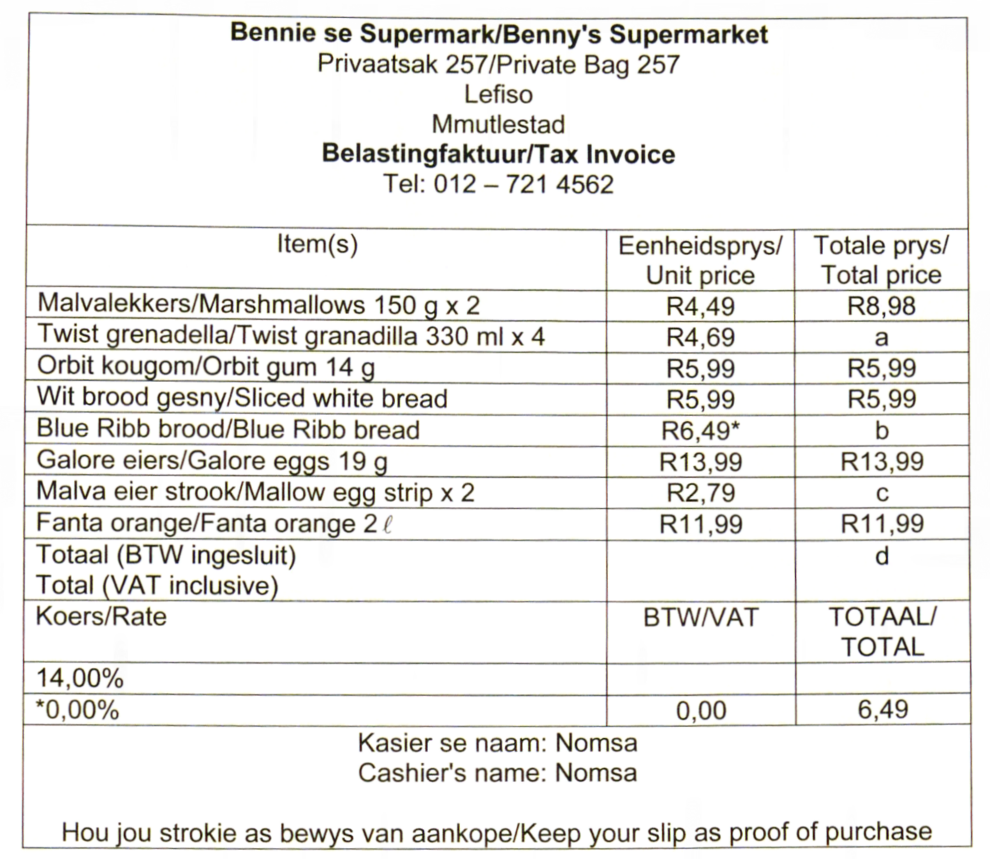
3.1 Fill in the missing values in the total price column and calculate the total price paid.
3.2 On which item is no VAT charged?
3.3 The total price is inclusive of VAT. Calculate the VAT charged on the total, excluding the item that was not charged VAT.
3.4 The price of eggs increases by 8%. What is the price of eggs after the increase?
3.5 A container with 18 eggs costs R24.9S and a container with 6 eggs, R8,99.
3.5.1 Calculate the price per egg for each of the containers.
3.5.2 Which container's price per egg is the cheapest?
Tariff Systems
1. Ellen has a 4U prepaid package for her cellphone. The tariffs for this package is
given below:
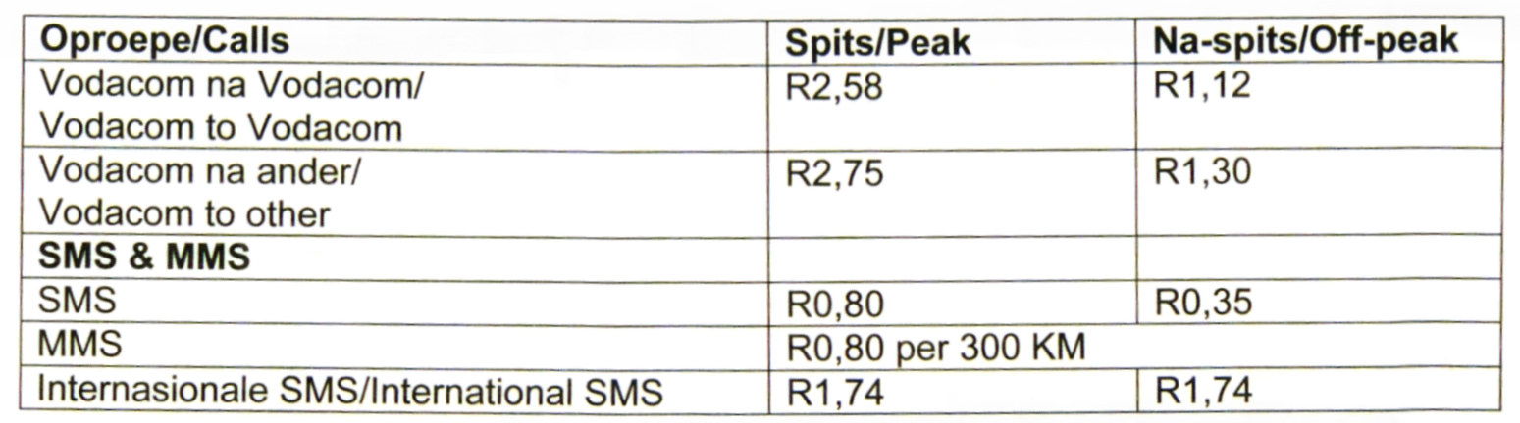
Ellen budgets R240 per month for her cellphone.
1.1 How many rands can she use on her cellphone per day? You can assume that a month has 30 days.
1.2 Call fees are per minute or part thereof. Ellen tries not to exceed her budget. She writes down each call and determine the cost of the day.
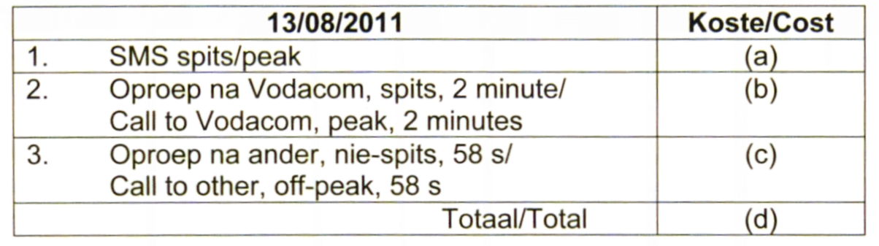
Calculate the values of (a), (b), (c) and (d).
1.3 Did she stick to her budget?
1.4 If she on average uses R12 per day on her cellphone, with what percentage does she exceed her budget?
1.5 Calculate the savings in cost if Ellen made the 2 min call in off-peak time.
1.6 Give two hints on how Ellen can stay within her budget.

2. To calculate the cost of electricity on a prepaid meter, use the following formula:
Cost = R1,20 x number of kWh electricity used
2.1 What is the tariff for electricity consumption?
2.2 Use the formula above to calculate the cost of electricity on a prepaid meter if you use 80 kWh electricity.
2.3 How many kWh of electricity will be credited if R375 worth of electricity was bought for a prepaid meter?
2.4 The heating element in an oven uses approximately 1 500 watts of electricity per hour.
2.4.1 How many kW of electricity does the oven use per hour?
2.4.2 Thando has R35,00 worth of electricity on her prepaid meter. If she uses the oven for 4 hours while baking, how much money will she have left on the meter when she has finished baking?

MEASUREMENT
Measuring Length and Distance
1. Convert the following measurements to the specified units:
1.1 530 cm to metres 1.2 12,5 km to metres
1.3 10,5 m to millimetres
2. Complete the following table by filling in the missing measurements:
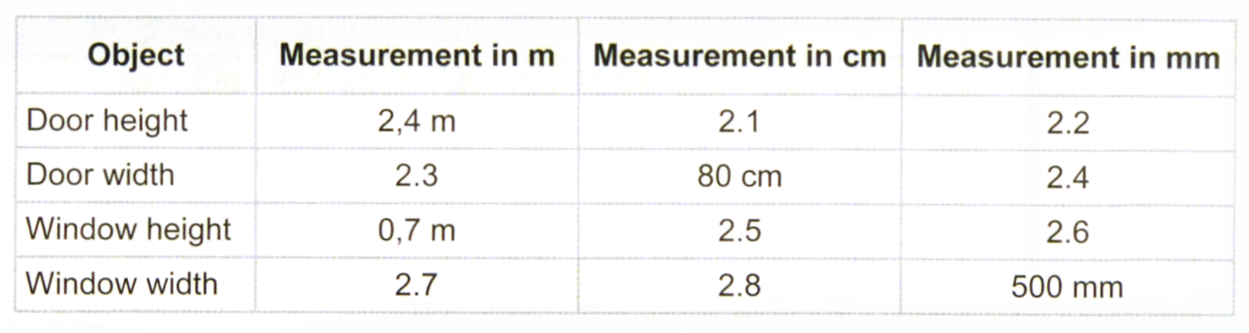
3. At an athletics meeting, Jim runs in the 1 500 m race.
3.1 How many km does Jim run?
3.2 If the athletics track that Jim runs around is a 400 m track, how many times does he run around the track during the 1 500 m race?
4. The following distances were travelled between different consecutive destination points:
A —► B: 3 km B —► C: 690 m
C —► D: 5 300 cm D —► E: 840 700 mm
4.1 Determine the total distance travelled from A to E, in km.
4.2 If the odometer reading at the start of the journey was 678 km, determine the reading at the end of the journey. Round your answer off to the nearest km.
4.3 If a company sponsored a charity R2,50 for every completed kilometre they travelled, then how much money would the company need to sponsor for the journey from B to E?
5. 2,2 m long tables are available and have to be set for a function.
5.1 If each setting requires a minimum of 50 cm, how many settings could you fit down the length of one table?
5.2 If the material needed for making tablecloths cost R2,85/cm, determine the cost of material needed for 6 long tables.
Measuring of Mass / Weight
1. How many grams are there in 4 kg?
2. How many kg are there in 8,67 mg?
3. Convert 35 tons to grams.
4. Apples cost R8,99 per kilogram.
4.1 How much would 2 300 g of apples cost?
4.2 What would the weight of R15's worth of apples be?
5. A cake recipe calls for 0,8 kg of flour, 650 g of sugar and 900 000 mg of butter.
5.1 Determine the total mass of these ingredients. Give your answer in kilograms.
5.2 If you have a 0,5 kg block of butter, will you have enough butter for the recipe? Show all calculations to justify your answer.
5.3 If sugar comes in 150 g bags at a cost of R5,95 per 150 g bag, determine the total cost of the sugar needed for this recipe.
6. You are about to go on holiday and only have your small bathroom scale to help you weigh your luggage. You decide to weigh yourself first and then to weigh yourself together with your suitcase. The scale reading with just you is 65 kg. The reading together with the suitcase is 103 kg. Do you need to remove or add a few items if the airline's maximum weight allowance is 35 kg?

Measuring of Volume
1. Convert the following measurements to the specified units:
1.1 4,89 kl to ml 1.2 3,2 ml to l 1.3 0,006 l to kl
2. 3 cups of liquid beef stock are needed to make soup.
2.1 How many ml is this?
2.2 If you need 3 teaspoons of beef stock powder to make one cup of liquid beef stock, how many tablespoons do you need to make 3 cups of liquid beef stock?

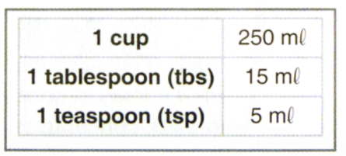
3. The tuckshop uses 12 tablespoons of mayonnaise to make 50 chickemayonnaise sandwiches.
3.1 How much mayonnaise is this in ml?
3.2 How many teaspoons of mayonnaise is this?
4. A soup kitchen makes 23 000 litres of soup a month for the homeless.
4.1 How many cups of soup is this?
4.2 How many ml of soup do they make in two weeks?
(Assume 4 weeks in a month)
5. To get green paint, one must mix 3 parts yellow paint with 1 part white paint and 4 parts blue paint. Determine how many millilitres of each colour paint one would need to make a total volume of 2l of green paint.
6. Jenny is evaluating which nail polish is cheaper.
Paint & Go Polish which costs R85,99 for 5 ml.
Perfect Glow Polish which costs R71,50 for 3 ml.
Which nail polish should Jenny choose?
Measuring of Temperature
1. A temperature thermometer reads 60°F. If degrees Celsius is about $\frac{1}{3}$ of a Fahrenheit reading, determine the approximate temperature in degrees Celsius.
2. At what temperature (in °F) was the oven set below?
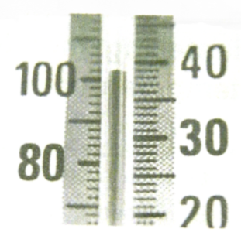
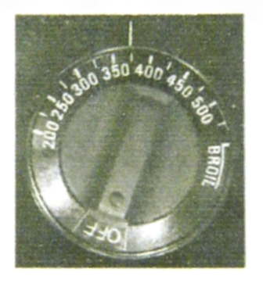
3. The following mercury thermometer was placed in a water bath:
3.1 Read off the temperature of the water bath.
3.2 If the water of the bath must be 67°C, by how much must the
water be cooled or heated?

4. The following weekly weather was forecasted, as shown below:
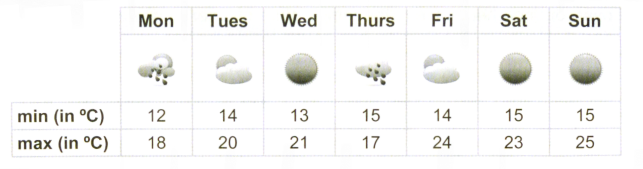
4.1 What is the minimum temperature predicted for:
4.1.1 Tuesday?
4.1.2 the week?
4.2 What is the maximum temperature predicted for:
4.2.1 Friday?
4.2.2 the week?
4.3 Would it be a good idea to go for a long day-hike on Saturday?
Give reasons for your answer.

Measuring of Time

1. Write down the time shown on each of the following watches, in 12-hour and 24-hour format (for both morning and evening times.)

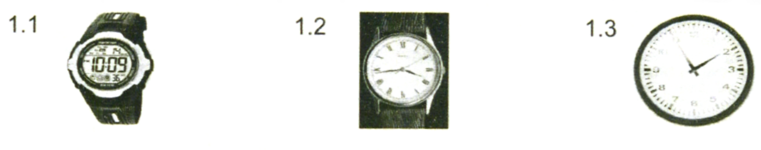
2. Convert the following:
2.1 2,5 hrs to minutes
2.2 convert 8 months to weeks (assume 4 weeks in a month)
2.3 convert 6 weeks to days
2.4 2 days 4 hours and 10 minutes to minutes
2.5 236 seconds to minutes and seconds if necessary

3. Given the following six times below:
A: 11:00 B: 3:00 pm C: 10:45 am
D: 21:00 E: 04:50 F: 12:15 am
3.1 Place the times in order from earliest to latest.
3.2 How much time has elapsed between the earliest and latest times?
4. How much time has elapsed (passed) from 06:08 am to 16:55?
5. Study the calendar of the month of April 2012 given below and answer the questions that follow:

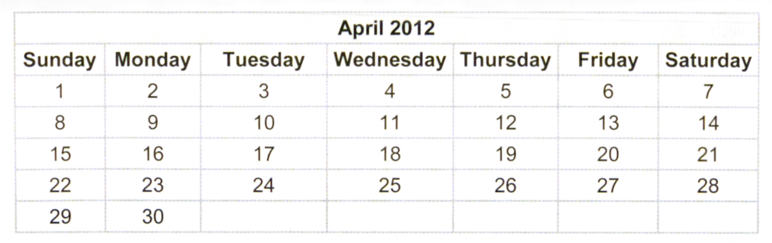

5.1 What day will 1 May fall on?
5.2 How many working days are there in April?
5.3 How many hours are there in the month of April?

MAPS, PLANS AND OTHER REPREENTATION
Scale
1. The rectangle below represents a rectangular swimming pool with a diving board at one side. The scale of the diagram is 1 : 250.
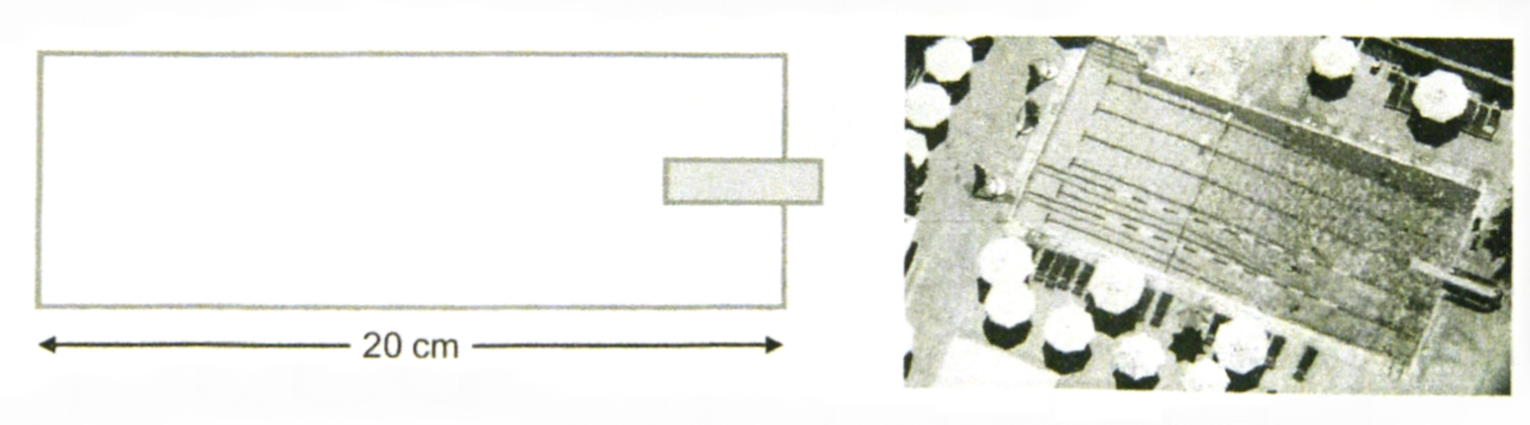
The length of the pool in the diagram is 20 cm. Find the actual length of the pool in metres.

2. A section of a school plan is shown below. The scale of the map is 1 : 2 500.

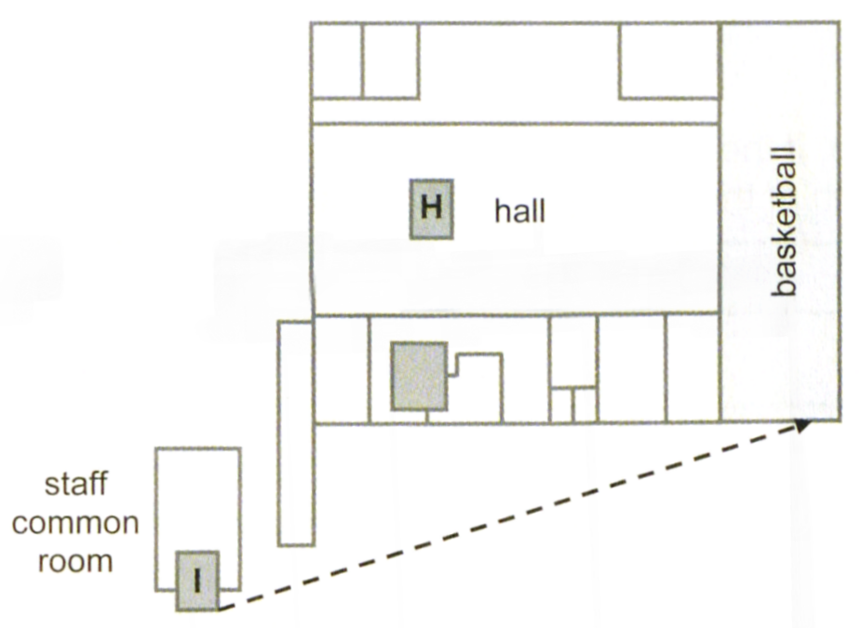

2.1 Determine the length of the hall in reality (in metres).

2.2 Determine the distance (in metres) from the staffroom (I) to the entrance to the basketball courts, using the route represented by the dashed arrows.

Maps

1. You have a friend staying with you in your house and he is not sure where to find things in your kitchen. Your friend is working at the computer and wants to make himself some coffee.

You keep coffee in cupboard A, mugs in cupboard B and teaspoons in drawer C.

Using the computer as a reference point, describe to your friend where to find the coffee, mugs and teaspoons. You can also use other objects that you can see to help in your descriptions.

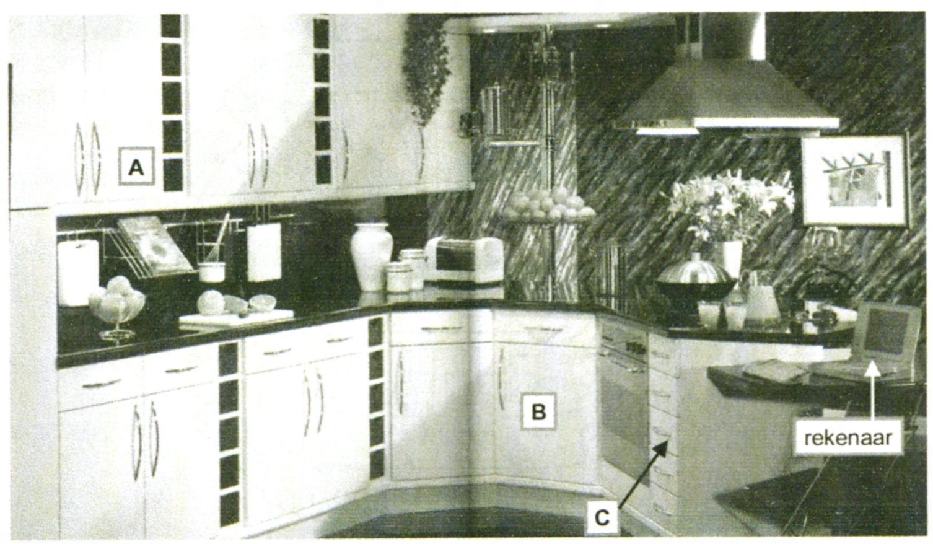

2. Below is a copy of the seating plan of a cinema.
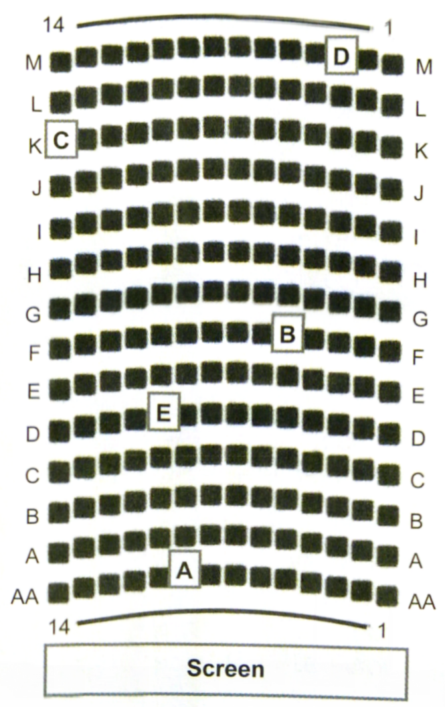
2.1 How many seats are in this cinema?

2.2 Which row is furthest from the screen?

2.3 Describe the seat number and row of the seats indicated in bold, A - E.

2.4 You want to go to a movie with three friends. You get to the cinema
late so seats are limited. You are given the following three options:

Option 1 - D1, C1, C2, C3
Option 2 - M14, M13, F5, F6
Option 3 - AA11, AA13, AA15, A12

Which option would you choose? Give a reason for your answer, explaining why you would not choose the other two options.

2.5 Which seat would be most suited to someone in a wheel chair?
Explain your answer.

2.6 Where would the most comfortable seats be for someone with
long legs?

3. The following is a section of a mall map of the V&A Waterfront. Use the map
below to answer the following questions:

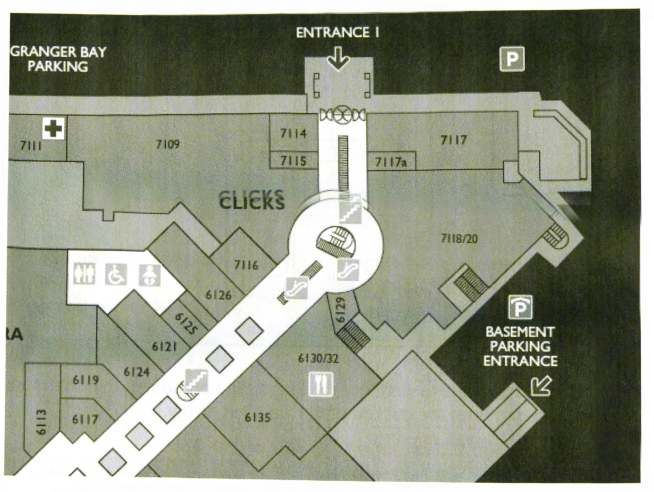
3.1 What is the shop number of Clicks?

3.2 Where is shop 7116 relative to Clicks?

3.3 Describe how to walk from the basement parking entrance to shop 6135.

3.4 How many escalators are shown in the map?

3.5 What other facilities are shown in the map? (Hint: Have a look at the
symbols indicated on the map.)

3.6 The scale of the map is 1 : 2 500. Calculate the actual distance (as the crow flies) from the inside of the doors at Entrance 1 to the door (front centre) of shop 6135.

4. The scale of the bedroom floor plan below is 1 : 50.

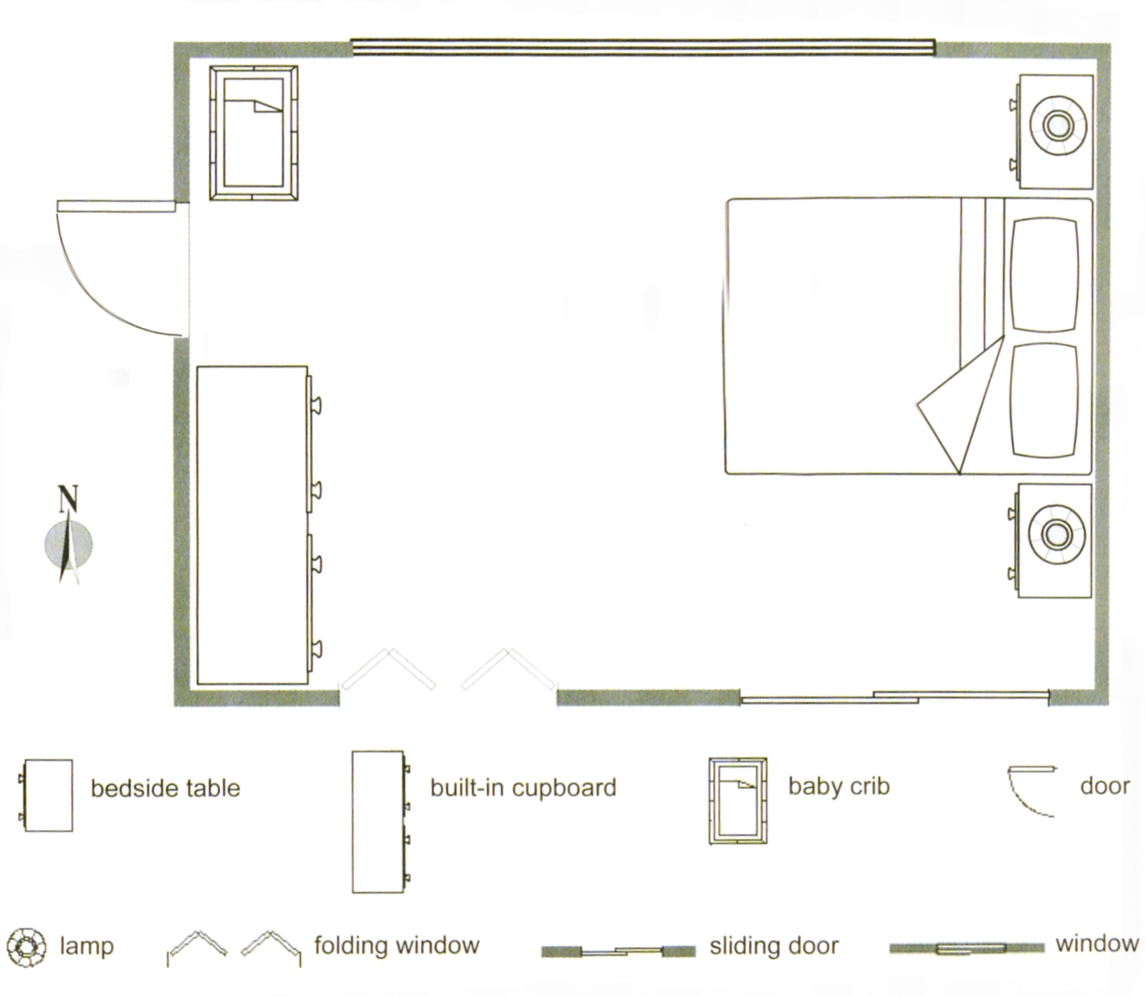
Complete the following table:
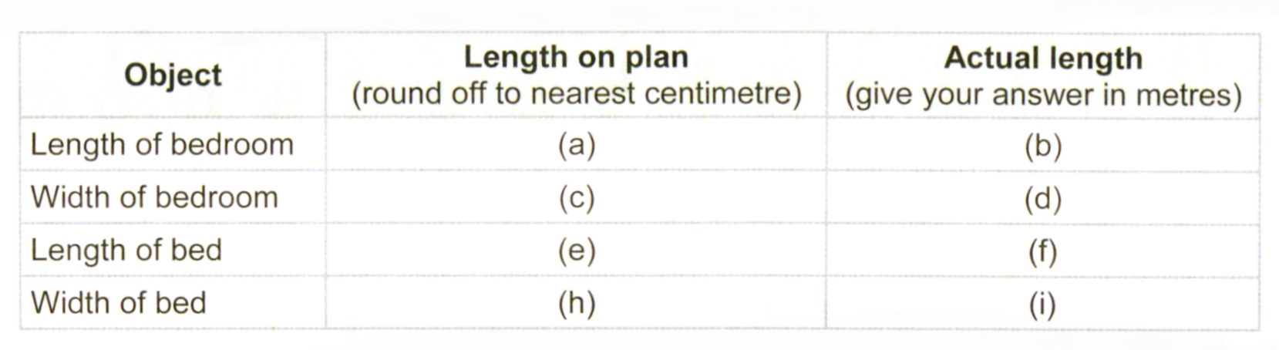

Diagrams
1.
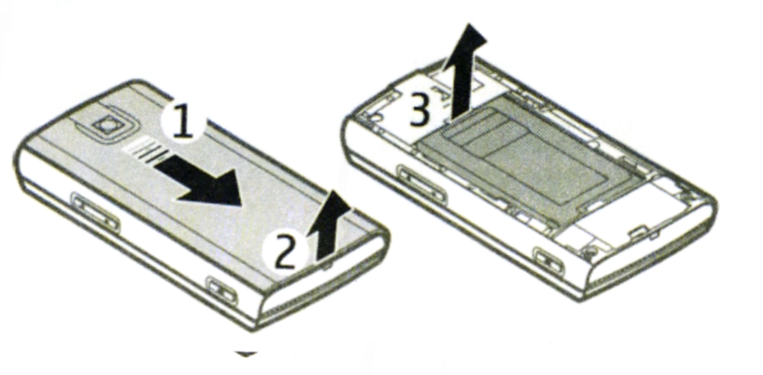

This diagram shows how to remove the battery of a cellphone.
Describe each step in detail in words.

