
Western Cape Education Department
Directorate: Curriculum FET

INFORMATION TECHNOLOGY

REVISION BOOKLET
TERM 3 and 4

Grade 11

This revision program is designed to assist you in revising the critical content and skills planned to be covered during the year. The purpose is to prepare you to understand the key concepts and to provide you with an opportunity to establish the required standard and the application of the knowledge necessary to succeed in the final examination.

The revision program covers the following topics:
- General programming skills
- Database manipulation
- Array and method manipulation
- Problem solving

DATA FILES: Click to download the data

SECTION A: GENERAL PROGRAMMING SKILLS
Fundamental skills mainly developed in grades 10 and 11.
These skills and concepts are:
- Setting component properties in the object inspector and through code.
- Declaration of variables and selecting the appropriate data type.
- Understand when a global variable is needed as opposed to a local variable.
- Obtaining input from various components
- Data type conversion and assignment of values to variables.
- Displaying formatted output in various components
- Basic mathematical operations
- use the different mathematical methods to solve problems:
Random(), RandomRange(), Round(),Trunc(), Frac(), Ceil(), Floor(), Sqr(), Sqrt(), Inc(), Dec(), Pi and Power()
- use the following built-in string methods: Pos(), Copy(), Insert() and Delete()
- Use of a limited set of built-in functions and procedures. AS PER ABRIDGED CAPS (PAGE 55)
- Understand how decisions structures work.
  - Boolean test condition(IF..THEN..ELSE, Nested IF, Case)
  - Where code goes when the test evaluates to True or False
- Algorithms mentioned in the CAPS
- Basic problem-solving skills

QUESTION 1: GENERAL PROGRAMMING SKILLS
Scenario: Very Active Gym is a local gymnasium that asked you to develop a Delphi program for them.

Do the following:
- Open the incomplete program in the Question1 folder.
- Enter your name and surname as a comment in the first line of the Question1_U.pas file.
- Compile and execute the program. The program currently has no functionality.
- The program contains THREE tab sheets.
- Follow the instructions below to complete the code for EACH section of QUESTION 1, as described in QUESTION 1.1.1 to QUESTION 1.3.

Overview of the supplied graphical user interface
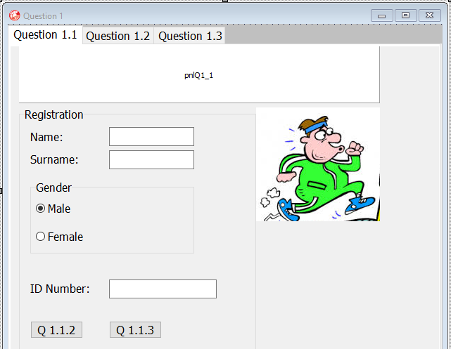

1.1.1 | Write CODE in the OnCreate event handler of the form to do the following:  - Change the background colour of pnlQ1_1 to clLime.  - Change the font name of pnlQ1_1 to 'Forte'.  - Change the font size of pnlQ1_1 to 36.  - Change the text on pnlQ1_1 to 'Very Active Gym'.  - The image component called imgLogo does not show the whole picture. Add code to correct this. | (5)
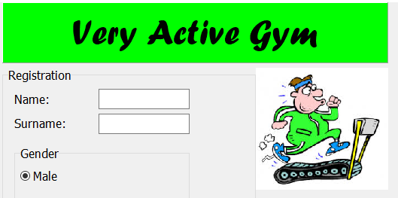
Example of output:

Pre-knowledge
Concept | Where to revise in DBE textbook
Changing the properties of various components  Changing the properties of the image component | Gr 10 – Unit 2.3 page 24, 25  Gr 10 – Unit 2.4 page 26-28

Question 1.1.1
Question |  | Important concepts to do
Change the background colour of pnlQ1_1 to Lime |  | Assign the correct value(colour) to the colour property of the panel.
Change the font name of pnlQ1_1 to ‘Forte’ |  | Assign the correct font name to the name attribute of the font property of the panel.
Change the font size of the pnlQ1_1 to 36 |  | Assign the correct font size to size attribute of the font property of the panel
Change the text ‘pnlQ1_1’ to display the text ‘Very Active Gym’ |  | Assign the text to the caption property of the label
The image component imgLogo must show the whole picture |  | Change the stretch property of the image to True
1.1.2 | TABSHEET Question 1.1  Button [Question 1.1.2]  To register a new member has to enter his or her name and surname and select whether they are Male or Female.  Write code to read the name, surname, and gender from the components and then display a welcome message in a message box as follows:  For a male member John Smith: "Welcome Mr J. Smith!"  For a female member Ann Jones: "Welcome Ms A. Jones!"  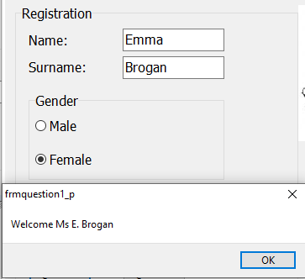  NOTE: The initial of the name is followed by a full stop and the surname should be displayed.  Example of input and output: |  |  | (5)
Pre-knowledge
Concept |  |  | Where to revise in DBE textbook
- Extracting from the following components.  - Check boxes and Radio Group  - List and combo boxes  - Get input from edit components and assign to respective variables  - Use the correct selection structure to code the instructions when a radio button is selected.  - Extract a character from a string  - Formatting of an output  Welcome <Mr/Ms> <Initial> ‘.’ <Surname> !  - Display output in a message dialog box |  |  | Gr 10 – Unit 5.3 page 105 - 107  Gr 10 – Unit 7.1 page 151  Gr 10 – Unit 3.2 page 47  Gr 10 – Unit 5.2 page 98  Gr 10 – Unit 8.3 page 220  Gr 10 – Unit 3.4 page 47  Gr 10 – Unit 5.3 page 108

Question 1.1.2
Question |  |  |  | Important concepts to do
Extract the name and surname from the respective edit boxes edtName and edtSurname |  |  |  | Assign the name and the surname values to the respective String variables
Use the character at the first index position to extract a single character instead of the copy function and assign it to a variable of type char |  |  |  | Assign the single character to a variable or join to the output message.
Use an appropriate selection structure to test which gender was selected from the radio group |  |  |  | The radio button test is also a condition of an if-else or case structure. Depending on which radio button is selected display the output message in the correct section of the selection structure
Concatenate ‘Welcome’ with either <Mr or Ms> and ‘.’ and <Surname> |  |  |  | Assign the correct string to the display message above. i.e. either Mr or Mrs depending on what is selected
Display the correctly formatted message on a message dialog box |  |  |  | The message dialog must output the correct message according to the user’s selection from the radio group.
1.1.3 | Button [Question 1.1.3]  The ID number should be validated as follows:  - It should consist of 13 characters: If it does not ,a suitable message should be displayed in a message box and the cursor should be placed in the ID number edit box component.  - In a South African ID number, a person's birthdate is indicated in the first four numbers (YYMMDD). Write code to test whether the MONTH indicated in the given ID is correct. If it is not a suitable message should be displayed in a message box and the cursor should be put in the ID number edit.  IF both these tests succeed, the message should be "The ID number is valid. You may proceed."  Note: Only these TWO tests need to be done! |  |  |  |  | (9)
 | Examples of output:
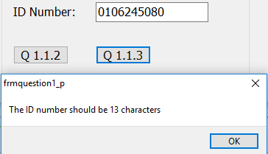 |  | 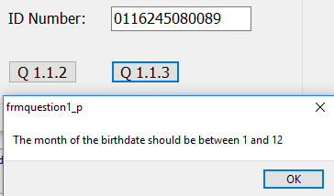
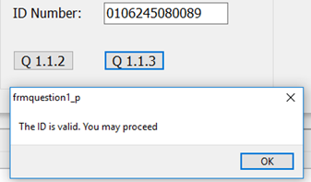

Pre-knowledge
Concept |  |  |  | Where to revise in DBE textbook
- Get the ID number from the edit box  - Determine the length of the ID number  - Use a selection structure (IF..ELSE) to check the length of the ID number.  - IF the ID number is 13 characters in length  - Extract the month(3rd and 4th characters) from the ID number  - Convert the month to an integer value.  - Use a 2nd selection structure, in the appropriate section of the first selection structure, to test whether the month is in the range 1 to 12 or not  - If the range of the month is within 1..12 inclusive(Condition is TRUE)  - Output a suitable message using a dialog box.  - If the month is not in the range(Condition is FALSE)  - Output a suitable message using a dialog box.  - If the ID number is not 13 characters in length  - Output suitable message using a dialog box  - Set the focus of the cursor to the edit box |  |  |  | Gr 10 – Unit 3.2 page 47  Gr 10 – Unit 6.2 page 137  Gr 10 – Unit 5.4 page 111  Gr 10 – Unit 6.2 page 137  Gr 11 – Unit 6.4 page 148  Gr 10 – Unit 3.2 page 47  Gr 10 – Unit 6.3 page 141  Gr 10 – Unit 6.1 page 130
Question 1.1.3
Question |  |  | Important concepts to do
Extract the id number from the edit component |  |  | Declare a correctly typed variable to store the id Number  Assign the text obtained from the edit box to the variable.
Determine the number of characters in the ID |  |  | Use the length method to calculate the number of characters in the ID number.
Check if the ID number is 13 characters long or not |  |  | Use an if-else statement to test whether the ID number is 13 characters long or not
If the ID number is 13 characters in length  - Extract the month from the ID number  - Convert the month to an integer value  - Use an appropriate selection structure to test whether the month is in the range 1 .. 12  - If the month is not in the correct range 1..12 Output a suitable message ‘ ID is valid you may proceed’ using an output dialog box  - If the month is the incorrect range  - Output a message ‘Month should be between 1 and 12’ using a dialog box |  |  | Test if the ID is 13 characters in length. If the condition is true do the following in the appropriate section of the condition:  Use the copy method to extract the 3rd and 4th  characters of the ID number which will represent  the month. Use the strToInt methods to convert  the month to an Integer value  Use a 2nd selection statement (IF .. ELSE ) – with a  new condition using either an IN statement (If  Month IN [1..12]) OR a compound condition (If  Month >= 1 and Month <= 12) to test whether the  month is in the correct range.  In the appropriate section of the 2nd selection structure (IF .. ELSE ) within the first selection statement display the correct message using a dialog box
If the ID number is NOT 13 characters in length  - Output a suitable message using a dialog box  - Set the focus of the cursor to the edit box |  |  | In the correct section of the selection structure place code to display an appropriate message using a dialog box(ShowMessage) and use the setFocus property of the edit box to set the focus of the cursor to the edit box

1.2.1 | TABSHEET Question 1.2  Button [Question 1.2.1]  To determine a proper exercise program for each new applicant, a person's BMI (Body Mass Index) is used by the gym staff to determine whether a new applicant is underweight, normal weight, overweight or obese.  To determine the BMI, the following formula is used:  Weight (in kg)  Height² (in m) in other words: Weight divided by (height x height)  When the BMI is calculated, the following table is used to determine the categories:  Write code to read the weight and height from the edits, calculate the BMI, determine the category and display the results in edtOutput as indicated below. |  |  | (10)
  BMI | CATEGORY
  Less than 18.5 | Underweight
  18.5 to less than 25 | Normal weight
  25 to less than 30 | Overweight
  30 and above | Obese
 | Example of input and output:  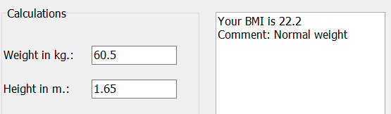 | 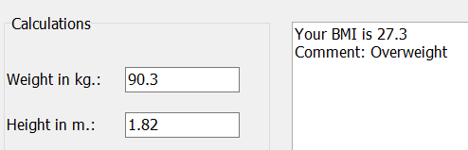
Pre-knowledge
Concept |  |  | Where to revise in DBE textbook
- Get input from the edit component and assign it to a variable of correct data type  - Implement a given formula with an operator precedence  - Display an appropriate message and the calculated BMI on a rich Edit component(redOutput).  - Use a nested IF.THEN..ELSE statements with correct conditions to check the range within which the BMI falls in  - Output an appropriate message in the rich Edit(redOutput) |  |  | Gr 10 – Unit 3.5 page 49  Gr 10 – Unit 4.1 page 62  Gr 10 – Unit 5.5 page 117

Question 1.2.1
Question | Important concepts to do
Extract the weight and height from respective edit boxes edtWeight and edtHeight | Declare correctly typed variables for the Weight and Height.  Assign the values obtained from the edit components, converted to the correct data type, to the respective variables
Calculate the BMI for the applicant  BMI is calculated as follows:  BMI = Weight /(Height * Height) | Declare a correctly typed variable for the BMI of an applicant. Use the Weight and Height obtained from the edit boxes when coding the formula
Display the BMI formatted to ONE decimal on the redOutput in the following format:  Your BMI is <calculated BMI> | Concatenate the message, ‘ Your BMI is ’, to the correctly formatted real number and display it on a rich edit component  Ensure that the data type of the BMI was converted to the correct output data type to be able to display the BMI. Check your conversion function carefully and remember to have the correct decimal point for your answer by either using the Format or FloatToStrF functions.
Check if the BMI calculated is within a given range  and display an appropriate message | Use the nested if selection structure (IF..THEN..ELSE) for the THREE different conditions  - BMI < 25  - BMI >= 25 AND BMI < 30  - BMI >= 30  Place the appropriate message in the correct section of the selection structure.

1.2.2 | Button [Question 1.2.2]  A weight loss program was developed that will help members of the gym to lose 1.25 kg per week if they follow the plan strictly. A member of the gym can enter his or her present weight and target weight and the program must then determine the weight after each week, as well as the number of the week in which the target weight will be reached.  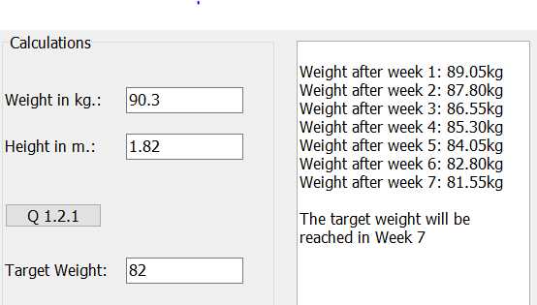  Read the member's present weight from edtWeight and the target weight from edtTarget, and then subtract 1.25 from the weight each week until the target weight is reached. Display the results in the rich edit edtOutput as follows:

Pre-knowledge
Concept | Where to revise in DBE textbook
- Get the input from the respective edit components and assign it to a variable of the correct data type  - Set the variable a variable iWeeks to 0  - Determine the condition of the loop to calculate the number of weeks it will take to achieve a target weight  - While the target weight is greater than the weight of the person  - Increment the iWeeks variable by 1  - Decrement the weight variable by 1.25  - Output each week and the adjusted weight per week  - When the target weight is reached display a message indicating that the target weight has been reached and display the variable correctly formatted to indicate the week in which the target weight was reached. | Gr 10 – Unit 3.5 page 49  Gr 10 – Unit 7.3 page 47  Gr 10 – Unit 7.7 page 182-187

Question 1.2.2
Question |  | Important concepts to do
Extract the weight and the target weight from the respective edit components edtWeight and edtTarget . |  | Declare correctly typed variables for the Weight and TargetWeight.Assign the values obtained from the edit components, converted to the correct data type, to the respective variables
Set a variable of type Integer to 0. |  | Assign iWeek to 0
Loop  Increment week  Decrement the weight: Weight = Weight – 1.25  Display ‘Weight after ’ <Week> ‘ ‘ <Weight> on the  redOutput formatted to TWO decimal places  Until weight >= target weight  Display’ The target weight will be reached in the week’ + <Week> |  | Study the given format. Note that some information is repeated hence use an appropriate loop structure.  Identify what should be inside and outside the loop, the variable(s) that will control the loop, which part of the output depends on a variable, and which part is hardcoded text
1.3 | TABSHEET Question 1.3  Button [Question 1.3]  The members of the gym need to be transported to competitions and outings regularly. The company that has the contract to transport the members uses minibuses that can take 12 passengers each. Write code to read the number of members that need transport to a competition from the spin edit and then calculate the minimum minibuses needed for the trip. Display the result on the panel pnlOutput, as follows:  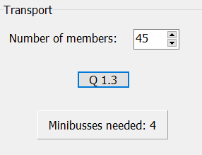  Example of input and output: |  | (4)

Pre-knowledge
Concept | Where to revise in DBE textbook
- Get the input from the spin edit and assign it to a variable of the correct data type  - Calculate the number of buses using the correct mathematical operator to obtain a real result  - Round up the value calculated to the nearest whole number  - Display the buses required with a suitable message and the value calculated on the panel’s caption | Gr 10 – Unit 3.5 page 53  Gr 10 – Unit 4.1 page 62  Gr 10 – Unit 4.3 page 72
Question 1.3
Question | Important concepts to do
Extract the number of members from sedNumber. | Assign the value property if the spin edit to a variable
The minimum number of buses needed is calculated using the correct mathematical operator  buses = rounded(buses/12)  The calculated value need to be ROUNDED UP to the nearest whole number | Calculate the minimum buses needed and assign the value to an integer variable  Use the function Ceil to round Up, then convert and assign to an output variable
Display ‘Minibuses needed ’ <buses>in pnlOutput | Assign the output variable to the panel’s caption.

SECTION B
QUESTION 2: DATABASE MANIPULATION  Hi there! My name is Mr. Kitten, and I will be your guide through this question.  I know I am super cheesy at times (though I am not a mouse) and somewhat childish, but I tend to have good advice – so make sure you listen up!  Some of my Advise    The following important notes are applicable:  - You are NOT allowed to modify or add to the supplied data in any way.  - Good programming techniques must be applied when coding your solutions.  - NO marks will be assigned for hardcoding. Use control structures and variables where necessary.  DB TIP #1  It is important to read through the information regarding the tables thoroughly.  If you do not know the design of the tables provided, the data types of the fields, or the relationships between the tables, you will not be able `to answer the question properly! |  | 
SCENARIO:
A local estate agent makes use of database to manage property rentals.

The RentalDB.mdb database contains one table called Property.
The Property table is structured with the following fields:
FIELD | DATA TYPE | DESCRIPTION
PropertyID | Short Text | Unique identity number for the rental property.
PropertyType | Short Text | House, Townhouse or Flat
Address | Short Text | Address of the rental property
Bedrooms | Number | Number of bedrooms
Bathrooms | Number | Number of bathrooms
Garage | Yes/No | Indicates whether the property has a garage or not
PetsAllowed | Yes/No | Indicates whether pets are allowed or not
Rent | Currency | Monthly rent

Example data from Property table:
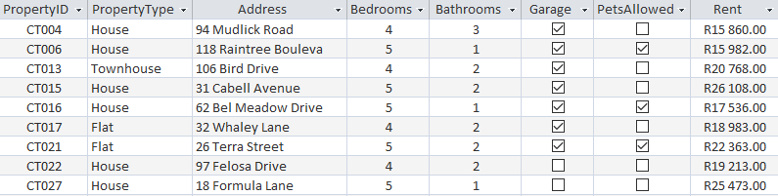
NOTE:
- Connection code has been provided.
- When the btnDBRestore button is clicked, the data in the database will be restored to the original data
DB TIP #2
In the exam, we provide you with a button to revert/restore the database at any time.

If you accidentally insert, delete, or edit a record by mistake, simply click this button.

Do the following:
- Compile and execute the program in the Question2 folder. The program currently has limited functionality.
- Complete the code for each question as described in QUESTION 2.1 to QUESTION 2.5

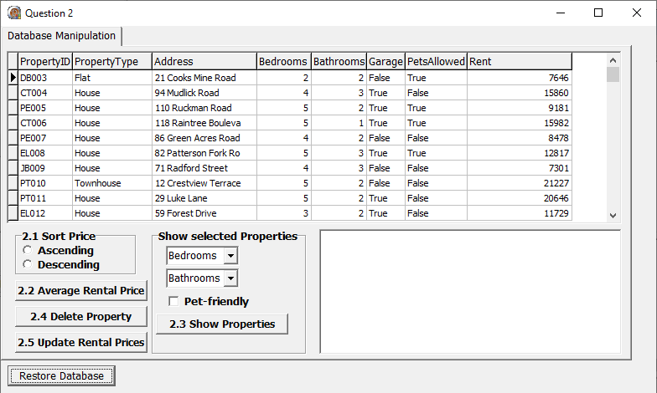
The program displays the following user interface:

NOTE:
- The name of the table to be used in your code must be tblProperty, which is a TADOTable object connected to the database.

Complete the code to meet the requirements specified in QUESTION 2.1 to QUESTION 2.5.
DB TIP #3
In the exam, you don’t have to include the data module in your code. You simply refer to the table directly e.g.
“tblProperty.Next” or “tblProperty.Post”


2.1 | Sort Records according to Rent  When the user clicks on the Radiogroup component, the records must be sorted according to the rental price, either ascending or descending, based on the user selection. | (3)
  QUESTION 2.1 (Gr 11 DBE Textbook Unit 8.5 page 188)
  - Start by looking for the keywords and breaking it up into tasks that you must do.
    - At the start, it really helps to underline and number the different parts until eventually it will come naturally. For example:
    - When the (1) user clicks on the Radiogroup component, the (2) records must be sorted according to the (3) rental price, either (4) ascending or descending, based on the user selection.
  - Now that you have identified that there are 4 key parts to your code, you can begin writing it.
    - Part 1: Get what was chosen from the radio group using a case-statement
    - Part 2: Based on the case, write the code to sort the records…
    - Part 3: ...according to rental price…
    - Part 4: …in either ascending or descending order.
  - Put all the parts together into one and check your answer.
2.2 | Average Rental Price  The manager would like to check the average rental price for a certain property type (House, Townhouse or Flat). An Inputbox component must be used to enter the property type.  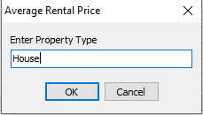  Sample Input:  The average rental price must be displayed as shown in the example.  Sample Output:  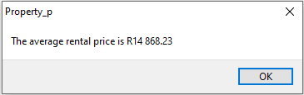    DB TIP #4  It is important to always start at the first record (“tblProperty.First”) and to make sure that you move to the next record in the loop (“tblProperty.Next”)! | (12)
  QUESTION 2.2 (Gr 11 DBE Textbook Unit 8.5 page 188)
  - Once again, break up the instructions into keywords/sections for yourself
    - The manager would like to check the (1) average rental price for a certain (2) property type (House, Townhouse or Flat). An (3) Inputbox component must be used to enter the property type. The average rental price must be (4) displayed as shown in the example.
  - Now that you have identified the parts, you can start to code:
    - First obtain the input from the user and store it in suitable variables
    - Write the code to prepare to iterate (cycle through) all the records in the table (e.g. “tblProperty.First”) and initialise all your variables.
    - Using a while loop with the condition “not tblProperty.Eof”, add up the value in each record and store it in a variable.
    - Finally, calculate the average and display it as indicated.
2.3 | Show Selected Properties  The manager would like to generate a property address list based on the following criteria:  - minimum number of bedrooms and bathrooms; and  - whether or not the property is pet-friendly (allows pets).  The user must select the minimum number of bedrooms and bathrooms from the Comboboxes.  In addition to this, the user has the option to select properties that are pet-friendly by checking the check box.  Display the address, monthly rental price (displayed as currency), number of bedrooms and number of bathrooms, in neat columns.  Sample Output:  DB TIP #5  With a large question like this, you may feel like you just don’t want to try it, or just want to give up on doing it half-way through. Don’t give up! Make sure to attempt the question and have some code for the teacher to mark.  ANY CODE IS BETTER THAN NO CODE | (10)
  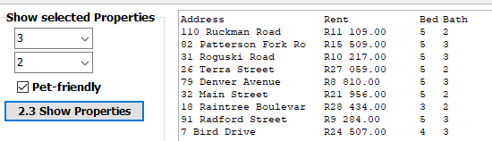
  QUESTION 2.3 (Gr 11 DBE Textbook Unit 8.5 page 188)
  - This one is a lot more complicated than the previous two questions, but as always, look for those keywords and number the important parts of the question for yourself.
  - With a question such as this, it helps to start with the input, then do the processing, and finally the output.
    - Start by creating your variables for the spin edits and the checkbox and get the input from the GUI.
    - As we need to iterate through the database to determine which records we must display, do the preparation code by ensuring you are at the first record, having a while loop, and having “tblProperty.next” inside the loop.
    - At every record you need to ask yourself a question, and that means an IF-statement. The question is a “compound” condition i.e. it is a question that involves more than one set of condition/criteria. Remember to have brackets for each condition!
    - Finally, with the output, set the rich edits tab count and positions.


2.4  DB TIP #4  It is important to always start at the first record (“tblProperty.First”) and to make sure that you move to the next record in the loop (“tblProperty.Next”)! | Delete Property  Add code for the btnDelete event handler. An Inputbox component must be used to obtain the PropertyID of the record that must be deleted from the table. Display a suitable message if the record was deleted.  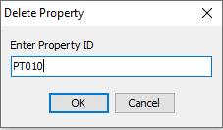  Sample Input:  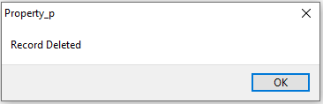  Sample Output: |  |  |  | (7)
  QUESTION 2.4 (Gr 11 DBE Textbook Unit 8.5 page 188)
  - By now it should be easier to break the question up into different parts.
  - The question requires you to iterate through the different records and delete a particular one
    - Start by doing the preparation code and making your variables – just like for the previous question.
    - Inside your if-statement, simply put the line of the code to delete the record and show the appropriate message.
2.5 | Update Rental Prices  Add code for the annual price update procedure. All rental property prices must be increased with 10%. Prices must be rounded to the nearest Rand. Display a suitable message showing how many records were affected.  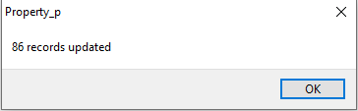  Sample Output:  DB TIP #6  There is a difference between “rounding an answer” and “displaying an answer rounded”  In the former, you use the ROUND function to alter the value, while in the latter you use FLOATTOSTRF to simply display it rounded but keep the value the same.   |  |  |  | (8)
  QUESTION 2.5 (Gr 11 DBE Textbook Unit 8.5 page 188)
  - Break the question up into different parts.
  - As you can see, this question follows the same trend as all the previous questions. You have to iterate through all the database records and do something at each one.
    - Again, do the preparation code and make your variables.
    - Overwrite the contents of the “rent” field with the new value.
- Enter your name and surname as a comment in the first line of the program file.
- Save your program.
TOTAL SECTION B: |  |  |  | 40

SECTION C

QUESTION 3: ARRAY MANIPULATION

SCENARIO : 2019 Tour de France.

The 2019 Tour de France was the 106th edition of the Tour de France, one of cycling's three grand tours. The 3480 km long race consists of 21 stages, started on 6 July in Brussels, Belgium, and concluded on 28 July with the Champs-Élysées stage in Paris.

The following TWO parallel arrays have been declared.
arrDistances: contains the individual distances of each of the 21 stages of the cycling race.
arrDistances : array[1..21] of real = (194.5,27.6,215,213.5,175.5,160.5,230,200,170.5,217.5,167,209,27.2,117.5,185,177,200,208,126.5,130,128);
arrPlaces: contains the name of the town where each of the 21 stages ended.
rrPlaces : array[1..21] of String =
('Binche', 'Epernay', 'Reims', 'Nancy', 'Colmar', 'La Planche', Belfort', 'Mâcon','Saint-Étienne', 'Albi', 'Toulouse', 'Bigorre','Pau', 'Tourmalet', 'Limoux','Nimes','Pont du Gard','Embrun','Tignes', 'Albertville', 'Paris');

An array is a temporary list of elements that can be used to save multiple values of the same data type. The skills developed in grades 11 and it is important to focus on the following skills when focusing on arrays:
These skills and concepts are:
- When thinking of an array the appropriate synonym to loop through items is a for loop
For loop i 1 to length of array
- For Loops are used to
  - Add elements in an array
  - Display elements in an array
  - Count elements in an array
  - Total elements in an array
- While using for loops counter variables (i, iCount) are used to inspect each
- element [i]
- For basic mathematical operations e.g. minimum, maximum and searching and sorting an array the following structure is used:
For loop i := 1 to length of array
If array [element number] <>= x then
Function is used to calculate something from a given input and return a value based on the calculation. While procedure is the set of commands, which are executed in a order.

The following skills and concepts are important:
- Method headers, the keywords Function and procedures, parameters and return type
- The use of the reserved word Result for the return value of a function
- Calling a function and procedure and assigning a value to a function.

The incomplete project Question3 is provided in your Question 3 exam folder. Currently the program has no functionality.
Complete the code for each section of QUESTION 3 as specified in QUESTION 3.1 to 3.4 below.

 | The program displays the following user interface:
 | 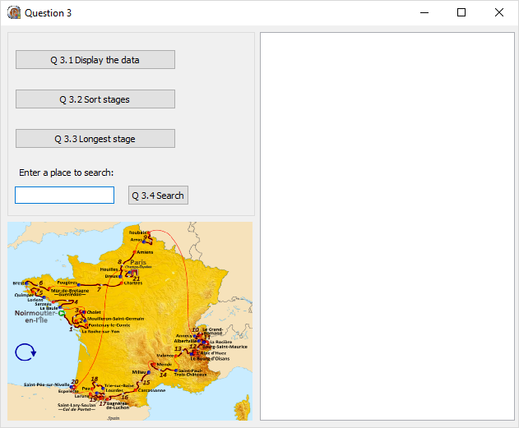
3.1 |  | Button [ Q 3.1 Display the data]  You want to print the data neatly in columns.  Do the following:  - Create a procedure named displayData and add code to the procedure to display the headings and data in the parallel arrays as indicated in the screenshot below.  - Call the procedure in the OnClick event of btnDisplay.  Note: Code for the columns has been provided in the OnActivate event of the form |  | (8)
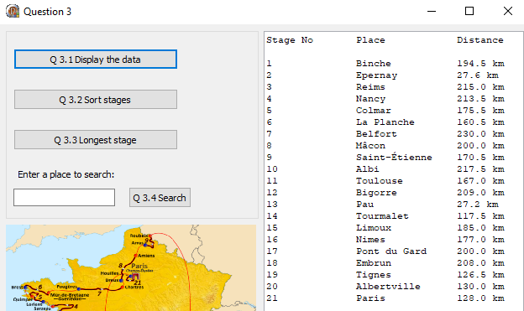
Sample Output

Pre-knowledge
Concept | Where to revise in DBE textbook
- To declare and initialize a procedure | Gr 11 Unit 6.3 page 132, 133, 134 and 135
- Loop through parallel arrays
- Display values in a Rich Edit | Gr 10 Unit 9.1 page 257
- Calling of method | Gr 10 Unit 6.4 P 133,135
- Converting values | G10 Unit 3.5 Page 47

Question 3.1
Question | Important concepts to do
- Create a procedure named displayData | Note that this procedure has no paramaters.  Declare this method under the last procedure and make sure to use the given name.  Press Shift + Ctrl + C to initiliaze.
- and add code to the procedure to display the headings and data in the parallel arrays as indicated in the screenshot below. | First add the headings and remember to make  use of tab spaces to separate neatly into  columns  Use one for loop to go to each element of  Both arrays  Remember to use the counter variable as [i]  after every array to inspect each element.  Remember to convert the arrays string and to include tabspaces
- Call the procedure in the OnClick event of btnDisplay. | Call the method by adding te name displayData

3.2 |  | Button [Q 3.2 – Sort stages]
 |  | 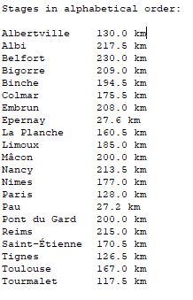  Write code to sort the stages in alphabetical order according to the places where the stages ended. The distance of each stage must still correspond with the correct stage.  Sample Output |  | (12)
Pre-knowledge
Concept |  |  | Where to revise in DBE textbook
Sorting Arrays |  |  | Gr 11 – Unit 3.2
Sorting parallel arrays |  |  | Gr 11 – Unit 3.3 page 64

Question 3.2
Question |  | Important concepts to do
- Write code to sort the stages in alphabetical order according to the places where the stages ended. The distance of each stage must still correspond with the correct stage. |  | Remember that an array can only store elements of the same data type. However, if you want to store related information of different data types, you need different arrays. When you sort an array, elements are swapped.  The places and distances are stored in two separate arrays but they are related and both need to be sorted.  The arrDistances array must be sorted in asscending order, the linked elements in the parallel array arrDistances must be swapped simultaneously.
3.3 | You need to display the distance of the longest stage in the tour.  Do the following:  - Create a function called longestStage that will determine and return the distance of the longest stage in the tour.  - Call the function in the OnClick event of btnLongestStage and display the information in a message box as follows:  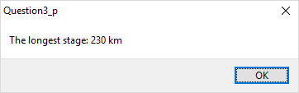 |  |  | (6)
  Pre-knowledge
  Concept | Where to revise in DBE textbook
  Declare and initiate a functions | Gr 11 Unit 6.4 Page
  Finding the Maximum in an array | G11 Unit 3.1 Page 47
  Question 3.3
  Question | Important concepts to do
  Create a function called longestStage that will determine and return the distance of the longest stage in the tour. | Note that this function has no parameters.  Press Shift + Ctrl + C to initialize.  Loop through the array to find the maximum value. Remember to assign the maximum value initially to the first item in the array. Compare the maximum value to each element in the array to determine what value is the highest  Functions make use of a result that needs to return a value. Assign the maximum value to the key word result.
  Call the function in the OnClick event of btnLongestStage and display the information in a message box as follows: | When a function is called it is important to remember that it needs to assigned to a value.
3.4 | Button [ Q 3.4 Search]  Write code to read the name of a place from the edit and then search for and display the distance of the stage that ended in that town in a message box as indicated in the screenshot.  Note: The search should stop as soon as the place is found. If the town is not found in the list a suitable message should be displayed. |  |  | (14)
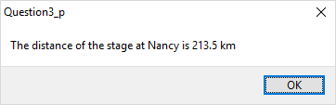
Sample Output
(if Nancy was entered in the edit)

Pre-knowledge
Concept |  |  | Where to revise in DBE textbook
Reading from components |  |  | Gr 10 Unit 2.2 Page 20
Converting values |  |  | Gr 10 Unit 3.5 Page 47
Search in array |  |  | Gr 11 – Unit 3.2 62 & 63
Search in parallel array |  |  | Gr11 Unit 3.3 Page 64

Question 3.4
Question | Important concepts to do
Write code to read the name of a place from the edit and then search for and display the distance of the stage that ended in that town in a message box as indicated in the screenshot. | Remember to search for a specic value in one array and access the corresponding element in the linked array, you can search for the specic value in the one array and if a match is found, use the index position of the match to access the element from the linked array.
Note: The search should stop as soon as the place is found. If the town is not found in the list a suitable message should be displayed. | Tip make use of a boolean value to establish is value if found or not
 | TOTAL SECTION C: | [40]

SECTION D

QUESTION 4: PROBLEM SOLVING
This first part of the question requires you to read information from a supplied text file. Each line of the text file contains FOUR pieces of information (Surname, First name, Grade, Responsibility) of a learner who is a member of the RCL of a school. You have to split and display the learners according to the responsibility (Sport, Culture, Academic).
The second part of the question requires you to add a new learner to the existing text file. It also asks you to use some string manipulation and a random number to create a code for the learner that you are adding.

SCENARIO:
The Representative Council of Learners (RCL) of a school in Cape Town allocate each of the members of the council to one of three groups: Sport, Culture and Academic. These learners then render services in that specific field.
 | Do the following:
- Compile and execute the program in the Question4 folder.
- Complete the code for each question, as described in QUESTION 4.1 to QUESTION 4.2.
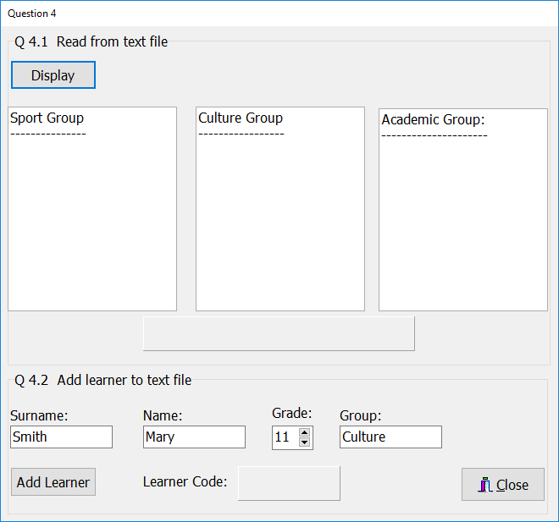
The program displays the following user interface:
4.1 |  | The text file names.txt included in the project contains the details of each learner on the RCL in the following format:  Surname,Name,Grade,Group  The first four lines contain the following information:  Ferreira,George,10,Sport  Honeywell,Leonore,12,Culture  Mendes,Ivan,11,Sport  Freulick,Irene,11,Academic  Complete the program as follows:  Button [Display]  Write code to check whether the file ‘names.txt’ exists. If the file exists, open the file for reading. If the file does not exist, show a suitable message and exit the procedure.  Read the information from the text file into suitable variables, determine the group the learner is in and add the initial (first letter of the learner's name), surname, and grade for each learner, either to redSport, redCulture or redAcademic, based on the group they are in. Refer to the screenshot below.  While reading from the file the number of learners in the sport group should be determined. This number should then be displayed on the panel pnlOutput, as indicated in the screenshot below.  Remember to close the textfile! | (19)
Sample output:
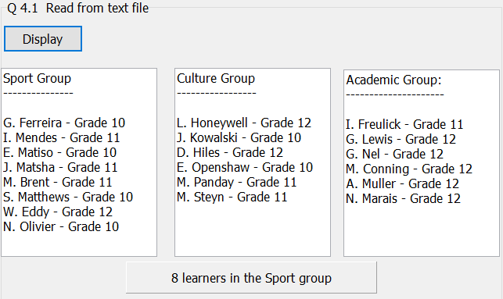
Pre-knowledge
Concept | Where to revise in DBE textbook
While loop  - used with text files  - counter | Gr 10 Unit 7.7 page 182  Gr 11 Unit 5.2 page 106
Text files  - test if a text file exists  - read from a text file | Gr 11 Chapter 5 page 101  Gr 11 Unit 5.5 page 106
String manipulation functions pos, copy and delete – delimited strings | Gr 11 Unit 4.2 page 86
if-then-else statements | Gr 10 Unit 5.4 page 111
Separating a single character from a String, e.g. sName[1] | Gr 10 Unit 8.3 page 220
ShowMessage | Gr 10 page 108
Formatting integer for output | Gr 10 Unit 3.5 page 49

Question 4.1
Question | Important concepts to do
Write code to check whether the file ‘names.txt’ exists. If the file exists, open the file for reading. If the file does not exist, show a suitable message and exit the procedure. | - Test if names.txt is accessible (can be done 2 ways: p. 106 – 107 in Gr 11 textbook)  - Display message if the file does not exist and  exit from procedure
Read the information from the text file into suitable variables, determine the group the learner is in and add the initial (first letter of the learner's name), surname, and grade for each learner, either to redSport, redCulture or redAcademic, based on the group they are in. Refer to the screenshot below. | - Declare variables for textFile, sLine, surname, first name, grade and group  - Create counter and set to 0 before loop  - Use Assignfile to link textfile variable to filename:  Assignfile(tFile, 'names.txt');  - Reset(tFile);  - Loop through the text file (While NOT EOF…)  - read line from text file  - Find pos of delimiter (comma), use copy and delete to read surname, first name, grade and group into variables  - Use if statements to determine the group and display initial (sName[1]), surname and grade as indicated
While reading from the file the number of learners in the sport group should be determined. This number should then be displayed on the panel pnlOutput, as indicated in the screenshot below.. | - In if statement for Sport in while loop when reading from file, increment counter  - Display counter (using IntToStr to convert to String) on pnlOutput
Remember to close the textfile! | - Remember to always use CloseFile when reading from or writing to a text file – even when there is no instruction to do so!

4.2 |  | Button [Add learner]  The program is also used to add new members that may be elected to the RCL.  Write code to read the information from the edits, which contain the information of a new member when the program is run, into variables and then add the learner to the text file names.txt.  Reminder: The details of a learner are written in the following format in the text file:  Surname,Name,Grade,Group  A learner code must be generated for each learner that is added to the RCL. The code consists of the first THREE letters of the learner's name, the last THREE letters of the learner's surname and a randomly generated number between 100 and 999 (both included). All letters must be displayed as capitals.  Display the generated learner code on the panel pnlCode as indicated in the screenshot on the next page. |  |  | (11)
 |  | Note: The number part of the code will change each time the program is run!
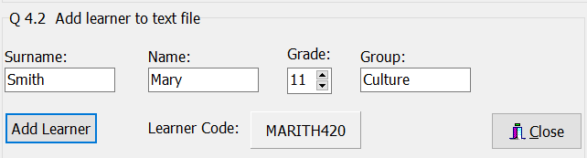
Sample output:

Pre-knowledge
Concept | Where to revise in DBE textbook
Adding data to an existing file | Gr 11 – Unit 5.3 page 113
String manipulation functions:  uppercase, copy, length | Gr 10 Unit 8.1 page 208
Random numbers | Gr 10 Unit 4.3 page 74

Question 4.2
Question | Important concepts to do
Write code to read the information from the edits, which contain the information of a new member when the program is run, into variables and then add the learner to the text file names.txt. | - Declare variables for textFile, surname, first name, grade and group  - Use Assignfile to link textfile variable to filename:  Assignfile(tFile, 'names.txt');  - Append(tFile); - used to add to existing file  - Read the information from the edits into variables  - Use writeLn to add a new line to the text file – remember to add delimiter (comma) between variables:  writeLn (tFile, sSurname + ',' + sName + ',' + IntToStr(iGrade) + ',' + sGroup);  - Remember to use CloseFile(tFile), otherwise data will NOT be written to file
A learner code must be generated for each learner that is added to the RCL. The code consists of the first THREE letters of the learner's name, the last THREE letters of the learner's surname and a randomly generated number between 100 and 999 (both included). All letters must be displayed as capitals.  Display the generated learner code on the panel pnlCode as indicated in the screenshot on the next page. | - Use UpperCase(copy(sName,1,3)) to extract first 3 letters from the name in upper case  - Use UpperCase(copy(sSurname, length (sSurname) – 2)) to extract the last 3 letters from the surname in upper case  - Use Random or RandomRange to generate a random number between 100 and 999:  iRandom := Random(900) + 100;  OR  iRandom := iRandomRange(100,1000);  - Combine the 3 parts of the code and display on pnlCode – remember to use IntToStr(iRandom) to convert the number to String

 |  |  | TOTAL SECTION D: | [30]
 |  |  | GRAND TOTAL: | 150

THE MARKS ALLOCATD ARE FOR CONCEPTS. IF YOU HAVE SIMMULAR CODE – MARKS WILL BE ALLOCATED FORR YOUR SOLUTION.
ANNEXURE A

QUESTION 1: MARKING GRID – GENERAL PROGRAMMING SKILLS
NAME AND SURNAME: |  | FOLDER:
 | DESCRIPTION |  | MARKS | L MARK
1.1.1 | procedure TForm1.FormActivate(Sender: TObject);  begin  pnlQ1_1.Color := clLime;  pnlQ1_1.Font.Name := 'Forte';  pnlQ1_1.Font.Size := 36;  pnlQ1_1.Caption := 'Very Active Gym';  imgLogo.Stretch := true;  end; |  | 5
1.1.2 | procedure TForm1.btnQ1_1_2Click(Sender: TObject);  var  sName, sSurname: String;  begin  sName := edtName.Text;  sSurname := edtSurname.Text;  if rgpGender.ItemIndex = 0 then  ShowMessage('Welcome Mr ' + sName[1] + '. ' + sSurname)  Else  ShowMessage('Welcome Ms ' + sName[1] + '. ' + sSurname)  end; |  | 5
1.1.3 | procedure TForm1.btnQ1_1_3Click(Sender: TObject);  var  sID: String;  begin  sID := edtID.Text;  if Length(sID) <> 13 then  begin  ShowMessage('The ID number should be 13 characters');  edtID.SetFocus;  end  else  if StrToInt (Copy(sID,3,2)) > 12 then  begin  ShowMessage('Month of the birthdate should be between 1 and 12');  edtID.SetFocus;  end  else  ShowMEssage('The ID is valid. You may proceed');  end end;  lblFinalOrder.Caption := IntToStr(iNumCopies)  + ' copies in ' + sPaperSize + ' @ R' + FloatToStrF (rCostPerCopy, ffFixed, 4, 2) + ' per copy';  end; |  | 9
1.2.1 | procedure TForm1.btnQ1_2_1Click(Sender: TObject);  var  rWeight, rHeight, rBMI: Real;  begin  rWeight := StrToFloat(edtWeight.Text);  rHeight := StrToFloat(edtHeight.Text);  rBMI := rWeight / (rHeight * rHeight);  redOutput.Lines.Add('Your BMI is ' + FormatFloat('0.0', rBMI));  if rBMI < 18.5 then  redOutput.Lines.Add('Comment: Underweight')  else if (rBMI >= 18.5) AND (rBMI < 25) then  redOutput.Lines.Add('Comment: Normal weight')  else if (rBMI >= 25) AND (rBMI < 30) then  redOutput.Lines.Add('Comment: Overweight')  else  redOutput.Lines.Add('Comment: Obese');  end; |  | 10
1.2.2 | procedure TForm1.btnQ1_2_2Click(Sender: TObject);  var  rWeight, rTarget : Real;  iWeek : Integer;  begin  rWeight := StrToFloat(edtWeight.Text);  rTarget := StrToFloat(edtTarget.Text);  iWeek := 0;  redOutput.Lines.Add('');  while (rWeight > rTarget) do  begin  Inc(iWeek);  rWeight := rWeight - 1.25;  redOutput.Lines.Add('Weight after week ' + IntToStr(iWeek) + ': ' + FormatFloat('0.00kg.', rWeight));  end;  redOutput.Lines.Add(#13 + 'The target weight will be reached in Week ' + IntToStr(iWeek));  end; |  | 7
1.3 | procedure TForm1.btnQ1_3Click(Sender: TObject);  var  iNumber: Integer;  begin  iNumber := sedNumber.Value;  pnlOutput.Caption := 'Minibusses needed: ' + IntToStr (CEIL (iNumber / 12));  end; |  | 4
 | Total Section A: |  | 40

ANNEXURE B
QUESTION 2: MARKING GRID –DATABASE
NAME AND SURNAME: |  | FOLDER:
 | DESCRIPTION |  | MARKS | L MARK
2.1 | case radSort.ItemIndex of  0 : tblProperty.Sort := 'Rent ASC';  1 : tblProperty.Sort := 'Rent DESC';  end; |  | 3
2.2 | Obtain Property type via Inputbox  Initialise sum  Initialise count  tblProperty.First;  while not tblProperty.Eof do  If tblProperty['PropertyType'] = PropertyType then  iSum := iSum + tblProperty['Rent'];  inc(iCount);  tblProperty.Next;  Calculate Average Sum/Count  Display Average Rental price formatted as currency |  | 12
2.3 | Set tab settings  Clear Richedit  if cbxPet.Checked then bPet true else bPet false;  tblProperty.First;  while not tblProperty.Eof do  if ((tblProperty['Bedrooms'] >= typecasted combobox value AND  (tblProperty['Bathrooms'] >= typecasted combobox value AND  (tblProperty['PetsAllowed'] = bPet))  then Display Address, Rent, Bedrooms, Bathrooms  neatly in colums  Go to next record |  | 10
2.4 | Obtain PropertyID via Inputbox  tblProperty.First;  while NOT tblProperty.Eof do  if tblProperty['PropertyID'] = PropertyID then  tblProperty.Delete;  ShowMessage('Record Deleted');  Else tblProperty.Next; |  | 7
2.5 | Traverse table  tblProperty.Edit;  tblProperty['Rent'] := round (tblProperty['Rent']*1.1);  tblProperty.Post;  tblProperty.Next;  Showmessage (IntToStr(tblProperty.RecordCount)  + ' records updated'); |  | 8
 | Total Section B: |  | 40

ANNEXURE C
QUESTION 3: MARKING GRID – ARRAY MANIPULATION
NAME AND SURNAME: |  | FOLDER:
 | DESCRIPTION |  | MARKS | L MARKS
3.1 | procedure TForm4.btnDisplayClick(Sender: TObject);  begin  displayDetails;  end;  procedure TForm4.displayDetails;  var  i: integer;  begin  redOut.Lines.Add('Stage No' + #9 + 'Place' + #9 + 'Distance' );  for i := 1 to 21 do  begin  redOut.Lines.Add(IntToStr(i) + #9 + arrStagePlace[i] + #9 + FormatFloat('0.0 km', arrStageDistance[i]));  end;  end; |  | 8
3.2 | procedure TForm4.btnSortClick(Sender: TObject);  var  i, j, k: integer;  sTemp: String;  dTemp: real;  begin  redOut.Clear;  for j := 1 to 20 do  for k := j + 1 to 21 do  if arrStagePlace[j] > arrStagePlace[k] then  begin  sTemp := arrStagePlace[j];  arrStagePlace[j] := arrStagePlace[k];  arrStagePlace[k] := sTemp;  dTemp := arrStageDistance[j];  arrStageDistance[j] := arrStageDistance[k];  arrStageDistance[k] := dTemp;  end;  redOut.Lines.Add('Stages in alphabetical order:' + #13);  for i := 1 to 21 do  redOut.Lines.Add(arrStagePlace[i] + #9 + FormatFloat('0.0 km',  arrStageDistance[i]));  end; |  | 12
3.3 | function TfrmQuestion3.longestStage: Real;  var  rLongestStage: Real;  k: integer;  begin  rLongestStage := arrDistances[1];  for k := 2 to 21 do  begin  if (arrDistances[k] > rLongestStage) then  begin  rLongestStage := arrDistances[k];  end;  end;  Result := rLongestStage;  end;  procedure TfrmQuestion3.btnLongestStageClick(Sender: TObject);  begin  ShowMessage('The longest stage: ' + FloatToStr(longestStage) + ' km');  end; |  | 6
3.4 | procedure TForm4.btnSearchClick(Sender: TObject);  var  sSearch: String;  bFlag: Boolean;  i: integer;  rDistance: Real;  begin  sSearch := edtSearch.Text;  bFlag := false;  i = 1;  while (NOT bFlag) AND (i <= 21) do  begin  if arrStagePlace[i] = sSearch then  begin  bFlag := true;  rDistance := arrStageDistance[i];  end;  Inc(i);  end;  if bFlag then  ShowMessage('The distance at ' + sSearch + ' is ' + FloatToStr(rDistance)  + ' km')  Else  begin  ShowMessage(sSearch + ' was not found');  edtSearch.SetFocus; |  | 14
 | Total Section C: |  | 40

SECTION D
QUESTION 4: MARKING GRID – PROBLEM-SOLVING
NAME AND SURNAME: |  | FOLDER:
 | DESCRIPTION |  | MARKS | L MARKS
4.1 | procedure TQuestion4.btnDisplayClick(Sender: TObject);  var  tFile: TextFile;  k, iPos, iran, iGrade, iCountSport: integer;  sSurname, sName, sGroup, sLine: string;  begin  if NOT fileexists('names.txt') then  begin  ShowMessage('File not found');  Exit;  end;  Assignfile(tFile, 'names.txt');  Reset(tFile);  while NOT EOF(tFile) do  begin  ReadLn(tFile, sLine);  iPos := Pos(',', sLine);  sSurname := Copy(sLine, 1, iPos - 1);  Delete(sLine, 1, iPos);  iPos := Pos(',', sLine);  sName := Copy(sLine, 1, iPos - 1);  Delete(sLine, 1, iPos);  iPos := Pos(',', sLine);  iGrade := StrToInt (Copy(sLine, 1, iPos - 1));  Delete(sLine, 1, iPos);  sGroup := sLine;  if sGroup = 'Sport' then  begin  redSport.Lines.Add(sName[1] + '. ' + sSurname + ' - Grade ' + IntToStr (iGrade));  Inc(iCountSport);  end  else if sGroup = 'Culture' then  redCulture.Lines.Add(sName[1] + '. ' + sSurname + ' - Grade ' + IntToStr(iGrade))  else  redAcademic.Lines.Add(sName[1] + '. ' + sSurname + ' - Grade ' + IntToStr(iGrade));  end;  ShowMessage('There are ' + IntToStr(iCountSport) + ' learners in the Sport group');  end; |  | 19
4.2 | procedure TQuestion4.btnAddClick(Sender: TObject);  var  sSurname, sName, sGroup: String;  iGrade: Integer;  begin  AssignFile(tFile, 'names.txt');  Append(tFile);  sSurname := edtSurname.Text;  sName := edtName.Text;  iGrade := sedGrade.Value;  sGroup := edtGroup.Text;  writeLn (tFile , sSurname + ',' + sName + ',' + IntToStr(iGrade) + ',' + sGroup);  CloseFile(tFile);  pnlCode.Caption := UPPERCASE (Copy(sName, 1, 3) + Copy(sSurname, length(sSurname) - 2))  + IntToStr(RandomRange(100, 1000));  // provided code  showMessage ('Learner added to text file');  end; |  | 11
 | TOTAL SECTION D: |  | 30

SUMMARY OF LEARNER'S MARKS:
 | SECTION A | SECTION B | SECTION C | SECTION D
 | QUESTION 1 | QUESTION 2 | QUESTION 3 | QUESTION 4 | GRAND TOTAL
Max. Marks | 40 | 40 | 40 | 30 | 150
LEARNER'S MARKS

