

TOURISM

REVISION BOOKLET TERM 2

CORE NOTES

Grade 11

This revision program is designed to assist you in revising the critical content and skills envisaged/ planned to be covered during the 1st term. The purpose is to prepare you to understand the key concepts and to provide you with an opportunity to establish the required standard and the application of the knowledge necessary to succeed in the NCS examination.

The revision program covers the following:

Car rental
The Domestic Tourism Growth Strategy (DTGS)
•The state of domestic tourism in South Africa
•Why a DTGS? (problem statement and vision) (no statistics)
•List current trends influencing tourism, with very short explanation
•The domestic marketing campaign (refer current Sho’t Left marketing campaign)
•The five (5) domestic market segments. Focus on the profile of the segment, why they travel (or not) and the type of travel/holiday they prefer (no % needed)
•The four strategic objectives and targets of the DTGS and the implementation plan to meet these objectives. List and shortly explain the activities/options

South African heritage bodies:
- South African Heritage Resource Agency (SAHRA): logo and functions
- Provincial heritage agencies
- Awareness of special heritage permits and protection regulations (structures older than 60 years, archaeological and paleontological sites and materials, meteorites, shipwrecks, burial grounds, graves)

Marketing
The marketing budget: costs related to marketing
- market research
- communication costs (printing, telephone, fax, internet)
•Travel costs (local and overseas travel, vehicle and flight costs)
•Personnel costs
Different types of promotional /advertising techniques used in the tourism industry:
- Above-the-line promotional techniques: conventional media tools such as renting space on television, in newspapers, and magazines, on posters and on radio. Printed material such as brochures, flyers, pamphlets, posters, bill boards, meander maps. Electronic advertising such as video walls, audio-visual presentations, digital displays, cellphone advertising, web-based

Advertising
- Below-the-line promotional techniques: personal selling, sales promotions, in-store discounts, promotional sponsorship, exhibitions, shows and expos
Match the type of promotion/advertising to the potential customer.

.

How to approach each question in this revision booklet:

- Read each question thoroughly.

- Find the relevant notes in your notebook as well as the relevant section in your textbook.

- Write down your answer to each question on your own without referring to the model answers provided below each question.
- Read the question again to make sure your own answer is complete.

- Now compare your answer to the model answer and mark your answer by allocating the marks according to the model answer provided.

Topic | Page number
Car rental | 8*
The Domestic Tourism Growth Strategy (DTGS) 2012 – 2020 | 5
South African heritage bodies: | 6
Marketing | 7
Advertising | 7

Domestic, regional and international tourism:
Make sure you are able to:
- Define basic concepts such as domestic tourism, segments, segment profiling etc.
- Identify the five (5) domestic market segments.
- Differentiate between the domestic market segments according to: - the profile of the segment, why people travel (or not) and the type of travel/holiday each segment prefers
- List the four strategic objectives of the DTGS
- Describe the implementation plan to meet the four strategic objectives. - List and briefly explain the activities/actions that takes place during the implementation plan
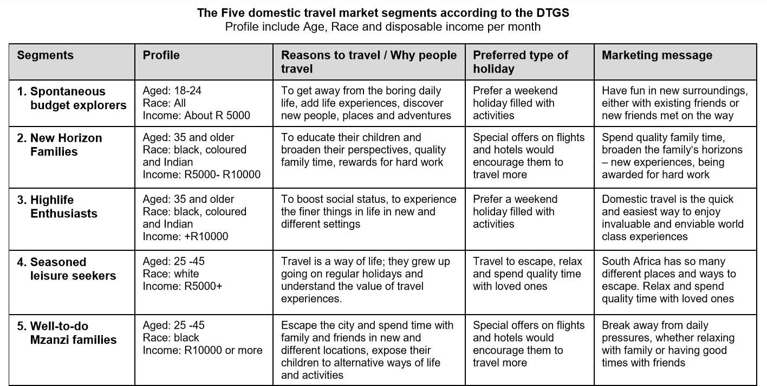

The four (4) Strategic Objectives of the DTGS 2012 -2020
- To increase domestic tourism revenue (expenditure).
- To Increase domestic tourism volume.
- To improve measures and efforts aimed at addressing seasonality and equitable geographical spread.
- To enhance the level of the culture of travel and tourism among South Africans.
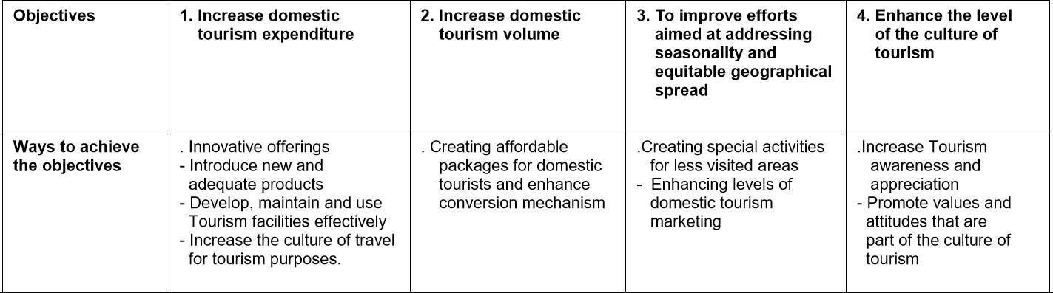

Here’s a possible question:
>> Supply a definition to the following concepts that is highlighted with bold text.

Answers:
Heritage sites
Model Answer: Sites of cultural significance and geographic areas of great value.

National Heritage
Model Answer: Structures or defined areas of land declared by the South African Heritage Resource Agency (SAHRA) to be of historic or cultural importance. National heritage sites are known as Grade I sites.

Provincial Heritage
Model Answer: Places or sites that are of heritage significance within the province that PAHRA has declared as a heritage site. Provincial heritage sites are known as Grade II sites.

South African heritage Agencies
Model Answer: Agencies responsible for declaring, managing, and protecting the heritage sites/resources within South Africa

SAHRA
Model Answer: South African Heritage Resource Agency`s (SAHRA)

PHRA
Model Answer: The Provincial Heritage Resource Authority (PHRA) PHRA also identifies places or sites that are of heritage significance and then declares them as heritage sites.

Provincial Heritage Agencies
Model Answer: Agencies that are responsible for compiling managing and maintaining heritage sites/resources in each province

Marketing: Promotional and advertising techniques used in the tourism industry:
Here’s a possible question:
Explain the following 4 concepts:
- Marketing
- Above-the-line promotional techniques
- Below-the-line promotional techniques
- Advertising

Answer:
- Marketing: Everything that a business does to bring attention to its product or service and to encourage customers to buy it.
- Above-the-line promotional techniques: Is not very personal and is designed to target large groups of potential customers with the minimum amount of cost. It uses mass media for example, television, magazines, billboards and the Internet.
- Below-the line promotional techniques: Are advertising methods that are more personal than above- the-line methods. Do not involve the media.
- Advertising - is the paid-for publication, display or broadcast of information that describes a tourism product or service.

Question:
Why do Tourism businesses advertise their products?

Answer:
Businesses advertise or promote themselves, and the products and services they offer for a number of reasons:
  - To increase and maintain the demand for their products
  - To increase and maintain the market share of their products
  - To let people, know about the products
  - To create a brand

Introduction to the Car Rental Industry in South Africa:

The car rental industry in South Africa refers to the business of providing rental vehicles to individuals and businesses for a set period of time.

The car rental industry is an important sector of the South African economy, as it provides a convenient and flexible transportation solution for travelers and locals alike.

Some of the major car rental companies in South Africa include Avis, Budget, Europcar, and Thrifty. These companies have a wide range of vehicles available for rent, including sedans, SUVs, vans, and trucks.
Conditions for Renting a Vehicle:

In order to rent a vehicle in South Africa, individuals must meet certain conditions. These may include:

Age requirements: Most car rental companies require renters to be at least 21 years old. Some companies may also have an upper age limit, such as 70 years old.

Driver's license requirements: Renters must have a valid driver's license and be able to present it at the time of rental.

Creditworthiness: Some car rental companies may require renters to have a credit card in order to secure the rental. This is because the credit card can be used to cover any damages or additional charges that may occur during the rental period.

Signing of contract: Before the rental can begin, renters must sign a rental contract that outlines the terms and conditions of the rental. This includes the rental period, the type of vehicle, and any additional fees or charges that may apply.

Different Rental Packages and Options:

Car rental companies in South Africa offer a range of rental packages and options to suit the needs of different customers. Some options include:
Long-term rentals: These rentals are typically for a period of 28 days or more. They are often more cost-effective than shorter rentals and can be a good option for individuals or businesses who need a vehicle for an extended period of time.
One-way rentals: These rentals allow customers to pick up a vehicle at one location and drop it off at another location. This can be convenient for travelers who are planning a road trip or for individuals who need to transport a vehicle from one location to another.

Other options: Some car rental companies also offer flexible rental periods, such as daily or weekly rentals, as well as special deals and promotions.
Types of Insurances Available for Car Rentals in South Africa:

Car rental companies in South Africa offer a variety of insurances to protect customers in case of damage or theft. Some common types of insurances include:

Collision Damage Waiver (CDW): This insurance covers damages to the rental vehicle that are caused by a collision or accident.

Theft Loss Waiver (TLW): This insurance covers the cost of replacing the rental vehicle in case it is stolen.

Super Collision Damage Waiver (SCDW): This insurance provides additional coverage for damages to the rental vehicle beyond what is covered by CDW.

Super Theft Loss Waiver (STLW): This insurance provides additional coverage for the cost of replacing the rental vehicle in case it is stolen, beyond what is covered by TLW.

Personal Accident Insurance (PAI): This insurance provides coverage for medical expenses and accidental death in case of an accident during the rental period.

Additional Costs and Charges:

In addition to the base rental rate, there are several additional costs and charges that may apply when renting a car in South Africa. These may include:
Tourism levy: This is a fee that is charged by the car rental company to help fund tourism- related projects in South Africa. The tourism levy is typically a percentage of the base rental rate and is included in the final rental cost.

Fuel deposits and charges: Some car rental companies may require a fuel deposit at the time of rental, which will be refunded upon the return of the vehicle with a full tank of fuel. If the vehicle is not returned with a full tank, the car rental company may charge a fuel surcharge to refill the tank.

Airport surcharges: Some car rental companies may charge an additional fee for rentals that are picked up or dropped off at an airport location.
Additional driver charges: If more than one person will be driving the rental vehicle, the car rental company may charge an additional fee for each additional driver.

Contract fee: This is a fee that is charged by the car rental company for processing the rental contract.

Delivery and collection charges: Some car rental companies may charge a fee for delivering the rental vehicle to the customer's location or for picking up the vehicle when it is returned.

Cross-border fees: If the rental vehicle will be taken out of South Africa, the car rental company may charge a fee for this service.

Optional equipment charges: If the customer wants to add any additional equipment to the rental vehicle, such as a GPS or a car seat, the car rental company may charge an additional fee for this service.

Incidental Costs:
Incidental costs are additional charges that may be incurred during the rental period, such as:

Administration fee for accidents: If the rental vehicle is involved in an accident during the rental period, the car rental company may charge an administration fee for handling the claim.

Traffic fines: If the rental vehicle is involved in a traffic violation during the rental period, the driver may be responsible for paying any resulting traffic fines.

Payment Options and Methods:
Car rental companies in South Africa offer a range of payment options and methods, including:

Credit card: Most car rental companies accept credit cards as a form of payment.

Debit card: Some car rental companies may accept debit cards as a form of payment, but this is not always the case.

Cash: Some car rental companies may accept cash as a form of payment, but this is not always the case.

Bank transfer: Some car rental companies may allow customers to pay for their rentals via bank transfer. This means that the customer can transfer the payment directly from their bank account to the car rental company's account. This can be a convenient option for customers who do not have a credit or debit card, or who prefer not to use one.

