
Western Cape Education Department
Directorate: Curriculum FET

ELECTRICAL TECHNOLOGY
(Electronics )
REVISION BOOKLET
TERM 3 & 4
2025
Grade 10

This revision program is designed to assist you in revising the critical content and skills that you have covered during the 2nd term. The purpose is to prepare you to understand the key concepts and to provide you with an opportunity to establish the required standard and the application of the knowledge necessary to succeed in the examination.
The revision program covers the following topics:
- Communications
- Principles of Magnetism
It is important to prepare yourself by practice answering questions from past papers.
You can ask your teacher to give you some previous year question papers to use as a guide to help you prepare for your final exam:
There are also lessons on various grade 10 topics on the WCED e-Portal (https://wcedeportal.co.za/)

GENERAL

Structure of the Final Exam paper and Important point to remember:

- The final paper consists of EIGHT compulsory questions.
- The weighting of the questions is as per the table below.
- It is important to remember that the final paper is out of 200 MARKS, and the time given is 3 HOURS ie 200 marks = 180 minutes.
- It is important to ensure that you manage your time properly when writing any test or exam. You don’t want to run out of time because of bad time management.
- The following rough guide will help you manage your time a bit better. 1 Mark = 1 Minute (If a question is out of 10 marks, do not spend more than 10 minutes on that question)
- Try and start with the easiest question and work your way up to the more difficult questions.
- All questions and sub questions must be kept together. DO NOT MIX QUESTIONS
- Draw a line after each completed question.
- It is important that you read all instructions slowly and carefully before you start answering any question.
- Also, please note that you must receive a formula sheet with every test or exam you write, covering at least the topics of the test or exam.
- The questions are asked in such a way that it will differentiate in terms of subject knowledge. It might start with an easy question and end off with more challenging question in the different questions per topic.

Final Examination Weighting in Electronics:

Topic | Grade 10 (Revised)
 | Percentage | Marks  +/- 4
Multiple Choice | 7.5% | 15
Occupational Health and Safety | 5% | 10
Tools and measuring instruments | 12.5% | 25
Basic Principles of Electricity | 20% | 40
Power Sources | 12.5 | 25
Electronic Components | 15% | 30
Communication Systems | 15% | 30
Principles of Magnetism | 12.5% | 25
Total | 100% | 200 Marks

BASIC SKILLS LINKED TO THE SUBJECT:

The following skills are tested in the paper:

- Ability to follow instructions
- Identifying labels/labelling/making drawings/diagrams/schematic representations
- Plotting and interpretation of graphs/data
- Working out and interpreting calculations
- Organizing/Recording and categorizing data
- Extraction and/or manipulation and/or evaluation of data

It is important that you have your own Scientific Calculator, and that you know how to use it. NEVER BORROR A CALCULATOR FOR ANY EXAMINATION!!!!!!!

TOPICS
NB!!!!! The mark allocation will indicate how you much information you are required to provide in your responses/ answers to questions.

TOPIC 1: Communication Systems
This topic contains theoretical questions, drawings, and sketches.
- Theoretical questions are normally a challenge, and many learners struggle to answer it properly.
- Learners must read all question with understanding before trying to answer the questions
- Theoretical answers should be short and to the point.
- The mark allocation is an indication about the number of facts that must be given.
- In this section of the work, you will learn more about the purpose and types of communication systems
- You will learn more about radio communication – basic concepts
- You will get a better understanding of the principle of Modulation, the radio antenna, feed lines and radio wave propagation

- Drawings and Sketches

- Always ensure all drawings/sketches are correctly labelled.
- All drawings and sketches must be neatly drawn
Always read questions with understanding before you try and answer a question

Typical questions and answers
- Describe the purpose of communication systems. (3)
- They are used to transmit signs, signals, writing, images, sounds, data or intelligence of any nature, as a whole or in part by wire, radio, electromagnetic, photo-electronic or optical system to a receiver.
- Name, explain and give an example of the TWO main types of communication systems (6)
- One-way communication: Information is only passed from transmitter to receiver. Eg radio and TV broadcasts.
- Two-way communication: Information is passed both ways- transmitter to receiver and visa-verse eg telephone, cell phone two way radio.

- Define radio wave propagation in communication systems. (3)
- Radio-wave propagation is the transmission of signals by modulation of electromagnetic waves with frequencies below those of visible light.
- State THREE types of radio-wave propagation. (3)
- Ground-wave propagation
- Sky-wave propagation
- Line-of-sight propagation
- Define the term frequency with reference to radio waves. (3)
- Frequency is the number of cycles an AC wave or signal is able to deliver in one second. It is measured in hertz (Hz).
- Label part 6.1 and part 6.2 in the figure below.
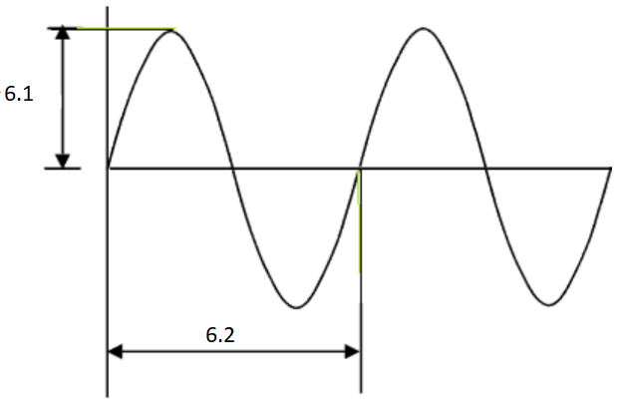

  - Peak Value/Amplitude
  - One cycle
- Make a simple sketch to show sky- wave propagation. (5)

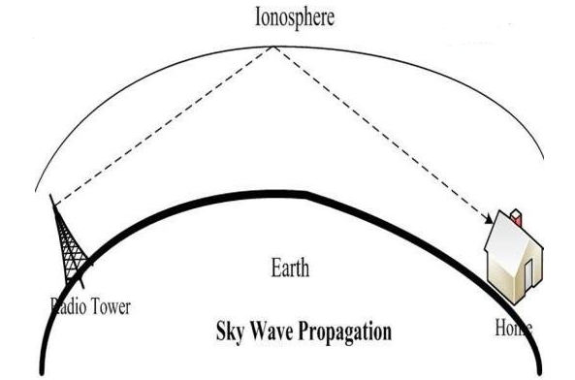
Remember, all sketches and diagrams must be neatly labelled

- Define the term ‘modulation’ (3)
- Modulation is the process of adding or mixing the information (intelligent data) onto an AC signal (carrier wave) at the transmitter.

- Name the THREE ways of modulating carrier waves. (3)
- Pulse modulation
- Amplitude modulation (AM)and
- Frequency modulation (FM)

- Define the term Amplitude Modulation. Use a sketch to help with the explanation. (8)
- AM is a process by varying the amplitude of the carrier wave in response to the amplitude of the signal to be transmitted
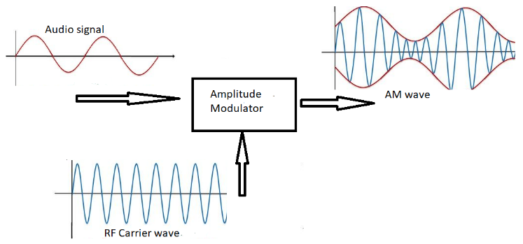

- Name TWO disadvantages of AM (2)
- The signal is subjected to interferences from external noise such as lightning, noisy electric motors
- AM has a wide band width, meaning that less transmitting frequencies are available.
- When it comes to power usage it is not efficient. (Any TWO)

- Make a neat, labelled drawing to show Frequency Modulation (FM) (4)
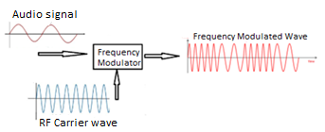

- Name TWO advantages of FM (2)
- Less affected by external noise, hence clear reception
- Uses less power
- The amplitude of modulated wave remains unaffected.
- Operates at a very high frequency. (any TWO)

- Name FIVE different types of antenna. (5)
Remember, the mark allocation indicates the number of facts that must be given
- Dipole
- Monopole
- Folded dipole
- The Yagi
- Microwave transmitting antenna

- Describe the function of an antenna in communication systems (3)
- A radio antenna is a device designed to do two things: It captures radio-frequency signals that are then converted to electrical signals by the receiver, and it takes electrical signals from the transmitter and converts them into radio-frequency signals.
- What is the typical impedance value for a feed line?
- 50 Ω

- Draw a neat, labelled block diagram for a simple radio transmitter. (6)
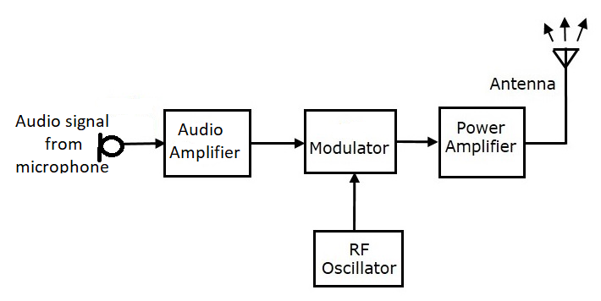

- Briefly explain the function of the Modulator in a radio transmitter. (2)
- The modulator loads the audio signal on the RF carrier wave.

- The figure below represents a simple block diagram of a radio receiver. Label the blocks 1-3 (3)
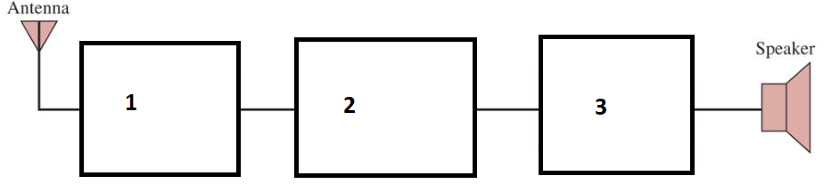

- Tuning & RF Amplifier
- Detector and Demodulator
- Audio Amplifier

TOPIC 2: Principles of Magnetism
This topic contains theoretical questions, drawings, and a few calculations.
- Theoretical questions are normally a challenge, and many learners struggle to answer it properly.
- Learners must read all question with understanding before trying to answer the questions
- Theoretical answers should be short and to the point.
- The mark allocation is an indication about the number of facts that must be given.
- In this section of the work, you will learn more about the basic principles of magnetism including magnetic flux, flux density and inductance
- Types of inductors and types of cores, including calculations (series/parallel)
- The functional operation of a relay and DC motor.

Calculations

- Always write down all the given information.
- All calculations count 3 marks (in a few instances calculations were 4 or 5 marks) 1 mark is for the correct formula, 1 mark for the correct substitution and 1 mark for the correct answer and unit. Please note if an answer does not have a unit, no marks will be given for the answer.
- Please also note that when substitutions of values are made that the correct prefixes are used with the numbers eg. 10 mA = 10 x 10⁻³ A or 0,010 A
- Mastering calculations is all about PRACTICE, PRACTICE

- Drawings and Sketches

- Always ensure all drawings/sketches are correctly labelled.
- All drawings and sketches must be neatly drawn

Typical questions and answers
- What are the invisible lines around a permanent magnet called? (1)
- Magnetic flux lines.

- Make a neat, labelled drawing to show the magnetic flux lines around a bar magnet. (4)
Remember all drawings must be neat and fully labelled
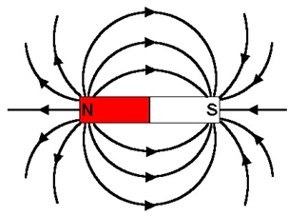

- Give THREE characteristics of magnetic flux lines. (3)
- Magnetic flux lines are continuous and form a close path.
- Magnetic flux lines will never cross each other
- The direction of these flux lines is from North to South outside the magnet and South to North inside the magnet.

- Write down the TWO laws of magnets. (2)
- Like poles repel
- Unlike poles attract

- Define the following terms: Magnetic Flux and Magnetic Flux Density (4)
- Magnetic flux: This is the invisible lines running around the outside of a magnet.
- Magnetic Flux density: This refers to the concentration of magnetic flux lines within a specific area.

- Define Maxwell’s right hand rule. (4)
- If the conductor is held in the right hand, with the thumb pointing in the direction of the current flow, then the fingers around the conductor points in the direction of the magnetic field.

- With reference to magnetic field around the current carrying conductor in the diagram below, which direction will the current flow? (1)
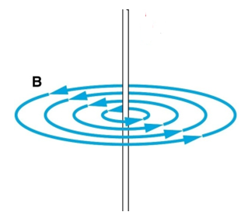

- The current will flow from bottom to the top.

- The following diagram represents the ‘cork screw rule’ Which direction will the magnetic flux be flowing with the current flowing in the direction as indicated. (1)
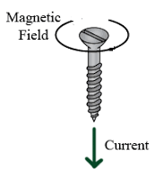

- The magnetic fields will be clockwise around the screw.

- Define an Inductor: (2)
- An Inductor is a coil of wire that’s stores energy in its surrounding magnetic field.

- Write down the symbol for an Inductor. (1)
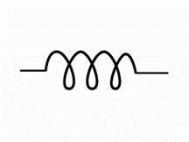

- In the figure below, L2 = 50 mH and L3 = 60 mH while the total Inductance is 150 mH. Calculate the Value of L1. (3)
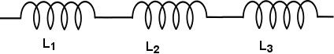
Remember all calculation= 3 marks
1=correct formula
1= correct substitution
1= correct answer and unit
$$L_{TOT}=L_{1}+L_{2}+L_{3}$$
$$150 =?+50+60$$
$$L_{1}=150-110$$
$L_{1}=40$ mH

- Explain the function of a Relay. (3)
- To isolate two parts of a circuit
- Allowing one circuit to switch another circuit, eg using a 12 V battery circuit to switch a 230 V mains circuit.

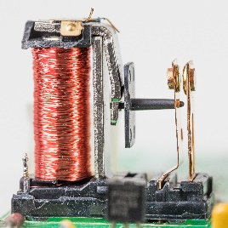
- The figure below represents a simple relay, Identify the two main parts of this relay. (2)

- The coil
- The switch contacts

- Give TWO practical Applications of a relay. (2)
- They are used in electronic circuits and home appliances for isolating low voltage or DC circuits from high voltage AC circuits.
- They are the backbone of industrial process automation systems. They are used in combination with PLCs for process control. They are one of the key components in an automation cabinet.
- Used for signalling and control in railway networks.
- In motor control circuits for motor switching, protection as well as control.
- In substations and power distribution centres for sensing various faults and operating the circuit breaker. (Any TWO)

- Write down the three main parts of the DC motor. (3)
- Armature/Rotor
- Field coils / Permanent magnet
- Brushes.

- Name the material of which the brushes of a DC motor is made? (1)
- Graphite/Carbon

- Explain the function of the brushes. (2)
- To make electrical contact with the stationary external circuit, by sliding on the surface of the commutator.

- Briefly explain how you would change the direction of rotation of a (2) DC motor.
- Swop the live and the neutral around. (Reversing the supply to the motor)


