
Western Cape Education Department
Directorate: Curriculum FET

BUSINESS STUDIES

REVISION BOOKLET
2025 TERM 3 & 4

Grade 10

This revision program is designed to assist you in revising the critical content and skills covered during the 3rd and 4th terms. The purpose is to prepare you to understand the key concepts and to provide you with an opportunity to establish the required standard and the application of the knowledge necessary to succeed in the Final NSC examination.

The revision program covers the following topics:
- Creative thinking & Problem solving
- Business opportunity & Related factors
- Presentation of business information
- Business plan
- Relationships & Team performance

INDEX PAGE
 | Contents | Page numbers
1 | Creative thinking & Problem solving | 2 - 6
2 | Business opportunity & Related factors | 7 - 12
3 | Presentation of business information | 13 - 19
4 | Business plan | 20 – 26
5 | Relationship & Team performance | 27 – 32
6 | Consolidation Questions | 33

This revision booklet covers the FIVE topics that were taught in Terms 3 & 4.

The first topic we will focus on is:

- CREATIVE THINKING & PROBLEM SOLVING

At the end of this topic, learners should be able to:
❖ Elaborate on the meaning of creative thinking
❖ Outline/explain/describe/discuss the advantages/benefits of creative thinking in the workplace
❖ Explain how businesses can use creative thinking to generate entrepreneurial opportunities, for
example, designing environments that stimulate creative thinking
❖ Define/elaborate on the meaning of problem-solving
❖ Outline/explain/distinguish the differences between decision making and problem-solving
❖ Outline/explain/discuss/describe the problem-solving cycle
❖ Name//explain/discuss problem-solving techniques
❖ Explain/describe how businesses can apply problem-solving techniques to solve business problems
❖ Identify problem-solving techniques from given scenarios/case studies
❖ Meaning of a business opportunity
❖ Explain/describe how businesses can use mind mapping, brainstorming to identify innovative and
entrepreneurial business opportunities
❖ Recommend/suggest ways in which creative business opportunities can realistically be implemented..

The concepts related to all topics are important. You must remember the list of concepts and the meaning thereof.

Key concepts:
- Creative thinking: involves the process of generating innovative and imaginative ideas.
- Sustainable business practice: a business practice that is economically viable, socially
- responsible, and environmentally friendly is usually regarded as being sustainable.
- Indigenous knowledge: the local knowledge that is unique to a given culture or society.
- Non-conventional thinking refers to thinking differently and looking at something in a new way.
- Force Field Analysis: a technique used to determine the forces that are for and against a decision.
- Nominal Group Technique: a structured method for group brainstorming that allows every
- member to come up with ideas on their own.
- Brainstorming: a group activity to find a solution for a specific problem by gathering a list of ideas
- spontaneously.
- Delphi Technique: a method that relies on a panel of experts to find solutions to a problem.
- Problem solving: the process of finding solutions to difficult or complex issues.

Introduction
Creative thinking is one of the most important processes that add to the success of a business. It helps businesses keep up with the latest trends, and to always stay ahead of their competitors.
In addition to generating new ideas, businesses also need to be able to effectively solve problems. Whether it is dealing with customer dissatisfaction or a financial issue, there will always be unforeseen issues that arise which would require problem-solving.

The meaning of creative thinking
- Creative thinking involves the process of generating innovative and imaginative ideas.
- It is the ability to see something in a new way.
- It is also about being able to think of unique ideas or new approaches to solve problems.
- Whether businesses consider making changes to a product or creating a new advertisement in an
ever-changing world, creative thinking at the workplace can have a positive impact.


1.1: Complete the following regarding the advantages/benefits of creative
thinking in the workplace. Use the concepts below

motivation | productivity | problems
ideas | competitors

- New, innovative, and better … and solutions are generated.  - Creativity is key to staying one step ahead of...  - Complex business … may be solved.  - It leads to an increase … of the entire business.  - It improves … amongst staff members. | ideas  competitors  problems  productivity  motivation
1.2: Complete the following regarding ways in which businesses use creative
thinking to generate entrepreneurial opportunities. Use the concepts below

staff | brainstorming | alternative
ideas | communication | creative

- Design environments that stimulate… thinking.  - Encourage … to come up with new ideas and solutions.  - Encourage … ways of doing things.  - Respond enthusiastically to all … and never let anyone feel less important.  - Make time for … sessions to generate new ideas, for example, holding regular workshops.  - Place suggestion boxes around the workplace and keep … channels open for new ideas. | creative  staff  alternative  ideas  brainstorming  communication
1.3: Creative thinking
Answer the following questions:
1.3.1 Elaborate on the meaning of creative thinking. (4)
1.3.2 Read the scenario below and answer the questions that follow:
TOY STORES (TS)
Toy Stores (TS) sells toys to both the young and old. The toy sales have been declining for the past few months. The management of TS requested their employees to come up with new ideas on how this problem could be solved. Workshops were held to train staff about the different creative thinking techniques.

1.3.2.1 Quote TWO ways in which TS uses creative thinking to generate entrepreneurial opportunities. (2)
1.3.2.2 Explain other ways in which businesses can use creative thinking to generate entrepreneurial (6)

1.3.2.3 Advise the management of TS about the advantages of creative thinking in the workplace (6)
When required to quote from the scenario, rewrite the applicable sentence in full, directly from the scenario.
Only the first TWO answers will be marked if more than the stated number of facts are given.

The meaning of problem solving

- Problem solving is the process of finding solutions to difficult or complex issues.
- It is a process that requires creative thinking.
- Alternative solutions are identified and critically evaluated.
- Effective problem-solving results in good decision-making.
- Problems can be solved by a group/team or an individual.

The problem-solving cycle

- A problem-solving cycle is a valuable tool that businesses can use to solve problems.
- The illustration below shows an example of a problem-solving cycle.

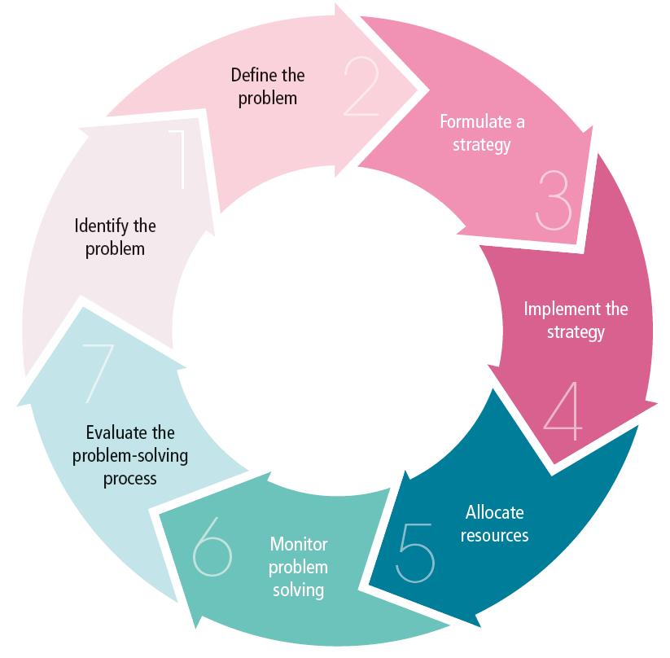
`

1.4 Indicate which of the following statements refers to decision making or problem solving.
 |  | Decision making /Problem solving
1 | The process of choosing from several alternatives. | Decision making
2 | Involves a group/team. | Problem solving
3 | It involves analysing the problem to identify solutions. | Problem solving
4 | One person usually makes decisions. | Decision making
5 | Alternative solutions are identified and evaluated | Problem solving
6 | Various alternatives are considered before deciding on the best one. | Decision making
7 | It is part of the problem-solving process where a solution is chosen. | Decision making
8 | The process of finding a solution to a problem. | Problem solving

Problem-solving techniques
1.5 Use the list below to Identify the problem-solving technique for each
of the descriptions below

Brainstorming | Nominal Group Technique | The Delphi Technique | Force Field Analysis

- Force Field Analysis | - The Delphi Technique
- Technique used to compare the driving and restraining forces to create an informed decision.  - This technique will improve the quality of decisions and increase the chances of success. | - A method that relies on a panel of experts to find solutions to a problem. Experts do not have to be in the same place.  - This technique uses a series of questionnaires to obtain feedback from experts. The questionnaires are summarised to bring about the agreement from the different views.
- Brainstorming | - Nominal Group Technique
- Brainstorming is a group activity to find a solution for a specific problem by gathering a list of ideas spontaneously.  - It is a method for inspiring creative  problem solving by encouraging group members to come up with thoughts and ideas.  - Some of the ideas can be crafted into original, creative solutions to a  - problem, while others can spark even more ideas. | - Nominal Group technique requests each employee to silently brainstorm and generate many ideas on their own and to write them down.  - A voting process is added to rank the ideas that are generated.  - Everyone in the group is expected to participate in silence.

  You should be able to | - Explain/describe how businesses can apply problem-solving  techniques to solve business problems
- Identify problem-solving techniques from given
scenarios/case studies

- BUSINESS OPPORTUNITY & RELATED FACTORS

At the end of this topic, learners should be able to:

❖ Elaborate on the meaning of a business opportunity and give practical examples
❖ Explain the importance of assessing needs and desires in identifying a business opportunity
❖ design a research instrument to assess needs and desires, for example, questionnaires, interview
structure/schedule
❖ Outline/explain/describe protocol for conducting research
❖ Outline/explain the difference between internal and external market research
❖ Compile a swot analysis to determine a viable business venture
❖ Identify a business opportunity based on the findings from compiling a swot analysis
❖ Apply a swot analysis from a given scenarios/case study.

Key concepts in this topic are the following:

- Research: the systematic process of collecting and studying data and information according to a
specific methodology.
- Research protocol: refers to the procedure that must be followed before research is conducted. The
research protocol will depend on the type of information you need.
- Research ethics: supplies guidelines for the responsible conduct of research.
- Research instruments: is the different methods can be used to collect data from customers, for
example questionnaires, interviews, surveys, observations and experimenting
- Internal market research is the gathering of information of factors within the business such as the
financial spending and the return of investment on products.
- External market research is the gathering of information of factors of the wider business
environment that affects your business.
- Questionnaire: is a research instrument that consists of a set of questions or other types of prompts
that aims to collect information from a respondent.
- SWOT analysis: is a strategic planning technique used by a business to find strengths, weaknesses,
opportunities, and threats related to the business.
- Market research: the collecting of data and information to provide an insight into target markets
- Data: units of information that are collected through observation.
- Information: knowledge, facts, and processed data obtained from research.
- Viable: something that is feasible, logical, or sensible.

Introduction

A business opportunity arises when there is a gap in the market. To take advantage of this gap, we conduct research to identify the opportunities and threats of this opportunity. Research helps us to identify problems and use the information to make informed decisions about how we want to address the problems. It also helps us to understand potential customers/clients better, and to find ways of communicating with them.

Meaning of a business opportunity
- A business opportunity is an idea for a person to start a business so that they can generate an income.
- It is a chance of improving the current operations of a business which can contribute to greater
profitability.
- Entrepreneurs are people who constantly look at new business opportunities so that they can remain
competitive.

Examples of business opportunities:
- car wash services
- tutoring online
- catering and ready-made meals.

  - Complete the following regarding the importance of assessing needs
and desires in identifying a business opportunity. Use the concepts
below

target | business | desire
unlimited | market | successful

- Needs and desires are the keys to a … business opportunities.  - The success of a business opportunity depends on the awareness and fulfilment of  the … market.  - Businesses should create a … for their product through well-designed advertising and  marketing campaigns.  - Needs and desire create a guarantee for a ….  - Every need and every desire are a possible … opportunity.  - It is easier to find something that people want and to create a business around that  since desires are … | successful  target  desire  market  business  unlimited

Different research instruments
- A research instrument is a tool used to collect, measure, and analyse data related to a business
opportunity.
- A good research instrument will provide information about a target market, which is meaningful,
that is, the respondents actively participated in the research.

Examples of research instruments:
- surveys
- interviews
- questionnaires
- observations
- experimenting.

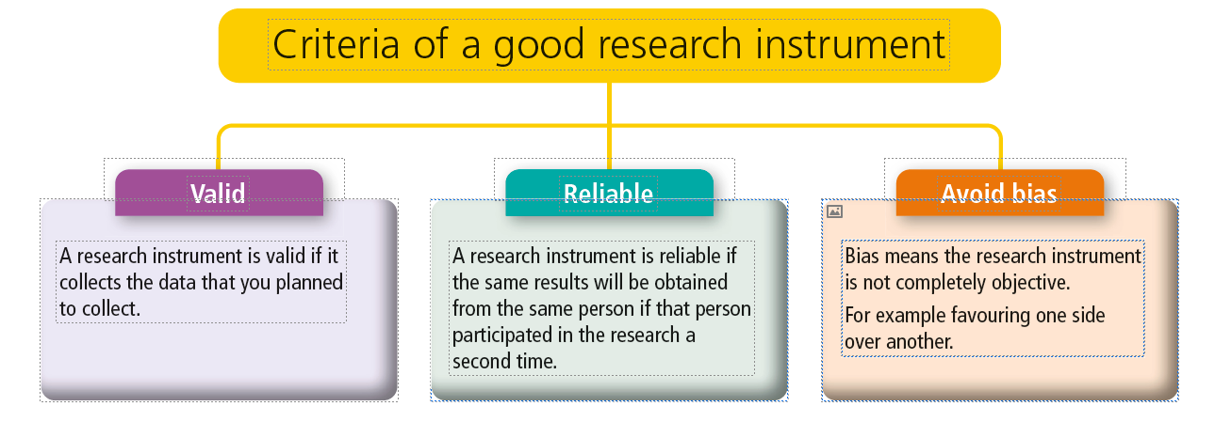

Meaning of research protocol
- A research protocol is a plan with detailed guidelines that explain the rules of the research.
- It will describe the objectives, design, methodology and statistical considerations of the research
depending on the type of information required.
- Ethical issues and protocols to be adhered to when doing research:
- The research should be conducted with the willing cooperation of participants.
- If research is taking place within an organisation, it must be approved first.
- The person conducting the research should not try to influence the opinions of the participants.

  - Complete the following with regard to the importance of market
research for a business. Use the concepts below

customer | product | opportunity | risks
information | gaps | needs

- Market research assesses the … and desires of customers  - Entrepreneurs gain … about industry trends and the actions of their  competitors  - Helps the business in developing and enhancing the …  - Guides business to minimise risks and identify … in customer expectation.  - Can be used to identify a business ...  - Can guide a business to minimise …  - To identify gaps in … expectations. | needs  information  product  gaps  opportunity  risks  customer

  - Indicate which of the following statements refers to internal market
research and which refers to external market research.

Statements | External/Internal
- Focuses on the interaction between the business and the customers.  - Usually conducted by a person within the company  - Employees are familiar with both customers and products which means they are uniquely capable of generating new ideas and how to market it  - Information about the target market, environment, customers’ needs, and desires are obtained  - The feedback is obtained from customers, potential customers, and suppliers  - Different resources with the business are used to gather information to make  - informed decisions  - Usually conducted by an outside specialist  - Focuses on the factors within the business | External  Internal  Internal  External  External  Internal  External  Internal

Advantages and disadvantages of internal and external market research
Advantages of Internal market research | Disadvantages of internal market research
- Lower research costs  - Shared information across the company  - High response rate | - Lack of anonymity  - Not as formalised as external marketing  Research
Advantages of External market research | Disadvantages of External market research
- Not influenced by company politics and  regulations.  - Market research done by market research  specialists,  - Objective results. | - Time consuming  - Expensive research cost

SWOT analysis
- A SWOT analysis is a strategic tool. It summarises a large amount of data into a user-friendly
diagram. SWOT stands for Strengths, Weaknesses, Opportunities and Threats.
- Strengths and Weaknesses relate to internal factors, which are under the control of the business
(micro environment).
- Opportunities and Threats relate to external factors over which the business has little (market
environment) or no control (macro environment).

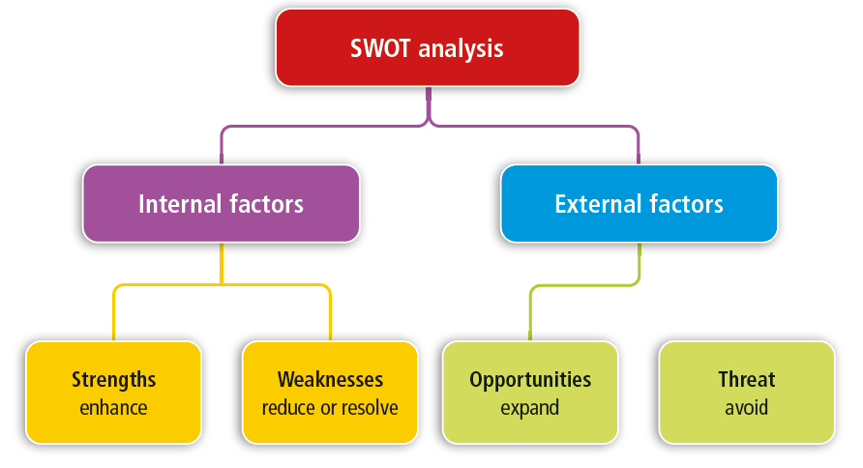
The SWOT analysis is usually a four-box diagram where each of the quadrants has a statement. Look at the following example:
STRENGTHS | WEAKNESSES
• Strong customer base  • Well-trained staff  • Adequate resources  • Strong financial strength | • Bad reputation  • Financial problems  • Lack of trained staff  • Lack of capabilities  •Lack of resources
OPPORTUNITIES | THREATS
• Strategic partnerships  • Possibility of obtaining tenders and contracts.  • New product and market development | • Economic factors- e.g., high inflation rate.  • Political factors like strikes and protest  • Environmental factors like climate change and  pollution.  • Legal for example Acts that can have an  impact on businesses, for example EEA, SDA,  BBBEE

    - Complete the following regarding the benefits of a SWOT analysis. Use the concepts below

quickly | opportunity | challenges
focus | expensive | planning

- It is not … to compile a SWOT analysis.  - It is a … tool that can help a business to make decisions.  - It gives a big picture of a business ...  - It can help a business to … on what is important.  - It can be done … , and you have the analysis immediately available.  - Useful to find possible … in all three business environments. | expensive  planning  opportunity  focus  quickly  challenges

2.4 Complete the following regarding the limitations of SWOT analysis. Use
the concepts below. Use the concepts below

business | solutions | ideas
information | prioritise

When you are conducting a SWOT analysis, you should keep in mind that it is only one stage of the business planning process. For complex issues, you will usually need to conduct more in-depth research. A SWOT analysis may be limited because it:
- Does not … issues  - Does not provide … or offer alternative decisions  - Can generate too many … but not help you choose which one is best  - Can produce a lot of … , but not all of it is useful.  - May cause businesses to overlook certain aspects in the … | prioritise  solutions  ideas  information  business

2.5 Read the scenario below and answer the questions that follow.

Veggie Market (VM)
Veggie Market is a well-established business located near a busy taxi rank. The shop has been vandalised on numerous occasions. The business does not have insurance for the stock and property. VM entered into an alliance with Green Farms to supply vegetables for local hospitals. Hamza, the manager of VM has a good leadership style. VM lacks financial strength to keep up stock levels. Many customers prefer to buy at King Fresh Fruit and Veg at a nearby shopping mall.

Compile a SWOT analysis for VM. Use the table below as a GUIDE to answer the activity.
STRENGTHS | WEAKNESSES
1. | 1.
2. | 2.
OPPORTUNITIES | THREATS
1. | 1.
2. | 2.

- PRESENTATION OF BUSINESS INFORMATION

At the end of this topic, learners should be able to:
❖ Outline/explain/discuss the importance of business reports
❖ Outline/explain guidelines on writing an effective business report
❖ Outline/explain/discuss the importance, advantages, and disadvantages of graphs/diagrams,
symbols/pictures
❖ Outline/explain/discuss factors that must be considered when preparing for a verbal presentation
❖ Outline/explain/discuss factors that must be considered when designing a presentation
❖ Explain the purpose of audio-visual aids
❖ Identify audio-visual aids from given scenarios/case studies/pictures/cartoons
❖ Support answers by quoting from given scenarios/case studies/pictures/cartoons.

Key concepts
- Verbal presentation: a presentation delivered through speech or orally.
- Non-verbal presentation: the transfer of information through the use of business reports, handouts,
charts, and posters with the support of visual aids.
- Business reports: a key communication tool that provides an evaluation of a particular issue relating to the performance of the business.
- Tables: a data structure that organises information into rows and columns.
- Graphs: diagrams that show the relationship between two or more data sets or values.
- Diagrams/flow charts: a simplified drawing showing a graphic presentation.
- Illustrations: a picture or a drawing.
- Handouts: a written summary of information dealt with in a presentation.
- Transparencies: transparent and flexible pages used to place information and images.
- Slides: a single page of a presentation created with software such as PowerPoint. A presentation consists of several slides.
- Charts (referred to as newsprint): is used to record and visually display information that will engage and stimulate audience participation.
- Audio-visual aids: devices that make use of both sound (audio) and sight (visual).
- Poster: usually a large, printed sheet that contains pictures and is posted in a public place.

Introduction
Businesses need information relating to their products, customers, procedures, sales, employees, on basically everything relating to a business. The information is used to guide its planning and operations, and for the evaluation of its activities. It also helps in the decision-making process, or to gain a competitive advantage.
Business information is conveyed from a speaker to an audience to inform, persuade, and/or to build goodwill. The audience could be made up of business’s board members, shareholders, clients, and/or other stakeholders. A good presentation promotes the image of the business/owner/management.
  - Complete the following regarding the importance of business
Reports. Use the concepts below:

department | issues | performing
decision | information

A business report is a key communication tool that provides an evaluation of a particular issue relating to the business.
- A business report aims to provide a critical analysis of how the business is … in  all business functions of the organisation.  - Business reports are used to guide … making in the business.  - It allows business owners and senior management the opportunity to  investigate and solve any identified ...  - Senior management relies on business reports to inform them of what each …  is doing.  - Business reports provide important … for management that is timely and  factual. | performing  decision  issues  department  information
  - Indicate which of the following refers to Verbal or Non-verbal
presentations
3.2.1 | 3.2.2
- Presentation is delivered through speech or orally. | - Refers to the transfer of information through the use of business reports, handouts, charts, and posters with the support of visual aids.

  - Complete the following regarding guidelines on writing an
effective business report. Use the concepts below:

basic | improvement | presented | information
scope | target | briefly | correct

- Determine the … of the report.  - Determine the … audience of the report.  - Determine how the report should be ...  - Collect the necessary ...  - Write … and only include important information.  - Use … language and clear short sentences.  - Spend time revising the report and … spelling mistakes and grammatical errors.  - Get someone to look at the report and to make suggestions for … | scope  target  presented  information  briefly  basic  correct  improvement

  - Read the scenario below and answer the questions that follow:

JOEY MANUFACTURER (JM)
Lita, the new CEO at Joey Manufacturer, is preparing a business presentation to the stakeholders. He enquired about the target market that the report is intended for. After writing the report, Lita asked Reuben to edit the report.

3.4.1 Quote TWO guidelines that Lita considered when writing a business report from the scenario above.
3.4.2 Explain other guidelines on writing an effective business report.

Visual Aids
Visual aids are items such as graphs and pictures used in addition to spoken/written information. They help add context to a presentation and make it more interesting for the audience. Graphs/diagrams and symbols/pictures help to organise information more clearly.

Types of visual aids
- Tables | - Graphs | - Illustrations | - Diagrams
  - Identify the type of visual aids from each of the statements
Below. Use the concepts below:

Graph | Diagrams | Tables | Illustrations

Statements | Type of visual aid
- Pictures or images to clarify texts.  - Used to enhance brand messaging and help persuade, inform, and influence customers. | Illustrations
- Pictorial representation or a diagram that represents data or values in  an organized manner | Graph
- Data structure that organises information into rows and columns.  - Used to compare and contrast information. | Tables
- Charts that clearly show what happens at each stage and how it affects other  decisions and actions.  - Used to communicate to others how a process is done. | Diagrams

Types of Graphs
- Line graph | - Bar graph | - Pie chart

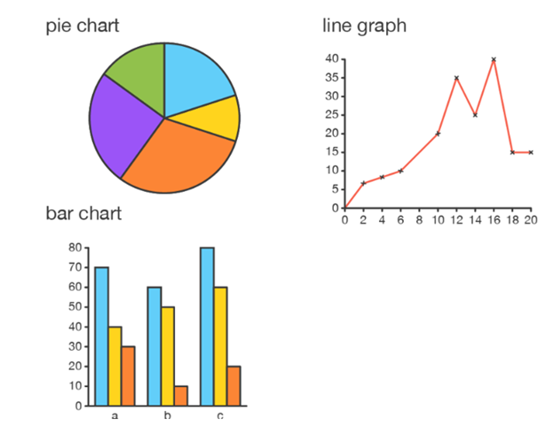

3.6 Identify the graphs from each of the statements below. Use the
concepts below:

Pie chart | Bar graph | Line graph

Statements | Type of graph
- Consists of points and lines showing the relation between the points.  - Used to compare changes over a specified period. | Line graph
- A circular graph that is divided into segments (that is, slices of pie).  - Used to show the relationship between parts or percentages of a whole. | Pie chart
- Shows data using rectangular bars.  - Used to compare data between distinct categories. | Bar graph

3.7 Complete the following regarding the importance of visual aids.
Use the concepts below:

interest | presentation | data
message | points | support

- Diagrammatic … presentation allows understanding of data more easily.  - It helps illustrate … to the reader/audience more easily and effectively.  - It also helps maintain the audience’s … during the presentation.  - It engages the audience with the … , making them remember it afterward.  - Diagrams are interesting, relevant, and … the presentation.  - Visual aids will effectively help convey the ... | data  points  interest  presentation  support  message
3.8 Indicate which of the following refers to the advantages or
disadvantages of visual aids

Advantage/
Disadvantage
- Visual aids simplify the presentation when using complex information. | Advantage
- Too many diagrams and graphs can be confusing to the audience. | Disadvantage
- Graphs do not require much explanation. | Advantage
- Information can easily be manipulated, causing false interpretations | Disadvantage
- It may distract the audience from the speech as they pay more attention to the visual aids. | Disadvantage
- Preparation of graphs and diagrams is time-consuming. | Disadvantage
- A lot of information can be displayed in an easy-to-understand format. | Advantage
- Graphical representation of information helps with understanding and identifying patterns and trends in data. | Advantage

3.9 Identify the visual aid that is applied to Wanda’s Construction in
each of the statements below:
3.9.1 Wanda showed the client a simple drawing of the processes for each stage of the project.
3.9.2 The sales manager presented a set of sales figures in a series of rectangles.
3.9.3 Images were used to show the front view of the building.
3.10 Factors that must be considered when preparing a presentation
Complete the following. Use the concepts below:
background | venue | draft | aim | time
presentation | feedback | content | purpose | visual

- The … and main points of the presentation  - Capturing the main … in the introduction of the presentation  - Being fully conversant with the … of the presentation  - Knowing the … of the audience to determine the appropriate visual aids  - Preparing a rough … of the presentation with an introduction, body, and  conclusion  - Creating … aids that will assist in getting the point across effectively  - Visiting the … and ensuring that the equipment provided is working and  suitable  - Considering the … frame for the presentation  - Practicing the … and note how long it takes  - Preparing for the … session by anticipating possible questions. | purpose  aim  content  background  draft  visual  venue  time  presentation  feedback
3.11 Factors that must be considered when designing a presentation
Complete the following. Use the following concepts.

legible | hyperlinks | content | background
images | effects | spelling | text

• starting with the … and headings  • using … font and font size  • selecting a suitable … that would not distract from the content  • choosing … that may help to communicate the message  • including graphics and images related to the …  • adding special … to support the message  • creating … to allow quick access to other files  • making sure there are no grammatical or … errors | text  legible  background  images  content  effects  hyperlinks  spelling

3.12 Read the scenario and answer the question that follows:

BICCO TRADERS (BT)
Jan, a marketing manager at Bicco Traders, will be making a presentation to the board of directors. The meeting will take place online face-to-face with the directors being in their different locations. He will also use a device that will allow the participants to take and share notes using a touch screen.

3.12.1 Identify TWO audio-visual aids used in the scenario above. Motivate your answer by quoting from
the scenario. (6)
Use the table below to guide your answer
 | Audio-visual aids | Motivation
1
2

4. BUSINESS PLAN
At the end of this topic, learners should be able to:
❖ Explain the importance of a business plan
❖ Use pestle analysis to explain the challenges of the macro environment on a business
❖ State/name the components of a business plan
❖ Explain the purpose of an executive summary
❖ Name/state aspects that must be included in an executive summary
❖ Formulate the vision/mission statements and goals of the envisaged business
❖ Explain the relationship between the structure of a business and forms of ownership
❖ Name/state different types of legal requirements of a business
❖ Compile a swot analysis for the envisaged business
❖ Explain the importance of a marketing plan and market research
❖ Explain the meaning of a marketing mix with specific reference to the 7ps
❖ Identify the 7ps from given case studies/scenarios/statements/cartoon
❖ Identify competitors from information gathered during market research, and explain the strategies
to overcome competition in the market
❖ Formulate a financial plan for the envisaged business.

Key concepts related to this topic
- Business plan: a document setting out a business’s future objectives and strategies for achieving them.
- Executive summary: a short document or section of a document produced for business purposes that is, summarises the entire business plan.
- Financial analysis: refers to the assessment of the viability and the profitability of the business.
- Environmental factors: refers to external influences on the business that it has limited no control over.
- Marketing mix: A set of actions that the business uses to promote its brand.
- Price: the amount of money required as payment for goods.
- Product: an object that is manufactured for sale.
- Promotion: a method used to advertise the product.
- Place: a location of the business.
- People: refers to employees as well as the target market.
- Physical environment: is the environment around the business.
- Process: the system used to deliver the product or service.
- Competition: It is a rivalry between two/more businesses selling the same goods or service.
- Marketing plan: A strategy of how the business is going to sell its products/service to customers.
- Market research: the action of gathering information about consumers’ needs and preferences.

Introduction

Have you ever heard the saying: ‘Failing to PLAN is planning to FAIL’? It means that if we do not plan a project before starting it, we are bound to end up being unsuccessful in the project. This also applies to a business’s plan – which is often referred to as a formula for success.
Once an entrepreneur has identified a business opportunity, the next step would be to turn the business’s idea into a workable plan. This plan is what we refer to as a business plan. It provides details on where the business would like to go with its idea and how you will get there.
  - The importance of a business plan

Complete the following. Use the following concepts

investors | success | problems | financial
entrepreneurs | direction | guides

- A business plan helps … to set goals and objectives.  - It can be used to attract … and prospective employees.  - The business plan … the entrepreneur on the viability of his/her business idea.  - It also helps the entrepreneur to identify … that may arise and helps  management to take steps to avoid these problems.  - It evaluates the … of the business.  - It is essential when applying for … assistance from investors or lenders.  - It gives … once the business is operating. | entrepreneurs  investors  guides  problems  success  financial  direction

The components of a business plan

- Cover page
- Contents page/index
- Executive summary
- Description of the business/overview
- Swot analysis
- Legal requirements of business
- Marketing plan
- Operational plan
- Financial plan
- Management plan
- Competitor analysis.

  - Indicate which of the following refers to the vision; mission or
goals & objectives of a business

 | Vision; Mission or Goals & Objectives
- Describes the purpose of the business and explains why the business exists. | Vision
- The long-term objectives are formulated to provide direction for the company to achieve the vision. | Goals & Objectives
- Describes how the business will achieve its purpose. | Mission
- They are also specific and measurable – just like the mission statement. | Goals & Objectives
- It addresses how entrepreneurs hope to achieve their vision. | Mission
- It is the long-term goal of how entrepreneurs see their business in the future, and how they want to grow. | Vision
- It focuses on business operations, and it is specific and measurable. | Mission
- It addresses profit, growth, purpose, and stability. | Vision
- The short-term objectives are specific steppingstones to reach short-term goals to achieve long-term goals. | Mission

Different types of legal requirements of a business

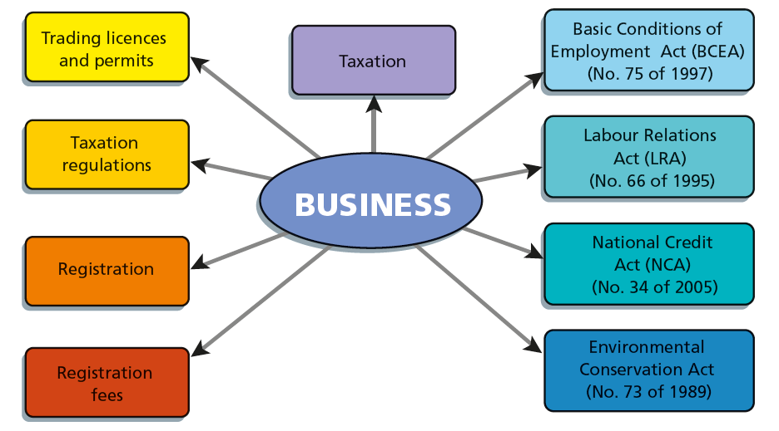

A vision statement describes the company's purpose, what the company is striving for, and what it wants to achieve.

Meaning of a Marketing plan

A marketing plan is an operational document that outlines an advertising strategy to generate leads and research the target market. It is a description of the market analysis, which includes the target market, and an analysis of the target market, customers, and competitors. It explains the marketing mix and provides the marketing strategy of the business. It also guides businesses on how to advertise the products/services of the business.
4.3. Importance of a Marketing Plan

Complete the following: Use the concepts below:

target | promote | research
results | customers'

- A marketing plan helps businesses to … products and services.  - It is a process to understand more about what the business’s … need.  - The … market refers to the people who are likely to buy the product or service offered by the business.  - The business must conduct a market … to know about the following factors of the target market: age group, gender, personality, income, and education.  - The … of the market research are important – they indicate the target market and their interest in goods and services. | promote  customers’  target  research  results

Meaning of the marketing mix
The marketing plan can be explained by using seven elements, which is often referred to as the 7Ps of marketing. There are four main elements and three additional elements – it is a combination of product, price, place, people, promotion, process, and physical environment.

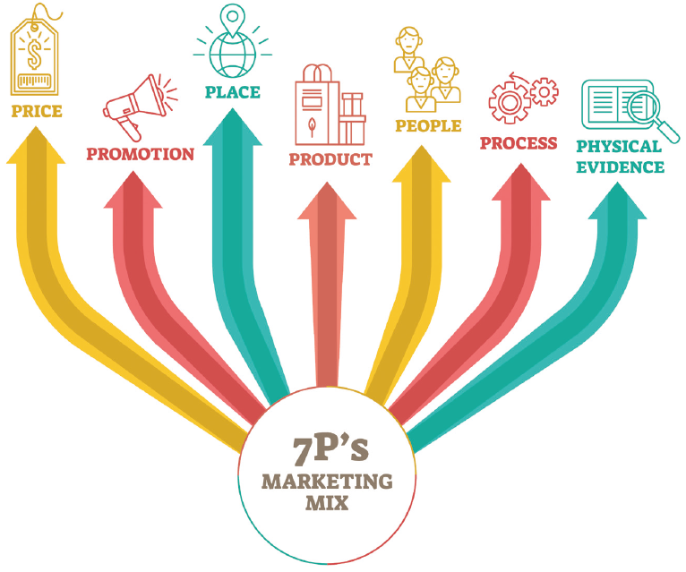

Marketing mix

Product | Price |  | Place |  | Promotion
People |  | Process |  | Physical environment

Promotion | Place
- A promotion should communicate the benefits of the product to customers.  - It refers to how the business is going to make its target market aware of its product or service  - The proposed business must include details about its promotion policy.  - The promotion policy must describe how sales of products will be promoted. | - This refers to the location where goods and services will be sold/the place where consumers can access the goods or services.  - The business can sell the product directly to customers itself or can market the product through other businesses.
Price | Product
- The price of a product refers to the amount of money that must be paid by the consumer to obtain the product.  - The proposed business must include its pricing policy in its business plan.  - The pricing policy describes how the price is used to attract customers.  - The price needs to cover all costs and must appeal to the target market.  - It must be affordable for the consumers. | - It is a description of the product, appearance, and usage that is available to customers.  - It can be a picture, drawing, or photograph of what the product looks like.  - The manufacturing process is used to make the product.  - The appearance of the product/services must be different from competitors’ products  - The packaging of the product should protect and preserve the product.
People | Process
- This refers to employees, management, directors, and shareholders./All people involved in selling the products.  - The business plan must include detailed information of people that will be involved in the proposed business.  - They can offer the business their knowledge, skills, and attitudes. | - Refers to processes that are designed and implemented to ensure a pleasant shopping experience.  - Describes how the marketing and sales processes are conducted.  - The process of giving service and the behaviour of those delivering the service are important for customer approval of staff, and to keep customers happy.
Physical environment
- Refers to the environment where goods and services are sold/service rendered.
- It includes the appearance of the building and the uniforms of employees.
- The physical environment must be appropriate and make the customer feel comfortable.
- Clean and functional facilities attract and retain customers.

You should be able to | Identify the 7ps from given case studies/scenarios/statements/cartoon

4.4 Identify the 7Ps of the marketing mix that applies to Zama Zama
Wholesalers in each of the statements below:

    - Zama Zama Wholesalers advertise their products on social media to increase the number of customers.
4.4.2 Zama Zama Wholesalers employed skilled workers who contribute
4.4.3 Zama Zama Wholesalers keep their goods in a secure location (6)

4.5 Identify from the list below FIVE strategies to overcome
competition

- Sell quality products and services  - Offer after-sales services  - Promote inferior products  - Charge reasonable prices  - Deny customers after care services  - Conduct intensive marketing campaigns  - Sell products are the highest possible price to customers  - Make use of creative advertising slogans | X  X  X

Financial planning

A financial plan is a detailed description of an entrepreneur’s financial contribution, the funding requirements, and projected cash flow statements. This financial plan is usually estimated for a three-year-period. The purposes of financial analysis are to project/predict the profitability of the proposed business and also to project how long it will take before the business starts to show a profit.

Steps of Financial planning

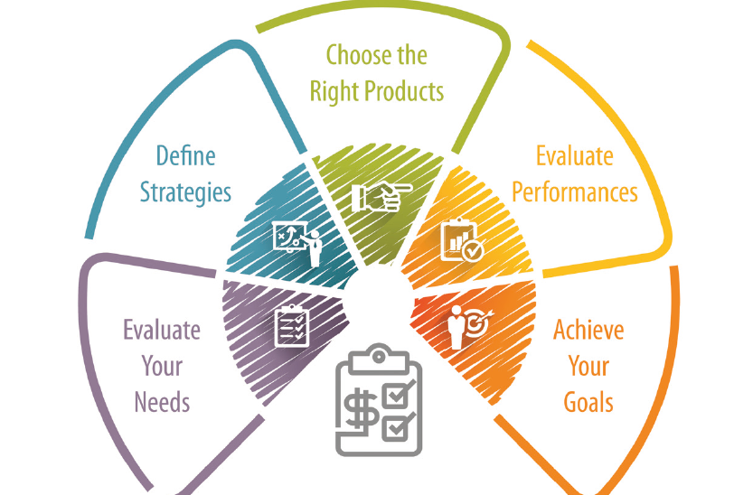

5. RELATIONSHIPS & TEAM PERFORMANCE

At the end of this topic, learners should be able to:

❖ Discuss/explain ways in which people need to work together to accomplish business objectives
❖ Discuss/explain factors that can influence team relationships
❖ List/understand business objectives
❖ Explain/define interpersonal relationships in the workplace
❖ Discuss/define personal beliefs and values and how they influence business relationships
❖ List/discuss the criteria for successful and collaborative team performance in a business context and
assess a team against these criteria
❖ Explain how team members can work in a team to accomplish business objectives

Key concepts

- Team: consists of two or more people who work together in a business or organisation to achieve a
common goal.
- Relationship: the connection between employees, colleagues, customers, and suppliers.
- Prejudice: a preconceived opinion or judgement of something or someone.
- Beliefs: a feeling of being sure that a person or thing exists or is true or trustworthy.
- Values: the beliefs, philosophies and principles that drive a business – the core values that guide the
business.
- Diversity: what makes people unique and includes different cultures, backgrounds, beliefs, gender,
language and life experiences.
- Productivity: a way to measure efficiency in a business
- Service: an activity that is rendered by the business to another party like a customer, or another
department.
- Interpersonal relationships: the relationship between two employees working at the same place.
- Discrimination: certain prejudices that occur when an employee is treated unfairly because of race, gender, sexuality, religion, or disability.
- Equity: the practice of being fair or impartial in the workplace. Equity is achieved when there is no
discrimination.
- Profit: the financial advantage or benefit derived when income exceeds expenditure
- Management levels: refers to a line of demarcation between various managerial positions in an
organization.
- Collaboration: the action of working with someone to produce something.
- Openness: the quality of being relatively free from obstruction or relatively unoccupied:
- Mutual respect: underpins good relationships. To have respect for a person involves a fundamental belief in their right to exist, to be heard, and to have the same opportunities as everyone else.
- Mutual trust: when employees enjoy a culture of honesty, and psychological safety.

Introduction

Teamwork occurs when two or more people come together to reach a common goal. Successful teams communicate frequently and openly, team members can engage with one another, and they are flexible to ensure the overall success of the team.
Teamwork can be natural for some people, but difficult for others. Poor relationships amongst team members can be characterised by emotional and behavioural actions that can create distress, anger, and withdrawal. This can create a divided team, which in turn can lead to poorer team performance.

Business objectives

A business objective explains in detail the steps a business plan to take in order to achieve a specific goal. Types of business objectives: profit, productivity, service. A good business objective focuses on profit, productivity, and service. Good business objectives are also aligned to the vision, mission, and purpose of the business.

5.1 Benefits of teamwork

Complete the following. Use the following concepts

support | communication | control | learn
more | productivity | objectives

- The members of the team … from each other and grow.  - The team achieves … than the individual.  - Good teamwork helps business to achieve its...  - Gives employees more … over their jobs.  - The performance of all team members improves because they … each other’s skills.  - Teamwork encourages workers to increase their range of skills to increase ...  - Teamwork improves effective ... | learn  more  objectives  control  support  productivity  communication

5.2 Ways in which businesses can create an environment that
enables teams to work effectively

Complete the following: Use the concepts below:

values | brainstorming | communicating
ideas | objectives | rules

- Ensure the team clearly understands the business ...  - Set ground … for the team.  - Establish team … and goals  - Consider each employee’s … as valuable.  - Be clear and specific when … to prevent confusion.  - Encourage listening and ... | objectives  rules  values  ideas  communicating  brainstorming

Different hierarchies and management levels

The levels in business hierarchy refer to the levels of chain of command and the employee designations. The business hierarchy continues till the highest level consisting of the Chief Executive Officer (CEO) or the board of directors. The business hierarchy usually narrows from bottom to top.

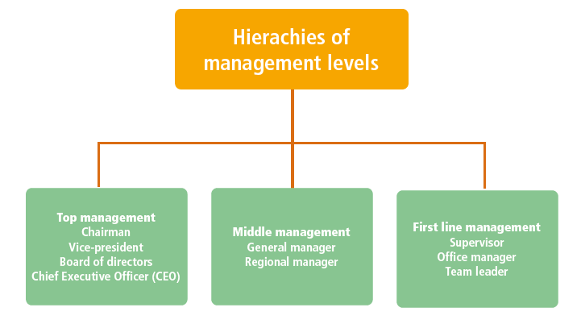

Meaning of Interpersonal relationships

Interpersonal relationships in the workplace refers to a strong association among individuals working together. Interpersonal relationships in the workplace allows team members to share a special relationship. Team members build up a relationship of trust, openness, understanding and effective communication. Everyone plays a role in achieving the business objectives.

The importance of each individual in achieving business objectives

- The quality of interpersonal relationships impacts on the productivity of teams.
- If employees are skilled and knowledgeable, teams will be strong and efficient.
- Great results can be achieved through teamwork, so it is important that a business creates an environment that enables teams to work effectively.
- Usually, employees will take pride in their work if they are aware of how their efforts impact on achieving the business objectives.
- Celebrating milestones and praising team members, helps employees feel excited to be part of the team.
- This in turn, can lead to higher productivity.

Ways to promote healthy interpersonal relationships in the workplace

- Having empathy for others is an important skill employees need to build healthy interpersonal relationships in the workplace.
- Empathy helps team members to consider the thoughts, feelings and needs of others.
- Relying on other people builds trust and teamwork establishes strong relationships.
- Despite occasional disagreements, an effective team enjoys working together and shares a strong bond.

5.3 Ways in which businesses can address factors that influence team
relationships

Complete the following. Use the following concepts

decisions | communicating | rewarded
members | ideas | employees

- The business can make sure that …. understand and believe in business objectives.  - The business should listen to employees when they share ...  - Important … should be taken through a process of teamwork.  - Good teamwork needs to be … and mistakes must be viewed as opportunities to learn and grow.  - Being clear and specific when … to prevent confusion.  - Encouraging trust, respect, and cooperation among … of the team. | employees  ideas  decisions  rewarded  communicating  members

5.4 Read the scenario below and then answer the questions that follow.

OFFICE STATIONERIES (OS)
Office Stationeries formed a sales team that sells their stationery in the Free State. Some team members do not tolerate each other due to different cultural beliefs. Paul also does not like Zizi because he does not know her.

5.4.1 Identify TWO factors that influence team relationships. Motivate your answer by quoting from the
scenario above. Use the table below as the guide to answer this question. (6)

Factors that influence team relationships | Motivation

Criteria for successful team performance

Clear objectives and agreed goals | Interpersonal attitudes and behaviour
Shared values and mutual respect | Communication
Cooperation/Collaboration | Mutual respect, support, and trust

5.5. Indicate which of the following statements refers to the above
criteria for successful teams

1 Communication | 2 Cooperation/Collaboration
- Efficient communication between team members may result in quick decisions.  - Quality feedback from team members will improve the morale of the team.  - Open discussions between team members will lead to effective problem solving | - All team members should actively participate in the decision-making process.  - Show a willingness to cooperate as a unit to achieve team objectives.  - Cooperate with management to achieve team/business objectives.  - Agree on how to get a task done effectively and without wasting time on conflict resolution.
3 Clear objectives and agreed goals | 4 Interpersonal attitudes and behaviour
- Team members must agree on goals and set clear objectives.  - Team members who agree to the goals will be more committed.  - Team members will show more commitment if the objectives are understood clearly. Teams need to focus on the agreed goals essential for success.  - Team members should know what they want to achieve. | - Team members have a positive attitude of support and motivation towards each other.  - Good interpersonal relationships will ensure job satisfaction and, in this way, increase the productivity of the team.  - Team members are committed and enthusiastic towards achieving a common goal.  - Team leaders give credit to members for positive contributions.
5 Mutual respect, support, and trust | 6 Shared values and mutual respect
- Team members must not fear being laughed at or rejected for expressing concerns. This will encourage participation.  - Team members should consult with all group members.  - Team members should learn from one another. | - Shows respect for the knowledge or skills of other members.  - Perform team tasks with integrity meeting team deadlines with necessary commitment to team goals.  - Shows loyalty ,respect and trust towards team members despite differences

- CONSOLIDATION QUESTIONS

6.1 List any FOUR components of a business plan.
6.2 Identify the marketing mix components applied by Harry Hardware in EACH statement below:
6.2.1 The business is situated in a residential area.
6.2.2 Harry uses flyers to advertise his products.

6.3 Read the scenario below and answer the question that follows.

BANDY COMPUTERS SERVICES (BCS)
Bandy Computer Services specialises in the repair and sale of computers at a reasonable price. The business has employed a qualified computer technician. BCS signed a three-year contract with EC Electronics to supply electronic devices at reduced prices. BCS is located in a high crime area. The management of Bandy Computer Services lacks good financial planning skills. BCS does not have sufficient capital to buy the latest equipment for computer repairs. Loadshedding has affected their ability to render their services. Zanny Computers recently closed down their operations.

6.3.1 Compile a SWOT analysis for BCS.
6.3.2 Advise businesses on the importance of the business plan.
6.4 Define the following concepts:
6.4.1 Working relationship
6.4.2 Interpersonal relationships

6.5 Read the scenario below and answer the questions that follow.

HAZELNUT SYSTEMS (HS)
Hazelnut Systems (HS) is an IT company that specialises in implementing accounting systems. The team members work together closely with each other. The accounting projects team has a reputation of never missing a target date or deadline. Ayanda has a reputation for not always having a good relationship with all the team members. He never delegates tasks to younger team members because he believes that younger people do not have enough experience. This has led to discontent among the team and has caused quarrelling and fighting within the team.

6.5.1 Identify FOUR factors that influence team relationships from the scenario above.
6.5.2 Explain THREE different ways in which Hazelnut (Pty) Ltd can address factors that influence teams
relations

ACKNOWLEDGMENT OF SOURCE

- 2022 DBE Grade Business Studies 10 Learner book

