

GENERAL EDUCATION AND TRAINING
SOCIAL SCIENCES

GEOGRAPHY TEST 4
TEST
GRADE 8

MARKS : 50
DURATION: 1 HOUR
INSTRUCTIONS

- Answer all the questions found in this question paper
- Number your answers correctly according to the numbering used in this paper.
- Study all the sources provided when answering the questions.
- Note the mark allocation for each question to guide your answer.
- Write neat and legible.

GRADE 8 GEOGRAPHY TERM 1
MAPS AND GLOBES
Question 1: Maps and atlases
1.1. Fill in the missing words
1.1.1. Lines of latitude and longitude are measured in ………… (1)

1.1.2. Numbers indicating the lines of latitude and longitude that cross each
other at a place are called …………… (1)

1.1.3. Lines of longitude are sometimes called……………. (1)

1.1.4. Names of places in the atlas are listed in the …………… (1)

1.1.5. The……………shows the relationship between the map distance
and the ground distance. (1)

1.1.6.’As a crow flies’ means ……………… (1)
[6]
1.2. Study the map below and answer the questions that follow.
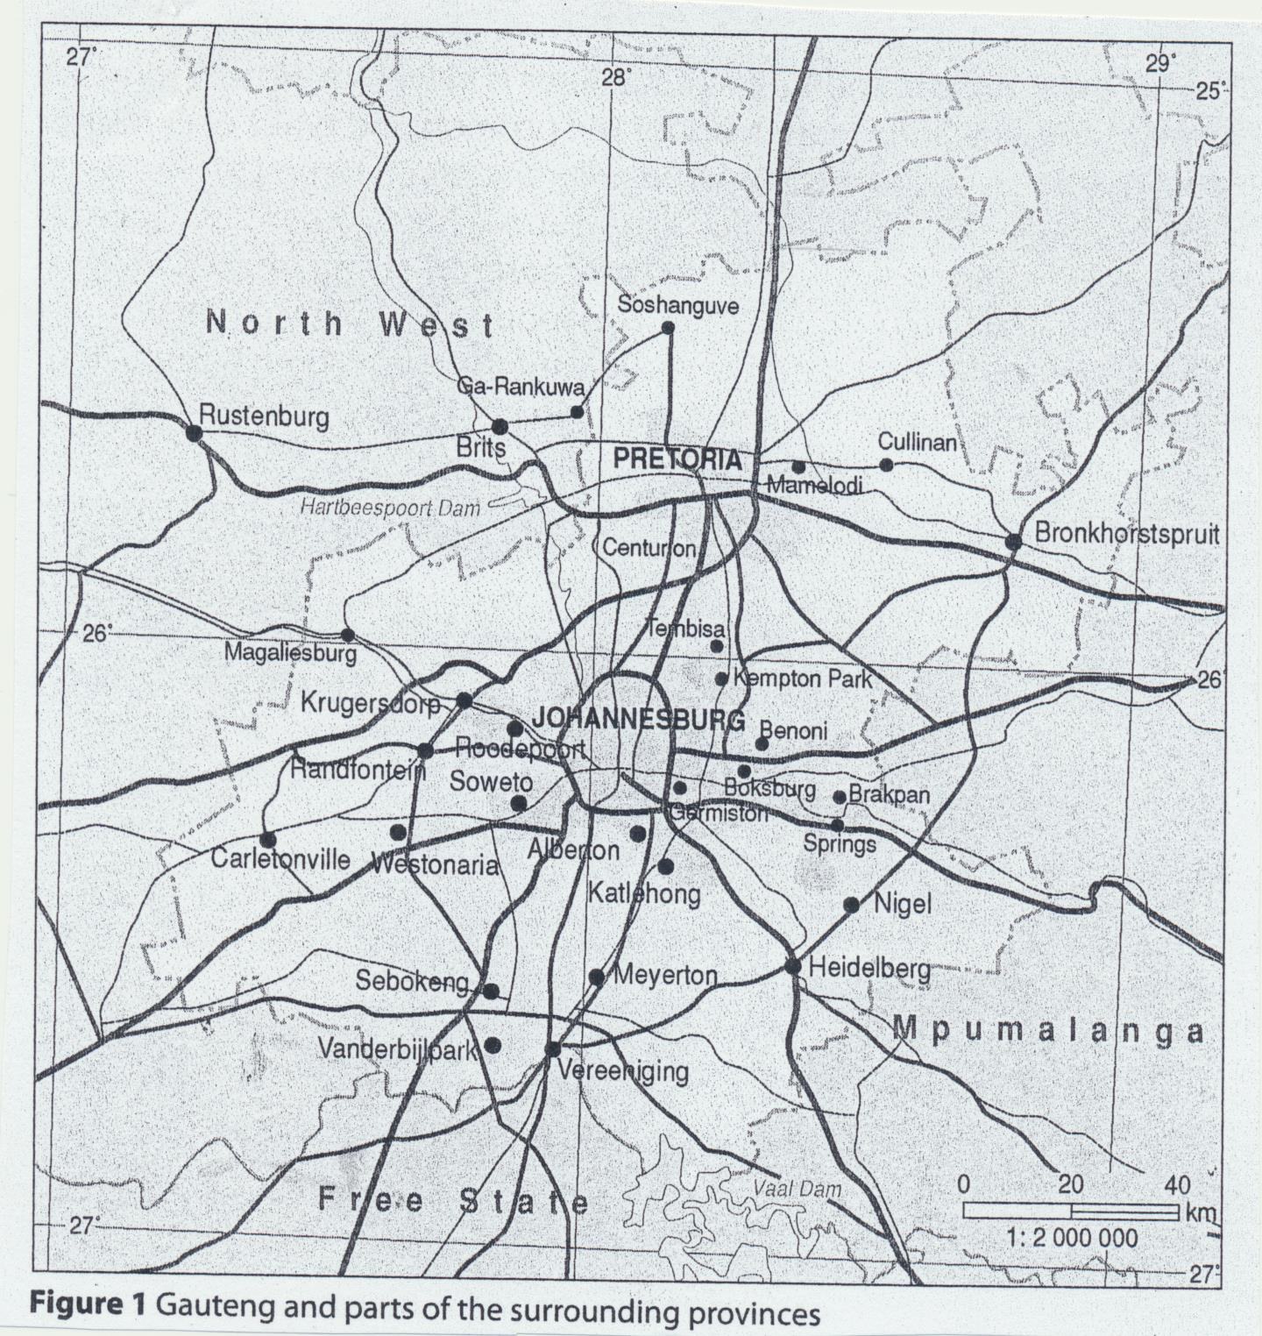

1.2.1. Is this a small or a large scale map? Give a reason for your answer. (3)

1.2.2. Give the latitude and longitude coordinates of Randfontein. (2)

1.2.3. Identify the settlements at the following location:
26$°00$’S, 28$°$14’E (2)

1.2.4. Use the line scale to calculate the straight line distance between
Soshanguve and Boksburg in kilometres. (4)

1.2.5. Study the map and identify the sources of water for the Gauteng
Province. (2)
[13]
Question 2: The globe

2.1. State whether the following statements are true or false. Write only
the answer. True or False
2.1.1. The equator divides the earth into the southern and northern
hemispheres. (1)

2.1.2. One complete rotation on the earth’s axis takes 12 hours. (1)

2.1.3. The earth rotates in a clockwise direction on its axis. (1)

2.1.4. The earth’s rotation causes day and night. (1)

2.1.5. The world’s time zones change by one hour for every 15$°$ (1)

2.1.6. In the poles there are effectively only two seasons, summer
and winter. (1)

[6]
2.2. Study the source below and answer the questions that follow

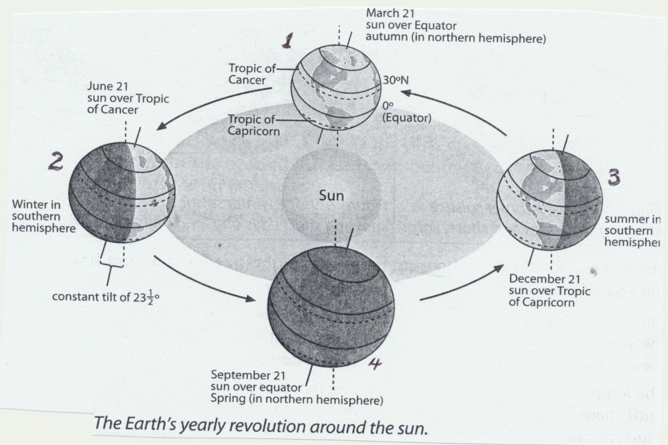
(Hambly,A.et.al Spot On Social Sciences.Heinnemann.Santon2012)

2.2.1. What is the difference between the Earth’s rotation and the Earth’s
revolution. (2)

2.2.2. Identify the three factors that cause the seasons. (3)

2.2.3. Explain a summer solstice. Use the southern hemisphere as an
example. (3)

2.2.4. Explain an equinox, provide the dates (3)

2.2.5. Use the earth’s revolution around the sun to explain how we come to
have a leap year. (3)

2.2.6. Name the three things that are caused by the tilt of the earth’s axis. (3)
[17]
Question 3: Satellite Images

3.1.1. What are satellite images? (2)

3.1.2. How do satellite images help the meteorologists? (2)

3.2. Write a paragraph of about five (5) to six (6) lines to explain how
satellite images can be used in the agricultural sector (5)

[9]

