

GENERAL EDUCATION AND TRAINING
SOCIAL SCIENCES

HISTORY TEST 1
TEST
GRADE 8

MARKS : 50
DURATION: 1 HOUR
INSTRUCTIONS

- Answer all the questions found in this question paper
- Number your answers correctly according to the numbering used in this paper.
- Study all the sources provided when answering the questions.
- Note the mark allocation for each question to guide your answer.
- Write neat and legible.

- Explain in your own words the following terms:
  - Primary Source
______________________________________________________ (1x2) (2)
  - Secondary Source
_______________________________________________________ (1x2) (2)

- Study Source 1A below and answer the questions that follow:
SOURCE 1A
“This extract is adapted from his book, The Philosophy of Manufacture in 1835.”

In 1834 Andrew Ure, a Scottish doctor, visited the factories in the North of England. He gave many speeches supporting industrialisation.
“I have visited many factories during a period of several months and I never saw a single beating of a child nor indeed did I see children unhappy. They seemed to be cheerful and alert, taking pleasure in the gentle use of their muscles. The work of these lively little children seemed to me to be more like a game for them. They showed no signs of being exhausted.”

  - Name and give the occupation of the person who wrote the source.
______________________________________________________________(2x1) (2)
  - Does the writer of Source 1A support industrialisation or is he against it? Give
ONE reason for your answer
______________________________________________________________(1x2) (2)

  - Extract FOUR reasons from the source that show that the writer supports
child labour. _____________________________________________________________________
______________________________________________________________________________________________________________________________________________________________________________________________________________________________________________________________________________________________________________________________________________ (4x1) (4)

- Refer to Source 1B and answer the questions that follow:
SOURCE 1B
“extract from Changing Britain by Samuel Coulson.”
This is an extract from Changing Britain by Samuel Coulson. Coulson was a factory worker. In this extract he describes what happened to his daughter when she was injured at work.

“The girls go to the mills at three in the morning and finish their work at ten in the evening…. My eldest daughter when she was there, the cog caught her finger-nail and screwed it off below the knuckle. She was five weeks in the Leeds Infirmary [hospital] and her wages were stopped.”

  - Name the writer of Source 1B. _________________________________ (1x1) (1)
  - What is the writer’s relationship to the injured girl he writes about in Source 1B?____________________________________________________________ (1x1) (1)
  - Describe the hours worked by the young girls in the mill.
______________________________________________________________ (2x1) (2)
  - Explain what happened to the girl who was injured at work.
________________________________________________________ (1x2) (2)
  - As a result of her injury what happened to the young girl?
____________________________________________________________(2x1) (2)
  - In your opinion, did the mill owners treat the girl fairly? Give a reason for
your answer. __________________________________________________ (2x2) (4)

- Refer to both Source 1A and 1B.

  - Are Source 1A and 1B Primary or Secondary Sources? Give a reason for your
answer.________________________________________________________ (1x2) (2)
4.2. Which source (Source 1A or 1B) would you consider to be more reliable
(trustworthy)? Give a reason for your answer. ______________________________________________________________
(2x2) (4)

5.SOURCE 2: A photograph of a closed compound in Kimberly in the 1890s.
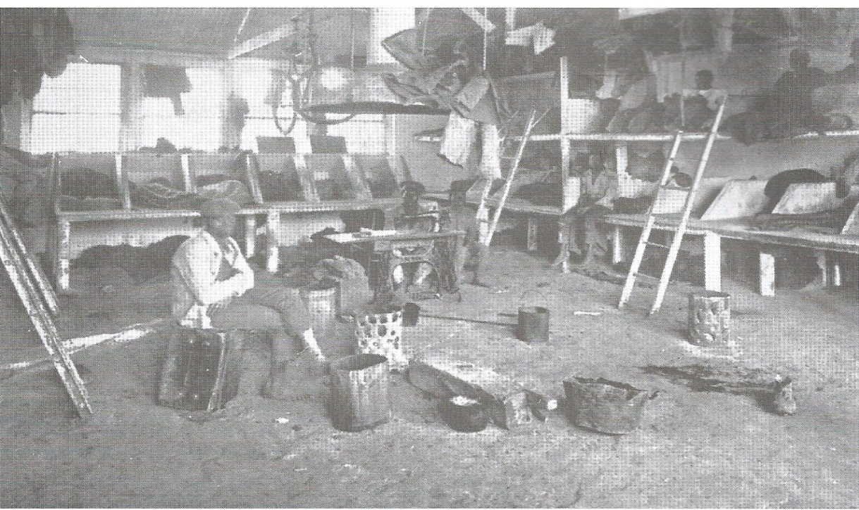
5.1. | What is a closed compound?  __________________________________________________________________(1X1)
5.2. | Why do you think mine owners built closed compounds and forced black workers to live in them?  __________________________________________________________________  __________________________________________________________________(1X1)
5.3. | Name ONE example from Source 2 to prove that the human rights of Black workers living in the compounds were violated.  __________________________________________________________________(1X1)
5.4. | Why women were not allowed in the compound?  __________________________________________________________________  _________________________________________________________________(1X1)
5.5. | Why do you think white workers were never forced to live in closed compounds? And why?__________________________________________________________________  ________________________________________________________________(2X2) (4)
5.6 | Look at Source B and explain if the miners had comfortable beds? Support your answer with evidence from the photo.  _________________________________________________________________  __________________________________________________________________(2X2) (4)
5.7. | Using Source B describe the living conditions of the miners.  __________________________________________________________________  __________________________________________________________________(2X2)(4)
5.8. | Explain why gold is a valuable mineral.  __________________________________________________________________  __________________________________________________________________(2X2)(4)
[20]

TOTAL 50 MARKS

