
Candidate Barcode Label/Stafieskodeplakker

NSC Answer Book
NSC-antwoordeboek

National Senior Certificate/Nasionale Senior Sertifikaat (Grade 12/Graad 12) 2024

CENTRE NUMBER
SENTRUMNOMMER
Sequence No. on mark sheet
Volgnommer op puntestaat

EXAMINATION NUMBER
EKSAMENNOMMER
DATE  DATUM |  |  |  |  |  |  |  |  |  | BOOK NUMBER  BOEKNOMMER |  |  |  |  |  | OF  VAN |  |  |  | BOOKS  BOEKE
SUBJECT CODE  VAKKODE |  |  |  |  |  |  |  |  |  | PAPER NUMBER  VRAESTELNOMMER |  |  |  |  |  |  | 2
SUBJECT NAME  VAKNAAM | TECHNICAL MATHEMATICS/TEGNIESE WISKUNDE
Confidential/Vertroulik
MARKER/NASIENER |  |  |  |  | MODERATOR'S INITIALS IN RELEVANT BLOCK/  MODERATORPARAAF IN BETROKKE BLOKKIE |  |  |  |  |  |  |  |  |  | RE-MARK/RE-CHECK/  HERNASIEN/HERKONTROLEER
Question  Vraag | Marks  Punte |  |  | Marker's Code  & Initials | Marks  Punte |  |  | SM | DCM | CM | IM | EM |  |  | Question  Vraag | Marks  Punte |  |  | Initials  Paraaf
1 |  |  |  |  |  |  |  |  |  |  |  |  |  |  | 1
2 |  |  |  |  |  |  |  |  |  |  |  |  |  |  | 2
3 |  |  |  |  |  |  |  |  |  |  |  |  |  |  | 3
4 |  |  |  |  |  |  |  |  |  |  |  |  |  |  | 4
5 |  |  |  |  |  |  |  |  |  |  |  |  |  |  | 5
6 |  |  |  |  |  |  |  |  |  |  |  |  |  |  | 6
7 |  |  |  |  |  |  |  |  |  |  |  |  |  |  | 7
8 |  |  |  |  |  |  |  |  |  |  |  |  |  |  | 8
9 |  |  |  |  |  |  |  |  |  |  |  |  |  |  | 9
10 |  |  |  |  |  |  |  |  |  |  |  |  |  |  | 10
11 |  |  |  |  |  |  |  |  |  |  |  |  |  |  | 11
12 |  |  |  |  |  |  |  |  |  |  |  |  |  |  | 12
13 |  |  |  |  |  |  |  |  |  |  |  |  |  |  | 13
14 |  |  |  |  |  |  |  |  |  |  |  |  |  |  | 14
15 |  |  |  |  |  |  |  |  |  |  |  |  |  |  | 15
16 |  |  |  |  |  |  |  |  |  |  |  |  |  |  | 16
 |  |  |  | TOTAL  TOTAAL |  |  |  |  |  |  |  |  | TOTAL  TOTAAL
HASH TOTAL
KAFTOTAAL
CONTROLLED AND CERTIFIED CORRECT  SURNAME AND INITIALS OF EA |  |  |  |  |  |  |  |  |  |  |  |  |  |  | PLEASE READ INSTRUCTIONS ON THE NEXT PAGE  LEES ASSEBLIEF INSTRUKSIES OP VOLGENDE BLADSY

This answer book consists of 27 pages./Hierdie antwoordeboek bestaan uit 27 bladsye.

PLEASE FOLLOW THESE INSTRUCTIONS CAREFULLY |  |  | VOLG ASSEBLIEF HIERDIE INSTRUKSIES NOUKEURIG
1. | Your examination number and centre number must be clearly written in the space provided and attach your examination number sticker in the space provided. | 1. |  | Skryf jou eksamennommer en sentrumnommer duidelik in die ruimtes verskaf en plak jou eksamennommer-etiket in die ruimte verskaf.
2. | Remember that your own name (or the name of your school) may not appear anywhere on or in this answer book. | 2. |  | Onthou dat jou eie naam (of die naam van jou skool) nie op of in hierdie antwoordeboek mag voorkom nie.
3. | Answer ALL questions in the spaces provided. | 3. |  | Beantwoord ALLE vrae in die ruimtes wat verskaf is.
4. | No pages may be torn from this answer book. | 4. |  | Geen bladsye mag uit hierdie antwoordeboek geskeur word nie.
5. | Read the instructions printed on your timetable carefully as well as any other instructions which may be given in each examination paper. | 5. |  | Lees die instruksies wat op jou eksamenrooster gedruk is, sorgvuldig deur, asook enige ander instruksies wat in elke eksamenvraestel gegee word.
6. | Candidates may not retain an answer book or remove it from the examination room. Answer books must be returned to the Invigilator at the end of the examination session. | 6. |  | Geen antwoordeboek mag deur die kandidaat gehou of uit die eksamenlokaal verwyder word nie. Antwoordeboeke moet aan die einde van die eksamensessie aan die toesighouer terugbesorg word.
7. | Answers must be written in black/blue ink as distinctly as possible. Do NOT write in the margins. | 7. |  | Skryf die antwoorde so duidelik moontlik met swart/blou ink. MOENIE in die kantlyn skryf NIE.
8. | Indicate the questions you have answered by drawing a circle around the relevant numbers on the front cover of the answer book where marks are to be recorded. | 8. |  | Dui die vrae wat jy beantwoord het, op die voorblad van die antwoordeboek aan, waar die punte aangebring word, deur 'n kringetjie te trek om die nommers van die vrae wat jy beantwoord het.
9. | Draw a line through any work/rough work that must not be marked. | 9. |  | Trek 'n netjiese lyn deur enige werk/rofwerk wat nie nagesien moet word nie.
10 | In the event that you use the additional space provided:  10.1 Write down the question number.  10.2 Leave a line and rule off after your  answer. | 10 |  | In geval jy die bykomende ruimte wat verskaf is, gebruik:  10.1 Skryf die vraagnommer neer.  10.2 Laat 'n lyn oop en trek 'n lyn ná jou antwoord.

QUESTION/VRAAG 1 Nov

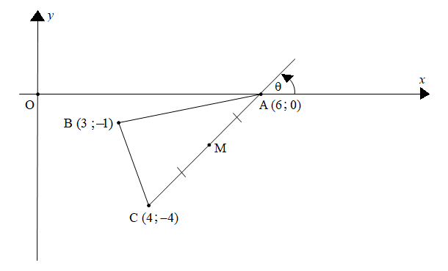

 | Solution/Oplossing | Marks Punte
1.1 |  | (2)
1.2 |  | (2)

 | Solution/Oplossing | Marks Punte
1.3 |  | (2)
1.4 |  | (2)
1.5 |  | (4)
 |  | [12]

QUESTION/VRAAG 2

2.1 | 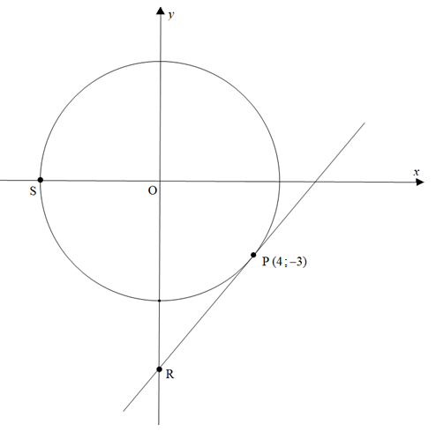

 | Solution/Oplossing | Marks Punte
2.1.1 |  | (2)
2.1.2 |  | (2)

 | Solution/Oplossing | Marks Punte
2.1.3 |  | (4)
2.1.4 |  | (1)

 | Solution/Oplossing | Marks Punte
2.2.1 |  | (1)
2.2.2 | 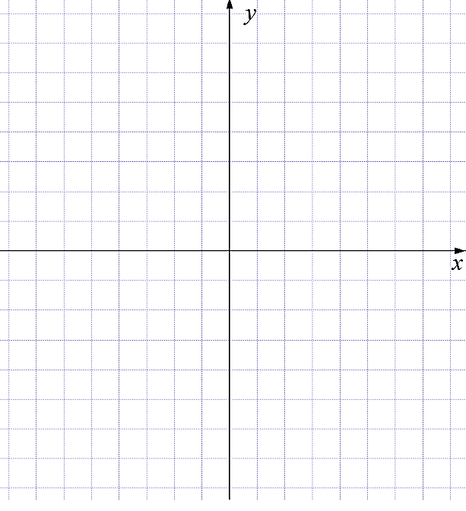 | (2)
 |  | [12]

QUESTION/VRAAG 3

 | Solution/Oplossing | Marks Punte
3.1.1 |  | (1)
3.1.2 |  | (2)
3.1.3 |  | (2)
3.2 | 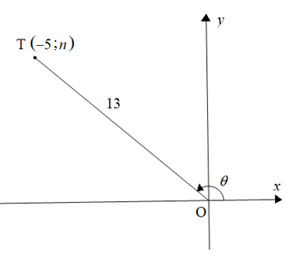
3.2.1 |  | (1)
3.2.2 |  | (4)

 | Solution/Oplossing | Marks Punte
3.3 |  | (4)
 |  | [14]

QUESTION/VRAAG 4

 | Solution/Oplossing | Marks Punte
4.1.1 |  | (1)
4.1.2 |  | (1)
4.1.3 |  | (6)

 | Solution/Oplossing | Marks Punte
4.2.1 |  | (1)
4.2.2 |  | (4)
 |  | [13]

QUESTION/VRAAG 5

 | Solution/Oplossing | Marks Punte
5.1 | 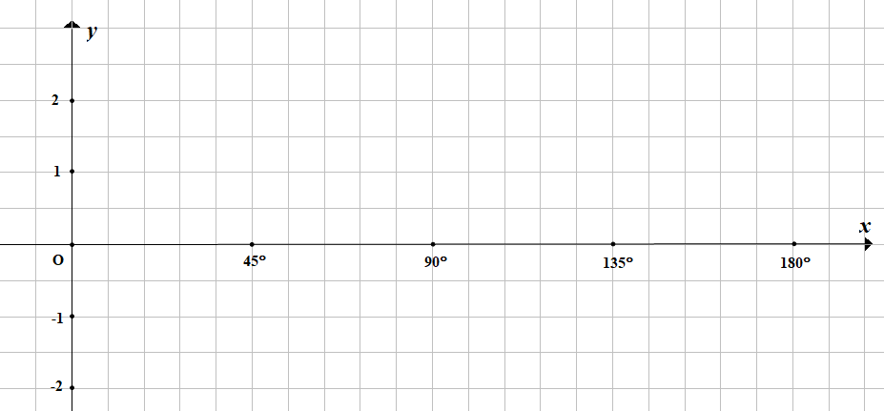 | (6)
5.2.1 |  | (1)
5.2.2 |  | (2)
5.2.3 |  | (1)
5.2.4 |  | (2)
 |  | [12]

QUESTION/VRAAG 6

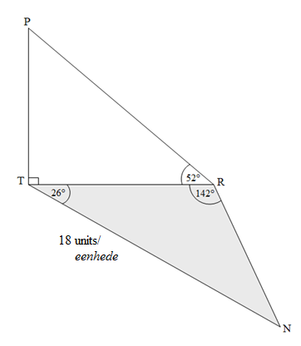

 | Solution/Oplossing | Marks Punte
6.1 |  | (1)
6.2 |  | (3)

 | Solution/Oplossing | Marks Punte
6.3 |  | (2)
6.4 |  | (5)
 |  | [11]

Give reasons for your statements in QUESTIONS 7, 8 and 9.
Gee redes vir jou bewerings in VRAAG 7, 8 en 9.

QUESTION/VRAAG 7

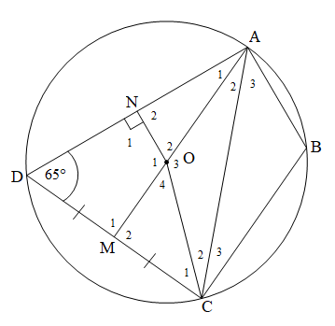

 | Solution/Oplossing |  | Marks Punte
7.1 |  |  | (1)
7.2 |  |  | (1)
7.3 | STATEMENT/BEWERING | REASON/REDE
7.3 |  | Opposite ∠s of cyclic quad/ Teenoorstaande ∠e van koordevierhoek | (1)
7.3 |  | Opposite ∠s of cyclic quad/ Teenoorstaande ∠e van koordevierhoek | (1)
7.3 | DN = … | … | (2)

 | Solution/Oplossing | Marks Punte
7.4 |  | (3)
7.5 |  | (3)
 |  | [12]

QUESTION/VRAAG 8

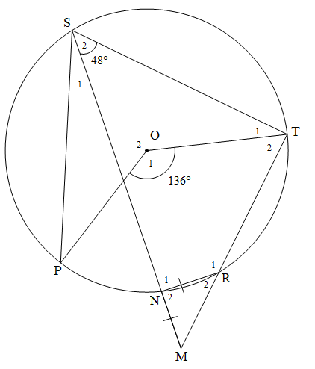

 | Solution/Oplossing | Marks Punte
8.1.1 |  | (3)
8.1.2 |  | (6)

8.2
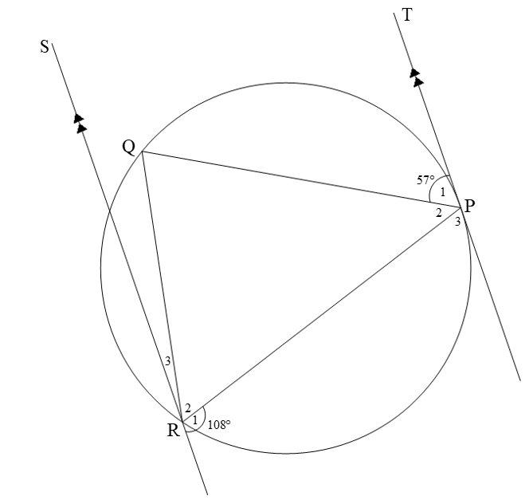
 | Solution/Oplossing | Marks Punte
8.2.1 |  | (2)
8.2.2 |  | (4)
 |  | [15]

QUESTION/VRAAG 9

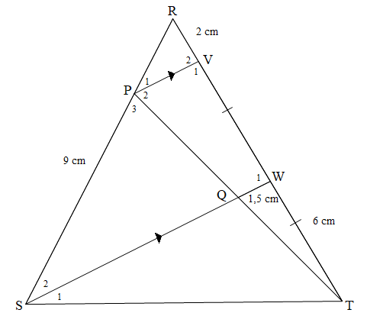

 | Solution/Oplossing | Marks Punte
9.1 |  | (1)
9.2 |  | (3)

 | Solution/Oplossing | Marks Punte
9.3 |  | (2)
9.4 |  | (3)
9.5 |  | (2)
 |  | [11]

QUESTION/VRAAG 10

10.1
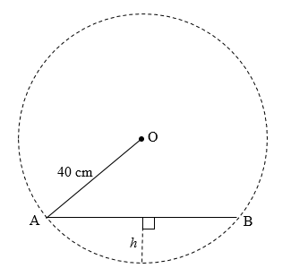

 | Solution/Oplossing | Marks Punte
10.1.1 |  | (1)
10.1.2 |  | (1)
10.1.3 |  | (1)
10.1.4 |  | (3)

 | Solution/Oplossing | Marks Punte
10.1.5 |  | (4)

10.2
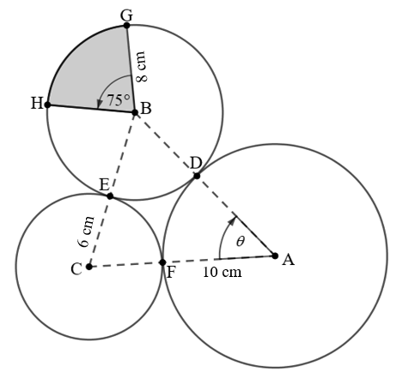
 | Solution/Oplossing | Marks Punte
10.2.1 |  | (1)
10.2.2 |  | (3)
10.2.3 |  | (1)
10.2.4 |  | (5)
 |  | [20]

QUESTION/VRAAG 11

11.1
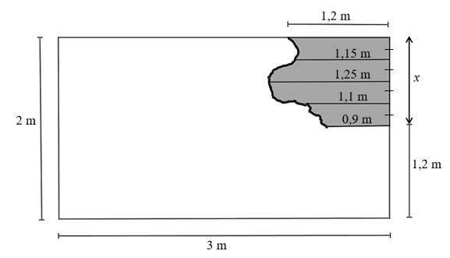
 | Solution/Oplossing | Marks Punte
11.1.1 |  | (1)
11.1.2 |  | (1)
11.1.3 |  | (3)
11.1.4 |  | (5)

11.2
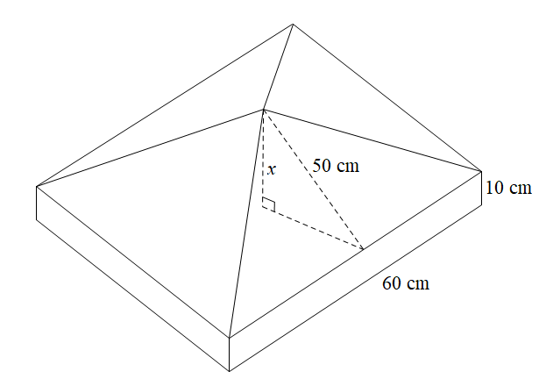
 | Solution/Oplossing | Marks Punte
11.2.1 |  | (3)
11.2.2 |  | (2)
11.2.3 |  | (3)
 |  | [18]

TOTAL/TOTAAL: |  | 150

 | Additional space/Bykomende ruimte | Marks Punte

 | Additional space/Bykomende ruimte | Marks Punte

