MID YEAR EXAMINATION 2023
GRADE 4 : SOCIAL SCIENCE PAPER 1
TIME : 1 HOUR 45 MINUTES

Instructions to Candidates
- Answer all questions
- Each question carries 1 mark
- Answer on a separate sheet provided
1. A child is a person below ____________ years.
A. sixteen B. fifteen C. eighteen D. two

2. My father’s sister is my
A. aunt B. uncle C. sister D. niece

3. Religious activities bring __________ in the family.
A. freedom B. divisions C. unity D. fights

4. Muslims are not allowed to ______ during Ramadan.
A. eat or drink B. fast C. travel D. pray

5. The ____________ religion believes in bringing back the spirit of the dead.
A. Christianity B. Judaism C. Islam D. Indigenous

6. A religious practice that is done in Judaism is
A. ngozi B. feast C. circumcision D. kurovaguva

7. An orphanage is a home for
A. street people B. orphans
C. old people D. the dead

8. Disability does not mean
A. inability B. the sick C. ability D. the blind

9. Jairos Jiri Association is known for helping the
A. old B. vulnerable C. rich D. church

10. The Braille is used by the
A. deaf B. blind C. slow readers D. handicapped

11. In Indigenous religion people call their god
A. Musikavanhu B. Allah C. Yahweh D. Jesus

12. In ________________ religion, religious knowledge is passed on from generation to generation orally.
A. Islamic B. Indigenous C. Christianity D. Jewish

13. _________ is a rain making ceremony
A. Amabhiza B. Isisthikitsha C. Mukwerera D. Kurovaguva

14. Which one of the following is a Jewish religious practitioner?
A. Muezin B. Pastor C. Rabbi D. Traditional healer

Look at the following artefact

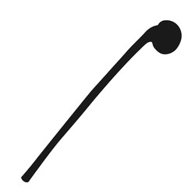

15. It is a _____________________
A. pointer B. wood C. knobkerrie D. stick

16. Christians use____________ as their religious symbol.
A. candle stick B. cross C. logo D. halfmoon

17. Jesus died on the
A. cross B. Mosque C. hospital D. river

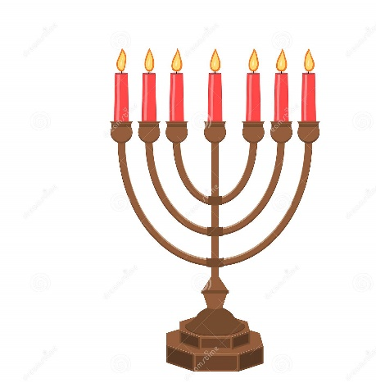

18. Name the artefact
A. cross B. menorah C. mezuzah D. yad

19. Yahweh is the name of the _____________ God.
A. Muslims B. Jewish C. Indigenous D. Christians

20. The Torah scroll contains
A. laws B. books C. rites D. rituals

21. An Islamic long journey made to a sacred place as an act of religious devotion is called a
A. Ramadan B. Pilgrimage C. A l-Aqsa D. Shrine

22. Abuse of substance can _____________________ people’s health.
A. destroy B. improve C. help D. maintain

23. Every child has the right to
A. have brothers B. be heard
C. belong to an orphanage D. be noisy

24. Indigenous processing tools make work
A. difficult B. easier C. tiresome D. heavy

25. Long ago people used ___________ to grind mealies.
A. a stick B. a grinding stone C. a mud D. a hoe

26. Njeleleis found in
A. Harare B. Kwekwe C. Matobo D. Chinhoyi

27. Give one example ofan indigenous game
A. chess B. tennis C. pada D. rugby

28. When girls give adults food they
A. look away B. kneel
C. stand D. put their left hand on the waist

29. Who leads a town or a city?
A. President B. Senator C. Mayor D. Councillor

30. The earliest known people to have lived in Zimbabwe were the
A. Nguni B. Khoisan C. Bantu D. Tanga

31. Which of the following is not a National Monument
A. Sports Stadium B. Matobo Hills
C. Great Zimbabwe D. Khami Ruins

32. A village court is presided over by
A. a chief B. a father C. an elder D. a headman

33. Child labour is a form of child
A. rights B. abuse C. responsibility D. friendship

34. Child trafficking is
A. sending children to hospital
B. sending children to school
C. keeping children working
D. taking children illegally away from their homes

35. Which of the following is not a right?
A. right to life B. right to steal
C. right to health D. right to education

36. Responsible children should
A. bully one another B. lie to their parents
C. take care of their bodies D. drink lots of alcohol

37. Good parents
A. leave their children playing far from home
B. leave their children with strangers
C. guide and counsel their children
D. sexually abuse their children

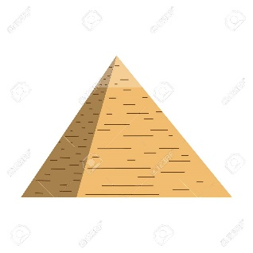
38. The above shelter is a
A. triangle B. pyramid C. Tonga hut D. igloo
~
39. A volunteer works for
A. the government B. donors C. food D. no pay

40. _____________ helps in paying for the education of underprivileged children.
A. Zimbabwe B. BEAM C. SAPP D. Red Cross

