Bedfordview Primary School
TERM 4 TEST

Name: | Grade: 7 A B C D
Subject: Creative Arts –Section A- Visual Art
Examiner: Mrs P Naidoo | Date: 23 November 2021
Moderator: Mrs M Pretorius | Total Time Allocation: 90 mins

1  0 – 29% | 2  30 – 39% | 3  40 – 49% | 4  50 – 59% | 5  60 – 69% | 6  70 – 79% | 7  80 – 100% | 25 | %

INSTRUCTIONS

- An extra 10 minutes will be provided for reading.
- This test consists of two sections (Section A- Visual art and Section B- Drama) to be completed in 90 minutes.
- Write neatly and legibly.
- You will need colour pencils.
- Answer in the spaces provided.
- Section A consists of 8 pages.

Question Analysis
Question  1 | Question  2 | Question  3 | Question 4 | Question  5 | Question 6 | Question 7 | Question  8 | TOTAL  50
6 | 4 | 6 | 3 | 9 | 10 | 8 | 4 | _______/50÷2=
 |  |  |  |  |  |  |  | _________/25

~~~~~~~~~~~~~~~~~~~~~~~~~~~~~~~~~~~~~~~~~~~~~~~~~~~~~~~~~~~~~~~~~~~~~~~~~~~~~~~~~~~~~~~~~~~~~~
SECTION A: VISUAL ART
Word box
red coiling blue seven proportion shadow

magenta twelve yellow wedge and knead indigo

harmony coral green orange turquoise

eight violet complementary olive gold

movement emphasis colour analogous

Question 1 [6]
Match the definition in column B to the Element in column A and write down only the correct number in column C. example: g – 12
A Element of art | B Definition | C Correct match
- Line | - An artist’s attempt to create an illusion of 3D on a flat surface | a.
- Tone | - It is made up of many points or dots. | b.
- Texture | - Shows the external outline  of an object. | c.
- Shape | - Shows the entire appearance of the object- its material, size, shape and texture. | d.
- Form | - Sows the change from light to dark in a drawn or painted picture or object. | e.
- Space | - Shows the surface quality of an object as well as the material that object is made of. | f.
_____/6
Question 2 [4]
Give the definitions of the following exactly as we learnt in class.
2.1.Pattern:
_______________________________________________________________________________________________________________________________________________________________________________________________________________________________________ (1)
2.2.Emphasis:
________________________________________________________________________________________________________________________________________________________________________________________________________________________________________(1)
2.3.Variety:
_______________________________________________________________________________________________________________________________________________________________________________________________________________________________________ (1)
2.4.Rhythm and movement: _______________________________________________________________________________________________________________________________________________________________________________________________________________________________________ (1)
_____/4
Question 3 [6]
Use the word box on page 1 to write one word or term for each of the following descriptions.
Description | Term
3.1. The darkest parts of an object/scene which do not have light on them. | __________________
3.2. The focus or main idea that grabs your attention in a picture. | __________________
3.3. The opposites on the colour wheel. | __________________
3.4. Fold and compress clay over itself a few times to squeeze out any air bubbles. | __________________
3.5. When elements work well together and relate to one another. | __________________
3.6. Creates mood and meaning in an artwork. | ___________________

________/6

Question 4 [3]
Use your grey lead pencil to draw in the shading techniques indicated below the vase.
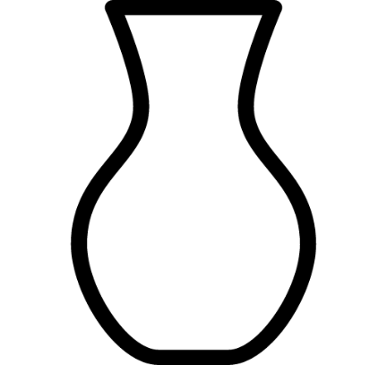
This Photo by Unknown Author is licensed under CC BY-NC
Contouring Cross-hatching Blending _______/3

Question 5 [9]
Use the word box on page 1 to help you answer the following about the colour wheel. You can use the colour pencil, or you can mix the colour.
5.1 Colour in the two colours that are analogous to yellow.

and
(2)
5.2 Colour in the colours that make magenta.

and
(2)

5.3 Turquoise is complementary to __________________ (write the name of the colour) (1)
5.4 A rainbow has _____________ colours. (1)
5.5 Name and colour in any 3 tertiary colours

_________________ __________________ __________________ 6x ½ = (3)
_____/9

Question 6 [10]
Study the picture below and read the paragraph. Then answer the questions that follow.

Old couple or musician – Salvador Dali – 1930
Salvador Dali Paintings

Salvador Felipe Jacinto Dali Domenech popularly known as Salvador Dali is a surreal artist. He was born in Catalonia, Spain on the 11th May 1904. When he was a child Salvador showed great interest in painting and drawing. He initially started off with charcoal drawings and his father helped set up various exhibitions to show off surreal Dali paintings. Even at such a young age, Salvador’s paintings were highly sophisticated and as an act of support his father built him a studio.
Salvador Dali graduated from San Francisco School of fine arts with a Fine Art degree in the year 1922. One of his most famous paintings were of melting clocks. During 1920 he went to Madrid, here he had the chance to meet Picasso and other artists, which changed his focus to surrealism, like the optical illusion above, His work always leaves onlookers amazed.

  - Who is the artist? ___________________________________________________ (1)
  - What is the title of the painting? ________________________________________ (1)
  - Where was the artist born and on which date?
___________________________________________________________________ (2)
  - In which medium did the artist originally start off?
___________________________________________________________________ (1)
  - Which two realities can you see in the painting? Describe each shortly. (4)
Reality one - __________________________________ ________________________________________________________________________________________________________________________________________________________________________________________________________________________________________________________________________________________
Reality two - ___________________________________
_____________________________________________________________________
_____________________________________________________________________
_____________________________________________________________________
_____________________________________________________________________
  - Choose the correct answer and underline it. (1)
His paintings are called…
- Surreal and optical illusion.
- Still life and optical illusion.
- Surreal and impressionistic. _____/8

Question 7 [8]
Look at the picture on the following page. Redraw figure1 and enlarge with grey lead pencil.
Criteria | 7- 8 | 5 - 6 | 3 - 4 | 2 - 1
Proportion | Excellent proportions and precisely redrawn | Good proportions and well redrawn. | Moderate proportions and drawing well tried. | Poorly redrawn and proportions warped.
Shading | Shading techniques excellently done. | Shading techniques well done. | Shading techniques lacks precision. | Shading techniques barely visible.
 |  | _______/16 ÷2 = | ______/8
RUBRIC:

Figure 1
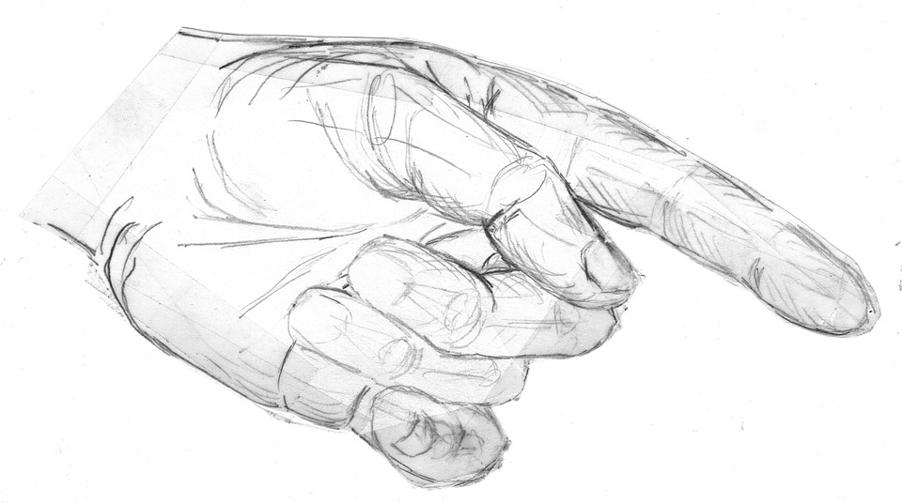
7.1. Redraw the picture in Figure 1 in the block below. Remember to enlarge and add shading techniques precisely.
Question 8 [4]
. Value is the range from light to dark in art. Do the following value scales.
8.1. Grey lead pencil shading value scale. (1)

8.2. Ink blue pen shading value scale with vertical lines. (1)

8.3. Red colour pencil shading value scale with dots. (1)

8.4. Use complementary colours on the colour wheel to show the value of contrast. (1)
_____/4

