Bedfordview Primary School
TERM 4 TEST

Name: | Grade 7:
Subject: Creative art – Section B: Drama
Examiner: Mrs S James | Date: November 2021
Moderator: Mrs P Naidoo | Total Time Allocation: 90 mins

1  0 – 29% | 2  30 – 39% | 3  40 – 49% | 4  50 – 59% | 5  60 – 69% | 6  70 – 79% | 7  80 – 100% | 25 | %

INSTRUCTIONS

- An extra 10 minutes will be provided for reading both sections of this test.
- Write neatly and legibly.
- Answer in the spaces provided.
- Section B (Drama) consists of 8 pages.
- Both Section A (Visual art) and Section B must be completed in 90 minutes.

Question Analysis
Question  1 | Question  2 | Question  3 | Question 4 | Question  5 | Question 6 | Question 7 | Question  8 | Question  9 | TOTAL
8 | 5 | 6 | 4 | 5 | 8 | 4 | 6 | 4 | 50

~~~~~~~~~~~~~~~~~~~~~~~~~~~~~~~~~~~~~~~~~~~~~~~~~~~~~~~~~~~~~~~~~~~~~~~~~~~~~~~~~~~~~~~~~~~~~ SECTION B: DRAMA
Question 1: Match the concepts in column A to the explanations in Column B. Write the correct letter for your answers e.g. 1. K (8)
 | COLUMN A |  | COLUMN B | ANSWERS
1 | Genre | A | A character that opposes the main character | 1.
2 | Procession | B | The main character or central figure in a drama | 2.
3 | Gels | C | The part of the theatre that is not seen by the audience | 3.
4 | Ululation | D | Someone whose voice explains what is happening in a story | 4.
5 | Narrator | E | A sharp sound by the tongue used to express extreme emotion | 5.
6 | Backstage | F | A gelatin thin sheet with transparent thin film, that is placed in front of the stage light | 6.
7 | Protagonist | G | A group of people who are moving forward marching, walking or riding | 7.
8 | Antagonist | H | The style that the play is written in | 8.
 |  | I | A prayer or a chant which is sometimes believed to have magical powers

Question 2: Complete the following the following sentences with terms from the box below (5)

agent acoustics producer imagination animated projection fable myth

2.1 An actor hires this person to promote him/herself to secure acting roles

_____________________________________________ (1)

2.2 To throw your voice into the space where the audience sits

_____________________________________________ (1)

2.3 A series of drawings that are photographed and shown as a movie

_____________________________________________ (1)

2.4 The power of forming pictures in your mind

_____________________________________________ (1)

2.5 A story that is made up to teach a lesson

_____________________________________________ (1)

Question 3: Below you have an empty stage. Look at the words below and write the correct positions in the blocks provided. (12x½= 6)

What is this called?

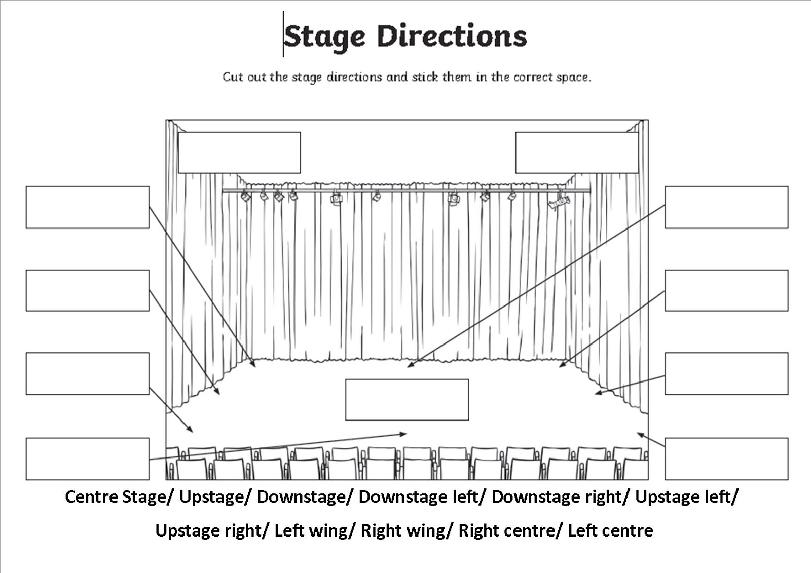

Question 4: Fill in the correct missing words to complete the following sentences. (4)

4.1. There is an imaginary wall between actors and the audience which is called a
______________________________. (1)

4.2. __________________________ is separating something into parts or segments to
understand it better. (1)

4.3. A ________________________________ works with the lights, sound and the stage and makes sure that everything on stage is working. (1)

4.4. A ______________________________________________ is a person who hosts a show on radio or television. (1)

Question 5: Create an animal mask and answer the questions below (5)

Complete the following questions

5.1 What is stage makeup used for? ________________________________________________

__________________________________________________________________________ (1)

5.2 What influences stage make-up? _____________________________________________

__________________________________________________________________________ (1)

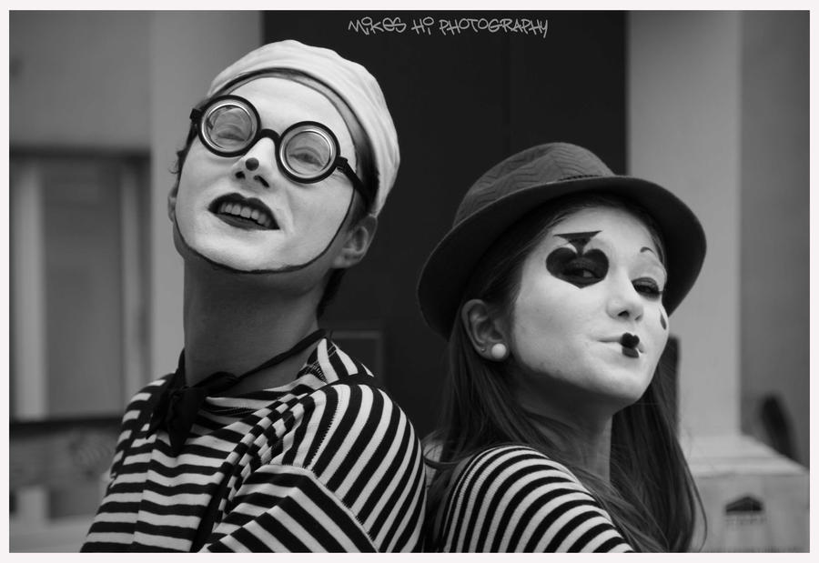

5.3
Career Focus: Makeup artist

- Decide on an animal that you would transform the character into
- Create a makeup look for the face below to make the human appear to be that animal
- Be creative. Write the name of the animal in the block below
- Use colour pencils or crayons to complete

Name of animal:

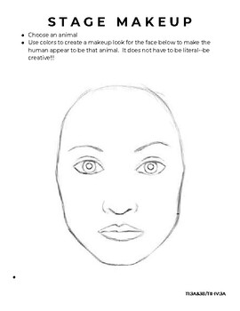

RUBRIC
Originality | 1
Total transformation to animal | 1
Creative use of makeup | 1

Question 6: Read the following dialogue. Answer the questions below. (8)
Messy bedroom
Setting: A boy’s bedroom. The story will begin in modern times. Through the magic of theatre, we will be going back through the ages.

Jamie: Mom, I put the dishes in the dish washer. Just like you asked. I’m going outside to play.
Mom: Jamie, have you finished your chores?
Jamie: Most of them.
Mom: Most of them?
Jamie: I already told you.
Mom: You put the dishes in the dish washer?
Jamie: Yes, and it was exhausting. Can I go outside a play now?
Mom: Did you clean your room?
Jamie: I cleaned it last Saturday!
Mom: You are supposed to clean it every Saturday. Please do it now, Jamie. It won’t take long. Then when all of your chores are out of the way, you can have the rest of the weekend to enjoy yourself.
Jamie: All right.
Mom: That’s my boy.
The Mom walks away. Jamie walks to his room, where other actors pretend to be toys scattered all over his floor. His bed (which might just be a pile of blankets and pillows) is very messy.
Jamie: Oh no. My room is a mess! Mom, this is going to take forever!
Mom: Then you better get started.
Jamie: Fine. First, I better pick up my Army Men. March, two three four.
(Two or three kids playing the role of army men stand up and march away.)
Army Men: Hup, two, three, four!
Jamie: And now my toy dinosaur collection. You guys better climb back on the shelf, back to where you belong.
(Two or three kids playing the role of dinosaur’s growl like as they crawl to their proper places.)
Jamie: Oh, and I almost forgot. My robot monkey action figures. Time to go back to you box.
(Two or three kids act like robot monkeys and climb into a cardboard box.)
Jamie: Hey, that didn’t take too long. Mom! I cleaned my room!
Mom: Well, now. It looks much better. (She notices his bed.) Uh-oh.
Jamie: What?
Mom: You forgot to make your bed.
Jamie: Oh, Mom! Why do I have to make my bed? I already did the dishes. I picked up my army men, my dinosaurs, and my robot monkey action figures. So why do I have to make my bed? It’s just going to get messed up again.
Mom: Hmm… That reminds me of a story about your grandmother when she was a little girl.
Jamie: Grandma used to be a little kid? Like me?
Mom: Of course. Why wouldn’t she?
Jamie: I just figured she started out old. Like you.
Mom: No, we were all little kids once. See down the hallway? That black and white picture hanging on the wall? That’s your grandmother when she was your age.
(A little girl from the 1950’s sits still as if she is in a photograph.)
Jamie: When was this?
Mom: It’s from the 1950’s
Jamie: Wow. She looks grumpy.
Mom: Oh yes, on that day, I bet she was as grumpy as a groundhog because her mother said, “Make your bed.”

6.1 Write an ending to the story. Be creative and use dialogue form.
__________________________________________________________________________________
__________________________________________________________________________________
__________________________________________________________________________________
__________________________________________________________________________________
__________________________________________________________________________________
__________________________________________________________________________________
__________________________________________________________________________________
__________________________________________________________________________________
__________________________________________________________________________________
__________________________________________________________________________________
__________________________________________________________________________________
__________________________________________________________________________________ (4)

6.2 What is the setting of the dialogue?
_________________________________________________________________________________________________________________________________________________________ (1)

6.3 These children are advocating “the elements of drama” rules. Write one element in each of the big speech bubbles. (3)

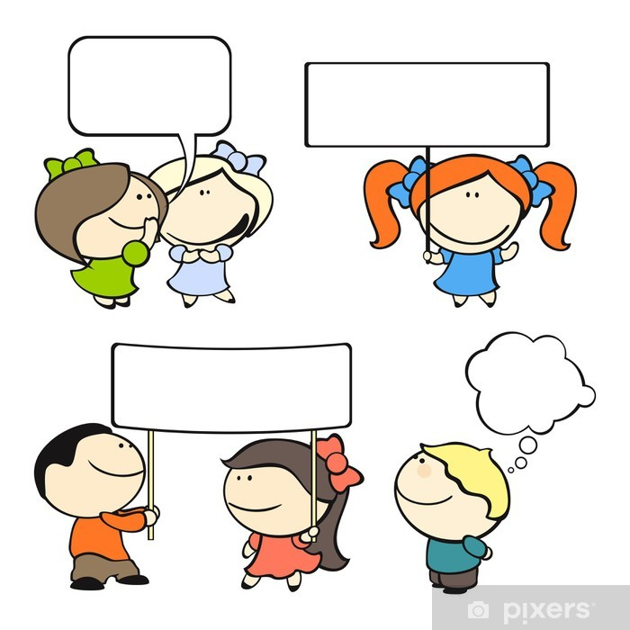

Question 7: Complete the Globe theatre crossword below. To find the correct answer of the highlighted box, you will have to solve number 1 to 4 first. You may use the blocks for numbers 1 to 4. Write the highlighted “Box B” answer below (4)

Theatre

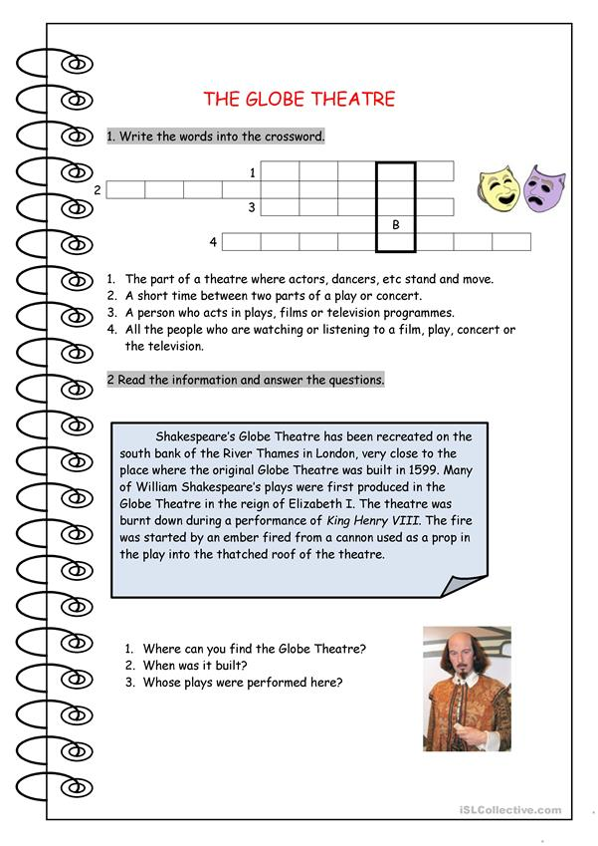

7.1 Crossword answer to “Box B” _______________________________________________(1)

7.2 Where can you find the Globe Theatre? ______________________________________ (1)

7.3 When was it built? _______________________________________________________ (1)

7.4 Whose plays were performed here? _________________________________________ (1)

(4)

Question 8: Unjumble the following words to illustrate typical theatre (jargon) style words (6)

Theatre terms
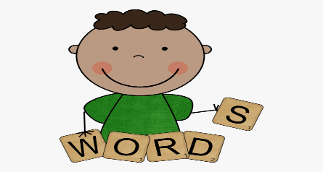

CUIEEADN
MUSTCOE
RPPO
KROABCPD
NEETR
TEXI

Question 9: Examine the flow chart. Match the letters to the appropriate job titles below. Enter the correct letter next to the job title. (4)

Career focus

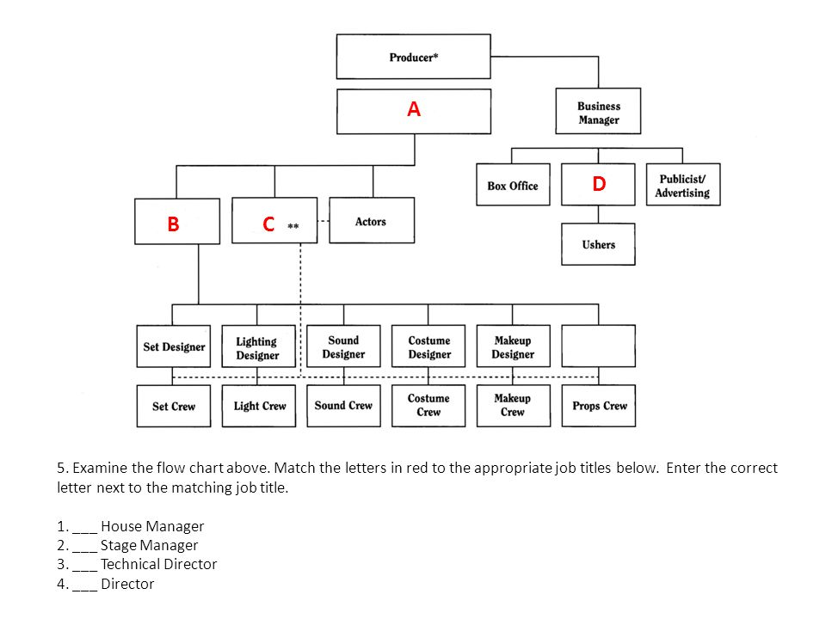

8.1________________ House Manager
8.2________________ Stage Manager
8.3________________ Technical Director
8.4________________ Director
TOTAL MARK 50

